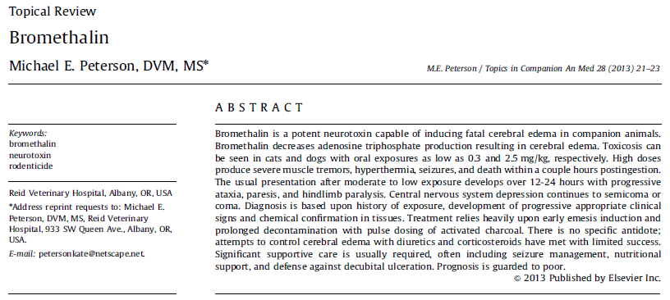

SUMMARY
- LD50: 2.38-5.6 mg/kg dogs, 0.4-0.71 mg/kg cats
- Reduces ATP synthesis affecting Na/K pumps leading to cerebral edema and increased intracranial pressure
- Treatment is symptomatic to control clinical signs and to decontaminate and decrease enterohepatic circulation

Bromethalin is usually marketed as 0.01% formulation (2.84 mg bromethalin per ounce of bait)
LD50: 2.38-5.6 mg/kg dogs (deaths have been reported with oral exposures as low as 0.95-1.05 mg/kg in dogs), 0.4-0.71 mg/kg cats
Clinical signs can appear as low as 10% of the LD50

Toxicokinetics:
- Rapid intestinal uptake > peak plasma concentrations 4hr post ingestion
- Metabolism occurs rapidly by hepatic mixed-function oxygenases via N-demethylation to its metabolite desmethyl bromethalin – toxic metabolite
- Plasma half-life of bromethalin is approximately 6 days
- Bromethalin and metabolites are widely distributed in all body tissues, highest concentrations occurring in fat
- Primarily excreted by bile > enterohepatic circulation, less than 3% renally excreted

Mechanism of Toxicity:
- Uncoupling of mitochondrial oxidative phosphorylation
- Results in reduction of ATP synthesis resulting in less energy available to maintain Na/K pumps due to weakened ion gradients
- Net effect is loss of oncotic control and retention of water causing edema of the myelin sheath and subsequent separation of the myelin lamellae causing dramatic increases in intracranial and cerebrospinal fluid (CSF) pressures

Clinical Signs:
- Primary target organ for bromethalin toxicity is the CNS
- Onset of signs approximately 10hr post ingestion (2-14hr), earlier onset generally due to higher dose ingested
- High exposure: severe muscle tremors, hyperesthesia, hyperexcitablity, hyperthermia, and seizures (focal motor or generalized or both) can be induced by external stimuli, primary cause of death is respiratory paralysis
- Moderate exposure: onset of these clinical signs may be delayed, paralysis of rear limbs, ataxia, paddling, hyperthermia, muscle tremors, hyperexcitiblity, occasionally loss of vocalization, loss of tactile sensation, forelimb extensor rigidity, seizures, and death within 2-4 days, rear limb ataxia progresses to diminished deep pain responses, upper motor neuron bladder paralysis, and patellar hyperreflexia
- Low dose: may take several days for onset of clinical signs that can progress over 1-2 weeks post- exposure, lethargy, depression, vomiting, tremors, ataxia, loss of voice, paralysis, lateral recumbency, coma, and death
- Most common presentation is hindlimb ataxia and paresis secondary to decreased hindlimb proprioception. GI signs can occur including vomiting, anorexia, and occasionally in cat’s abdominal distention from enlarged bowel loops.

Confirmatory Tests:
- History
- Chemical detection – long turnaround time
- Necropsy: diffuse white matter vacuolization in CNS tissue samples

Treatment:
- No specific treatment
- Symptomatic and supportive care
- Emesis
- Activated charcoal q 4-6h at 1g/kg for a minimum of 2-3 days
- Use IV fluids with caution as they can increase cerebral edema (only 3% cleared through kidneys)
  - Dehydrated animals are at risk of rebound cerebral and pulmonary edema when IV rehydration is attempted as evidenced by a deterioration of neurologic clinical signs
- Use PO water if possible
- Hyperosmotic agents if increased intracranial pressure
- Anticonvulsants
Prognosis:
- In mild poisoning cases, overt clinical signs usually resolve within several weeks of ingestion, although subtle signs of neurologic dysfunction may persist
- Severe clinical signs have a grave prognosis

Differential Diagnosis:
- Lead
- Ethylene glycol
- Organophosphates
- Strychnine
- Methaldehyde
- Zinc phosphide
- Monosodium fluoroacetate
- Tremorgenic mycotoxins

Questions:
- T or F: Bromethalin has a slow metabolism, which is why activated charcoal should be given for at least 2-3 days.

- What is the most common clinical presentation for bromethalin toxicosis?

- What is the mechanism of action of bromethalin?

Answers:
- T or F: Bromethalin has a slow metabolism, which is why activated charcoal should be given for at least 2-3 days.

- What is the most common clinical presentation for bromethalin toxicosis?
Hind limb ataxia and paresis

- What is the mechanism of action of bromethalin?
Reduced ATP synthesis > affected Na/K pumps > cerebral edema > ↑ ICP

