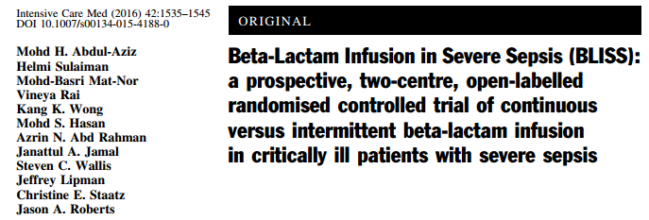

Main points:
- Since beta-lactams are time dependant antimicrobial, CRI may provide additional time over MIC than bolus dosing - this study supports that with improved outcomes and pharmacokinetics
- Cefepime, meropenem or piperacillin/tazobactam (similar to unasyn)
- All patients received initial loading bolus over 30 min
- Dosing was: 1 full dose, followed CRI that consisted of 24 hours worth given as CRI
  - Ex: Piperacillin/tasobactam normal dosing is 4g q6h, CRI group got 4g bolus followed immediately by 4g/6hr CRI

Other things
- Study drug ended when:
  - Clinician decision
  - Patient withdrew from study
  - ICU discharge
  - Death
Endpoints
- Primary
  - Clinical cure at 14 days after cessation of antibiotics
    - Resolution vs (improvement or failure)
- Secondary
  - PK/PD target attainment for patients with susceptible infections
  - Days in ICU, on Vent, to discharge
Results
- Most infections were in lungs, followed by blood, urine, skin, CNS
- Survival was improved for CRI groups compared to control groups
- Days on ventilator was less for CRI group than control
Other things of note
- Other studies have not demonstrated difference in cure rate
  - The authors say that this may be because other studies have had non-critical patients with susceptible infections, whereas this group had serious disease and resistant infections
- This study only had survival benefit for piperacillin/tazobactam group

