Questions
3 main characteristics of distal acidification:
- H+ secretion by H+/ATPAse and H+/K+ ATPase exchanger
- H+ secretory cells DO NOT transport sodium BUT H+ SECRETION is indirectly INFLUENCED BY Na+ reabsorption BY PRINCIPAL CELLS
  - Makes the tubular fluid electronegative promotes H+ accumulation in the lumen and facilitates passive reabsorption of HCO₃-
- HCO₃- exit is mediated by Cl-/HCO₃- exchanger in basolateral membrane

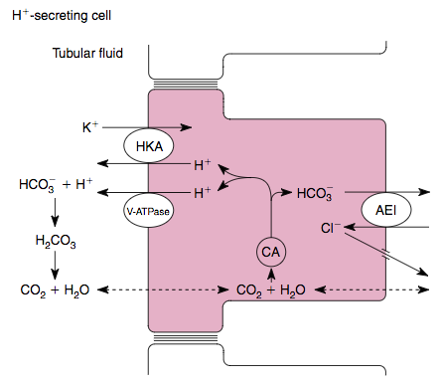

- Type B intercalated cells in collecting tubules are HCO₃- secreting cells
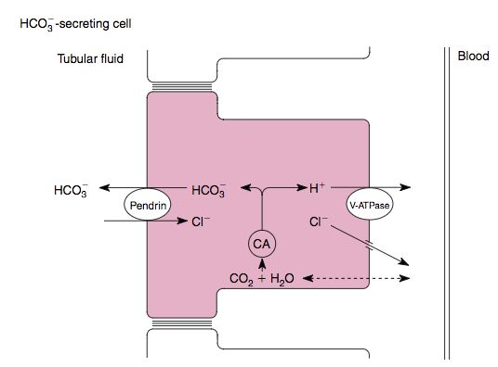
- 90% of the filtered bicarbonate is reabsorbed in the proximal tubule; this is facilitated by the presence of carbonic anhydrase
- To maintain acid-base, the kidneys must replace the HCO₃- lost during buffering of the nonvolatile acids by production of new HCO₃-. A portion of new HCO₃- is produced when urinary buffers like phosphate are excreted as titratable acids
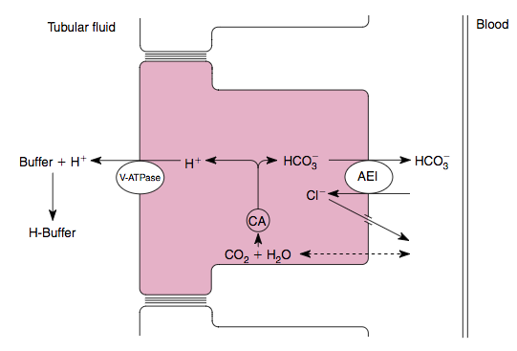
- In the distal part of the nephron, which pump secrete H+
  - Na+/H+ exchangers
  - H+/Cl- exchangers
  - H+/ATPase
  - Na+/K+/H+ cotransporters

- Which cell is represented
  - Type A intercalated cell
  - Type B intercalated cell

- Draw a type ___ intercalated cell (which is the one that is not represented in question 2…)

- Which is the major urinary buffer
  - Uric acid
  - Phosphate
  - Creatinine
  - Albumin

Questions & Answers
- In the distal part of the nephron, which pump secrete H+
  - Na+/H+ exchangers
  - H+/Cl- exchangers
  - H+/ATPase and also H+/K+ ATPase exchangers
  - Na+/K+/H+ cotransporters

- Which cell is represented
  - Type A intercalated cell
  - Type B intercalated cell

- Draw a type ___ intercalated cell (which is the one that is not represented in question 2…)

- Which is the major urinary buffer
  - Uric acid
  - Phosphate HPO₄²⁻
  - Creatinine
  - Albumin

