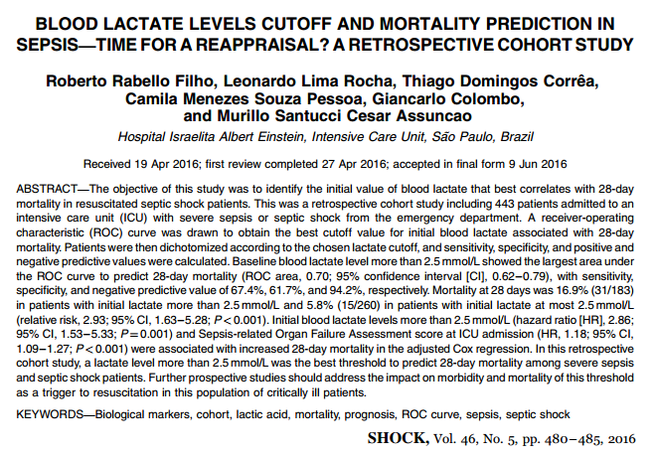

Takeaways: Maybe we should be more concerned/aggressive with even mild elevations in lactate with septic patients

Into: Older studies suggest Lactate >4 require more aggressive resuscitation, but maybe lower lactates need to have more attention
Goal: Determine lactate level that best correlates to 28 day survival
Setup: Retrospective cohort at single ICU in brazil
Population: Only severe sepsis or septic shock - 443 patients
Results:
Lactate clearance (absolute of ratio) did not correlate to survival
Absolute lactate >2.5 correlated to increased mortality at 28 days

