Antigens: Triggers of Acquired Immunity
Veterinary Immunology, Ch 7

Key Points:
- The best antigens are large, complex, stable, foreign proteins
- Small molecules may be made antigenic by conjugation to large proteins (haptens)
- Antigenic determinants or epitopes: distinct areas on the surface of foreign antigens recognized by the immune system

Antigens
- Foreign molecular structures
- Bacterial Antigens
  - Cytoplasmic membrane encased by a cell wall, and associated protein structures (pili, flagella, capsule)
  - Gram positive: peptidoglycan, lipoteichoic acids (transmembrane ion transport)
  - Gram negative: peptidoglycan (thin layer) and outer membrane of lipopolysaccharide (also called endotoxin)
    - LPS is responsible for the majority of antigenicity, as it binds to TLR and other pattern recognition receptors thus inducing cytokine production
  - K antigens: bacterial capsules consisting of polysaccharides
  - Pili and fimbriae: F or K antigens
  - Flagella: H antigens
  - Porins: form pores on the surface of Gm - organisms
  - Heat-shock proteins: generated in large numbers in stressed bacteria
  - Exotoxins: toxic proteins secreted or released during bacterial death
    - Highly immunogenic
    - Stimulate production of antitoxins
    - Toxiods: modified (by lab mechanisms) exotoxins
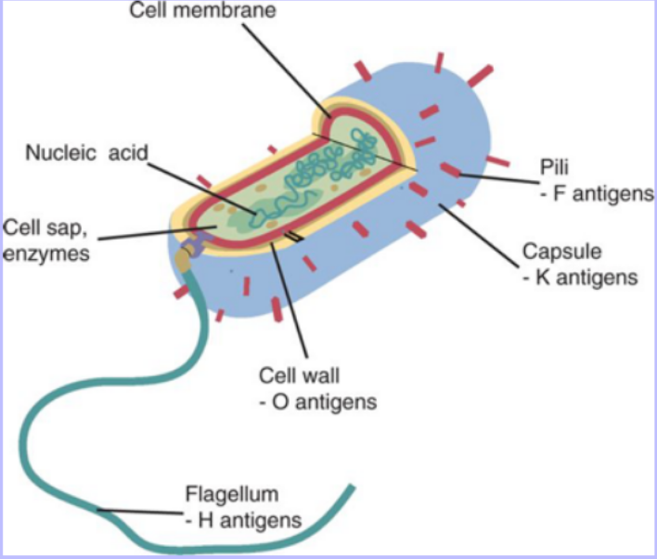

- Viral Antigens
  - Viruses are obligate intracellular parasites
  - Nucleic acid core surrounded by a protein layer (capsid, subunits: capsomeres)
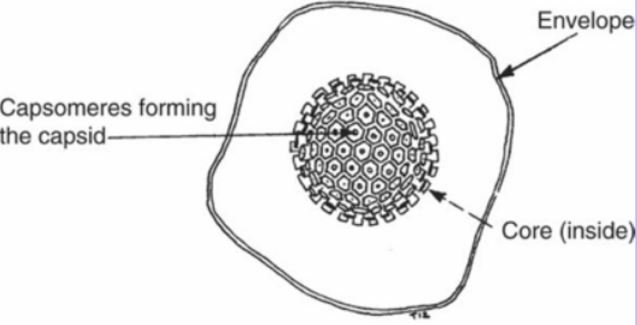
  - Some viruses are also surrounded by an envelope containing lipoproteins and glycoproteins
  - Viron: complete viral particle

  - Intracellular viruses evade the immune system, though viral nucleic acids can become integrated into a cell’s genome and result in cellular expression of viral proteins (endogenous antigens)
- Nonmicrobial antigens
  - Cell surface antigens
    - The cytoplasmic membrane of every mammalian cell has many proteins that can act as antigens
      - Major histocompatibility complex (MHC): most important cell surface protein that trigger graft rejection
  - Autoantigens
    - Immune response directed against normal body components
- What makes a good antigen?
  - Molecules have variable antigenicity
  - Foreign proteins make the best antigens, esp if large (>1kDa)
  - Simple polysaccharides (starch or glycogen) are poor antigens due to rapid degradation by the body
  - Poor antigens bound to glycoproteins or carbohydrates may trigger immune responses
  - Mammalian nucleic acids are poor antigens due to relative simplicity and flexibility, and rapid degradation
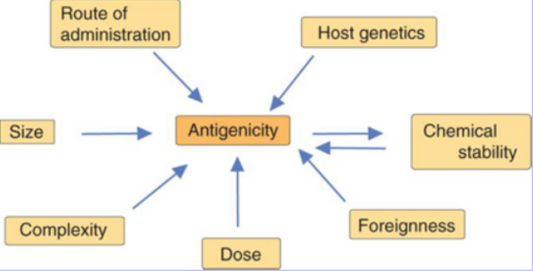
  - Microbial nucleic acids can stimulate a potent acquired immune response due to foreign protein sequences

- Epitopes
  - Specific regions, usually on the surface of the molecule, that stimulates an immune response
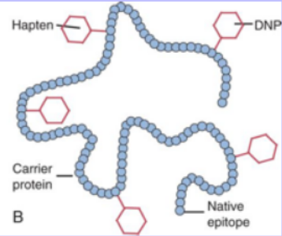
  - Large, complex molecules may have multiple epitopes with varying immunogenicity
- Haptens
  - Small molecules or groups that function as epitopes only when bound to a larger molecule
  - Carrier: the larger antigenic molecule the hapten binds to

- Cross-reactions
  - Identical/similar epitopes on apparently unrelated molecules
  - Immune response in an animal apparently naïve to the antigenic stimulus

Questions
- Name two factors that influence the antigenicity of a molecule.
- Describe the locations of gram-negative bacterial organism antigenic protein structures.
- Define epitope.

Answers
- Name two factors that influence the antigenicity of a molecule.
  - Size
  - Complexity
  - Foreignness
  - Host genetics
  - Route of administration
  - Chemical stability
  - Dose
- Describe the locations of gram-negative bacterial organism antigenic protein structures.
  - Capsule/K antigens
  - Cell membrane/LPS/O antigens
  - Pili/F or K antigens
  - Nucleic acids
  - Fimbriae/F or K antigens
- Define epitope.
  - Specific regions, usually on the surface of the molecule, that stimulates an immune response.

