Ammonium (NH4) Excretion
Summary
- Kidneys are able to increase their H+ excretion through ammonium excretion
- Tubular cells produce ammonia (NH₃), which freely diffuses into tubular lumen, combines with H⁺ to form NH₄ → excreting H+
- Ammonium recycling involves NH4 being reabsorbed in thick ascending loop to maintain NH3 recycling in the medulla and have NH3 available for acid base disturbances
- H+/ATPase pump continuously delivers H+ in collecting tubule which combines with NH3 to maximally acidify urine producing NH4
Ammonium excretion occurs in 3 main steps:
- NH4 is produced primarily in the early proximal tubular cells
- Luminal NH4 is partially reabsorbed in the thick ascending limb and the NH3 is then recycled within the renal medulla
- Medullary interstitial NH3 reaches high concentrations that allow NH3 to diffuse into the tubular lumen in the medullary collecting tubule, where it is trapped as NH4 by secreted H+
Step 1: NH4 (AMMONIUM) production in proximal tubular cells
- Metabolism of aminoacids , mostly glutamine produces NH4 (lipid insoluble, needs transporter)
- NH4 catalyzed by glutamate dehydrogenase producing α-keto-glutarate
- Metabolism of α-keto-glutarate produces 2 HCO3, which are returned through circulation through the Na-3HCO3 cotransporter
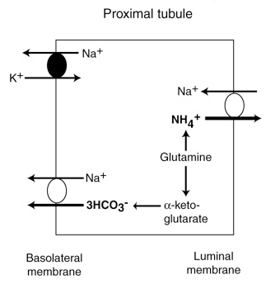
Step 2: Medullary recycling
- NH4 and NH3 exist in equilibrium in the tubular lumen, NH3 easily diffuses into peritubular capillaries
- NH3 is then trapped in the tubular lumen by combining with a H+ producing NH4
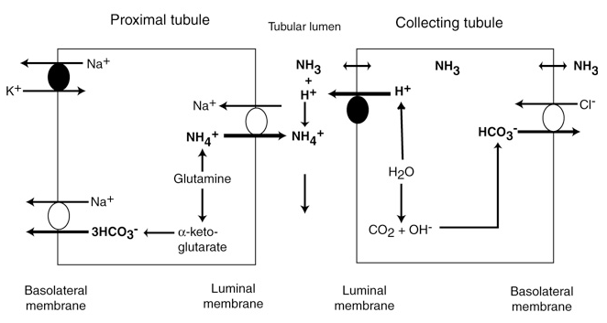
- NH4 is then reabsorbed at the thick ascending limb in substitution of K+ in the Na/K/2Cl carrier
- Equilibrium between NH3 and NH4 must be maintained, so NH4 dissociates to NH3 and a H+
- H+ are re-secreted into the lumen through Na/H exchanger, and NH3 diffuses through the basolateral membrane back into the medullary interstitium
- Luminal wall is impermeable to NH3 at the thick ascending limb, so it is trapped in the interstitium
- NH3 then diffuses back into proximal, cortical collecting and most of the medullary collecting duct where there is lack of carbonic anhydrase and starts over again

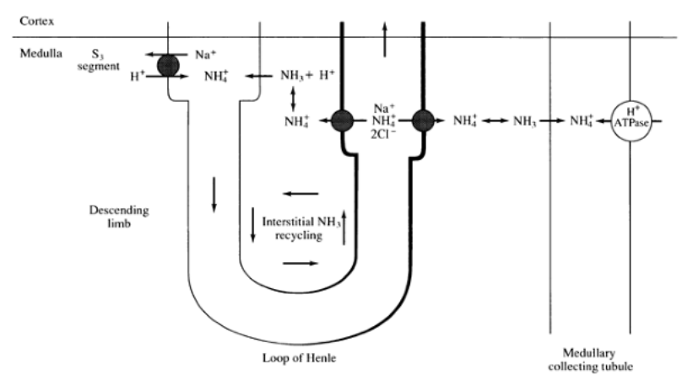
Step 3: NH3 secretion into the cortical and medullary collecting tubule
- Fluid enters collecting duct (no carbonic anhydrase), H+/ATPase is constantly pumping in H+ to maximally acidify urine
- NH3 combines with H+ producing NH4, being trapped in the lumen, this maintains a large gradient favoring diffusion of NH3 into collecting tubule

Response to Changes in pH
- NH4 can be increased in 2 ways:
  - Increasing proximal tubule NH4 production from glutamine
    - Maximal level within 5-6 days
    - Immediate increase due to enhanced efficiency of NH4 trapping and increased glutamine uptake by cells (increases with acidemia)
  - Lowering urine pH, increasing NH3 diffusion into collecting tubule
    - Maximum level within hours

Questions:
- What are the 3 steps involved in ammonium excretion?

- What are the 2 ways in which low pH increases ammonium?

Answers:
- What are the 3 steps involved in ammonium excretion?
Production of NH4
Medullary Recycling
NH3 secretion into collecting tubule

- What are the 2 ways in which low pH increases ammonium?

Increasing NH4 production from glutamine in proximal tubules
By lowering urine pH, which promotes diffusion of NH3 into collecting tubule, producing NH4

