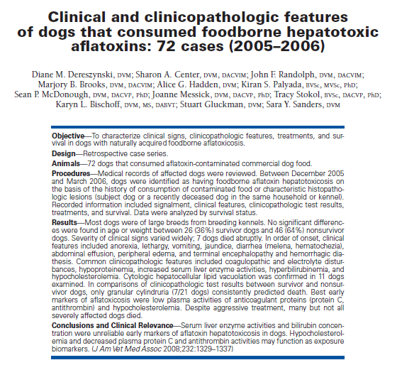
- Aflatoxins are potent hepatotoxic and hepatocarcinogenic agents produced primarily by strains of the fungus Aspergillus
- Many aflatoxins exist, AFB1 is the most common, potent and oncogenic in food-related aflatoxins
- Hepatoxicosis is dose related and caused by rapidly formed metabolites (8,9 epoxide) under influence of CYP450 > overwhelms detoxifying pathways by depleting glutathione
- Loss of hepatocellular glutathione compromises detoxification of AFB1, results in 2ary oxidative damage increasing epoxide mediated damage
- AFB1 binds irreversibly to cell enzymes, proteins and DNA causing impaired metabolism, gene transcription and protein synthesis
- Hepatocellular carcinoma can be induced
- Late 2005, a serious foodborne aflatoxin contamination from moldy corn in dog food was recognized by Cornell and NY state vets – food was distributed in eastern and southeastern USA and Europe – food was recalled – this study evaluated those pets
- Inclusion: ≥1 of the following - several week or month history of consumption of contaminated food, aflatoxin concentration in food > 60 ppb, histopath lesions consistent with aflatoxin
- Results:
  - 7 dogs died acutely with no recognized clinical signs
  - In order of onset: anorexia 91%, lethargy 86%, vomiting 91%, jaundice 73%, diarrhea 81%, abdominal effusion 64% (usually transudate), peripheral edema after fluid therapy 67%, encephalopathy 41%
  - Dogs were reluctant to eat the contaminated food, but not alternative food
  - Most dogs with abdominal effusion died (12/14)
  - Acquired PSS in 2 dogs that died and 2 that had abdominal effusion
  - Failure to survive was associated with severe enteric hemorrhage
  - Non-survivors had prolonged PT/aPTT, lower fibrinogen, lower antithrombin, protein C and FVII:C, lowerv Na, Ca, TP, albumin and cholesterol
  - Granular casts 33%
  - Elevated liver enzymes 83%
  - Cytology: diffuse hepatocyte lipid vacuolation
- Acute-high dose intoxication may not allow time for increase of bili or liver enzymes, degree of increase is not correlated with severity
- Mortality of this population was 64%
- Treatment:
  - N-acetylcysteine
  - SAMe
  - Silybin (from milk thistle), hepatoprotectant, modifies formation of CYP450 AFB1, enhances glutathione- transferase activity and promote glutathione synthesis
  - Antiemetics
  - Vit K
  - Vit E
  - L-carnitine
  - +/- Antibiotics
  - Supportive care
Questions
- What are the most common clinical signs associated to aflatoxicosis?

- Aflatoxin metabolite deplete glutathione reserves and lead to oxidative damage, name 2 medications that have the ability to replete glutathione

- T or F: Elevated liver enzymes and bilirubin is a prognostic indicator for survival in aflatoxicosis.

Answers
- What are the most common clinical signs associated to aflatoxicosis?
Anorexia, lethargy, vomiting, jaundice, diarrhea

- Aflatoxin metabolite deplete glutathione reserves and lead to oxidative damage, name 2 medications that have the ability to replete glutathione
N-acetylcysteine
SAM-e

- T or F: Elevated liver enzymes and bilirubin is a prognostic indicator for survival in aflatoxicosis.

