Main Concepts
- When diagnosing acute blindness, determing presence or absence of PLR is important. PLR positive = visual cortex (or lesion at or after lateral geniculate nucleus
- Know the visual pathway below:

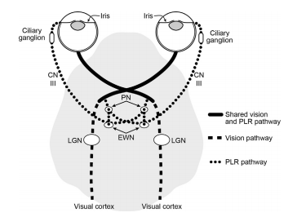
PN = Pretectal nucleus
EWN = parasympathetic nucleus of CN III
***LGN = Lateral geniculate nucleus**
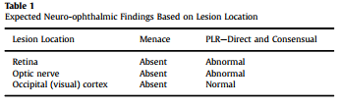

Retinal detachments

- Rhegmatogenous vs nonrhregmatomatous
  - Rhegmatogenous = (in general) problem with retina (tears or leaks)
  - Non = accumulation of fluid in subretinal space via leakage out of choroidal blood vessels or vitreous pulling on retina
    - Subretinal abnormalities are the important one for ER
  - Specific ones of concern to ECC
    - Hypertensive retinopathy
    - Chorioretinitis
      - Bacterial, fungal, viral, parasitic, protozoal
    - Treat with antiinflammatories (systemic NSAIDS) and target underlying cause (antihypertensives or antimicrobials)
SARDS
- Sudden acquired retinal degeneration syndrome
- NO FUNDIC ABNORMALITIES initially
- ERG is required for diagnosis

Fluoroquinolone retinopathy of cats
- Started occurring after increase in labeled dose of enrofloxacin over 2.5mg/kg BID
- Usually irreversible
- Clinical signs are usually within a few days of drug administration
  - Lowest dose reported was 4.6mg/kg
- Theoretically all fluoroquinolones but:
  - Pradofloxacin studied at 6 and 10x labeled dose has not been associated with blindness yet

Optic nerve diseases
- Optic Neuritis
  - Idiopathic (most common), immune mediated (GME most commonly), neoplastic, infectious
  - Can have elevated optic disc with blurred margins (not always)
- Neoplasia
  - More often unilateral
  - More often slowly progressive

Visual Cortex disease
- Normal PLRS
- Post-anesthetic cerebral blindness in cats with mouth-gags
- Seizures
- Tumors

Question:
Draw in cartoon form the pathways for vision and PLRs, including lateral geniculate nucleus, pretectal nucleus, parasympathetic nucleus of CN III, and CNs II + III

