Introduction to Acid-Base Disorders, Continued
DiBartola Chapter 9

Main Points
- AG = UA – UC = (Na + K) – (Cl + HCO3)
- Anionic composition of glomerular ultra-filtrate determines effect of Na avidity on electrolyte composition of reabsorbed tubular fluid
- Titratable acidity represents the amount of H+ excreted in the urine in combination with weak acid anions, primarily phosphate
- High pKa (9.2) of the NH3-NH4+ buffer pair allows the kidneys to excrete an acid load despite a urine pH that is not lower than pH 5.0

Anion Gap

- Major cations of ECF
  - Na, K, Ca, Mg
  - Magnitude of change in any of the UC (Ca, Mg) needed to change AG would be incompatible with life (most changes in UA)
- Major anions of ECF
  - Cl, HCO3-, plasma proteins (PP), organic acid anions (lactate), phosphate, sulfate
  - Plasma proteins majority of UA charge in mEq/L
    - AG decreases by 2.0-2.8 mEq/L for each 1 g/dL reduction in albumin
    - AG decrease by 1.3-1.9 mEq/L for each 1 g/dL reduction in globulins
    - For each 0.1 U increment in pH
      - 0.1 mEq/L increase in negative charge on PP
    - dogs @ pH 7.40 net PP charge = 19 mEq/L
      - AG changes 0.42 mEq/L for every 1 g/L change in albumin
      - AG changes 0.25 mEq/L for every 1g/L change in total PP
- Automated analyzers give values for Na, K, Cl, TCO2
  - AG = UA – UC = (Na + K) – (Cl + HCO3)
    - Normal AG = 12-24 mEq/L dogs, 13-27 mEq/L cats
  - In reality it doesn’t exist (law of electroneutrality)
- Increases (metabolic acidosis) more common than decrease in AG
  - Organic acidosis (lactic, keto)
    - HCO3 titrated by H+ ions from organic acids
    - Increase in organic acid anions should proportionately decrease HCO3-
    - AG should then increase but usually does not do so equally
      - Other buffers are titrated by H+ from organic acid (besides HCO3-)
      - Volume of distribution of organic acid can differ from HCO3-
      - Urinary excretion of organic anion
  - Alkalemia can cause increase in AG
    - Loss of protons from PP and increase in net negative charge
    - Hemoconcentration increases concentration of PP and net negative charge
    - Increases lactic acid generation by stimulation of phosphofructokinase
    - Net effect: increase in UA and AG
- Decreased AG
  - IgG multiple myeloma (isoelectric point (pI) > 7.4)
  - Hypoalbuminemia decrease concentration of net negative charge
    - ***most common cause of decreased AG ***
  - IVF (crystalloids) that dilute PP decrease concentration of net negative charge

Non-traditional approach

- Traditional
  - pH, PCO2, HCO3-
  - PCO2 respiratory component determined by alveolar ventilation
    - Independent variable
  - HCO3 metabolic component determined by kidneys
    - Not independent
    - When PCO2 increases, proteins (HGB) buffer H+ from dissociation of H2CO3, leading to increased [HCO3]
- Independent variables
  - Strong ion difference (SID)
    - Strong ions dissociate at physiological pH
    - Strong cations: Na, K, Ca, Mg
      - Only [Na] high enough in ECF where likely to cause change
    - Strong anions: Cl-, lactate, acetoacetate, β-hydroxybutyrate, sulfate
      - Cl- and some others can cause change
  - Total concentration of weak acid (HA+A-) or [A_{tot}]
    - Weak anions: HCO3-, PP, phosphate
      - PP and phosphate = independent A_{tot}
  - PCO2

Whole body regulation of acid-base balance
- Liver, kidneys, lungs
  - Lungs (ventilation) remove volatile acid (10,000 – 15,000 mmol CO₂) made each day
  - Liver metabolizes AA from protein catabolism to glucose or TG and releases NH4+
    - NH₄⁺ + CO₂ > urea (H⁺ made, HCO₃⁻ titrated)
    - Liver makes a lot of the non-volatile acid that needs to be excreted daily
  - Kidneys excrete NH4+ in urine (divert it from ureagenesis, makes net gain HCO₃⁻, net loss H⁺)

Renal regulation of acid base balance

- Maintain normal ECF [HCO3-]
  - Reabsorb all filtered HCO₃⁻
  - Regenerate all titrated HCO₃⁻
    - Excretion of titratable acidity (phosphate salts) and ammonium salts
  - Net acid excretion = sum of titratable acidity and ammonium minus HCO₃⁻ in urine (usually negligible HCO₃⁻ in urine)
  - All accomplished via renal tubular secretion of H+
    - 2/3 luminal Na⁺-H⁺ antiporter (NHE3)
    - 1/3 luminal vacuolar (V-type) H⁺-ATPase
    - depends on carbonic anhydrase in tubular cells
      - CAII in cytoplasm CO₂+H₂O > H₂CO₃
      - CAIV luminal membrane H₂CO₃ > CO₂ and H₂O in tubular fluid
    - 80% filtered HCO₃⁻ reabsorbed in proximal tubule, the remainder:
      - 10% thick ascending limb of Henle’s loop
      - 6% in distal convoluted tubule
      - 4% in collecting duct
  - if secreted H⁺ titrates HCO₃⁻, HCO₃⁻ effectively reabsorbed
    - 1 HCO₃⁻ added to ECF for each filtered HCO₃⁻ titrated by secreted H⁺
    - occurs in proximal tubules
  - net acid excretion and generation of new HCO₃⁻ occur when secreted H⁺ titrates phosphate in tubular fluid OR when NH₄⁺ is excreted in urine with Cl⁻ or in exchange for Na⁺
    - occurs in distal nephron

Factors affecting renal bicarbonate reabsorption

- If GFR and ECF volume (ECFV) are consistent then HCO₃⁻ reabsorbed by kidneys = filtered load
  - HCO₃⁻ tubular maximum (T_{M}) of ~ 3 mEq/min
  - HCO₃⁻ renal threshold 25 mEq/L
- Renal reabsorption of HCO₃⁻ is closely tied to reabsorption of Na and defense of ECFV
  - Primary expansion of ECFV > natriuresis and transient decrease in renal HCO₃⁻ reabsorption
  - Contraction of ECFV increases renal tubular Na (and HCO₃⁻) reabsorption
- Anionic composition of glomerular ultra-filtrate determines effect of Na avidity on electrolyte composition of reabsorbed tubular fluid
  - If adequate Cl⁻ present in filtrate, Cl⁻ reabsorbed with Na, no alkalosis
  - If too little Cl⁻ in filtrate, Na reabsorbed with HCO₃⁻ > alkalosis
  - At a given rate of renal Na reabsorption, change in reabsorption of Cl⁻ or HCO₃⁻ must be accompanied by a reciprocal change in reabsorption of the other anion.
- Renal HCO₃⁻ reabsorption
  - Increased by increase in arterial PCO2
  - Decreased by decrease in arterial PCO2
- Potassium
  - Hyperkalemia associated with decreased renal HCO₃⁻ reabsorption in distal nephron
  - Hypokalemia associated with increased renal HCO₃⁻ reabsorption

Titratable Acidity

- Amount of strong base needed to titrate a 24 hour urine sample back to a pH of 7.40
- Represents the amount of H+ excreted in the urine in combination with weak acid anions, primarily phosphate
- Sometimes synonymous with urinary phosphate (pKa 6.8)
  - amount of phosphate available for buffering fluid = [serum phosphorous] x GFR
- Of 50 -100 mEq fixed/nonvolatile acid produced by metabolic processes: 20-40 mEq (40%) is excreted as titratable acidity

Ammonium Excretion

- Excretion of ammonium by the kidneys needed for eliminating the daily fixed acid load and regenerating titrated HCO₃⁻
- Classical theory of ammonium excretion
  - NH₃ (lipid soluble, non-ionized) diffuses passively through luminal membrane of tubular cell into tubular fluid
  - H⁺ ions made from dissociation of carbonic acid combine with NH₃ > NH₄⁺ (pKa 9.2) (NH₄ less permeant, not transported by renal tubular cells)
    - pH tubular fluid = 6-7.0 so only 0.1-1% buffer pain exists as NH₃. So H⁺ strongly attached to NH₃ and NH₄ and does not affect urine pH
  - ammonium (from glutamine and glutamate in proximal tubules) substitute for H⁺ on luminal Na⁺/H⁺ antiporter (NHE3) and are secreted into tubular lumen
  - alpha ketoglutarate (from deamination of glutamine and glutamate) forming CO2 + H2O (Krebs) OR glucose (gluconeogenesis) > gain 2 HCO₃⁻
    - regenerated HCO₃⁻ returned to interstitial fluid via 3HCO3-/Na+ cotransporter (NBCe1)
  - secreted NH₄⁺ travels down the lumen of the descending limb of Henle’s loop and is reabsorbed in thick ascending limb by substituting for K in the luminal Na⁺-K⁺-2Cl⁻ cotransporter (NKCC2)
  - Cytoplasm of tubular cells has higher pH than tubular fluid so some NH3 can form and diffuse across to medullary interstitium
    - NH3 can’t diffuse to tubular fluid because luminal membrane in thick ascending limb impermeable
    - NH3 diffuses into segments of nephron without carbonic anhydrase (low luminal pH – S3 segment of proximal tubule, cortical collecting duct, medullary collecting duct)
    - Low pH traps NH₃ in lumen as NH₄
    - NH₄ trapped in collecting ducts an excreted as urine 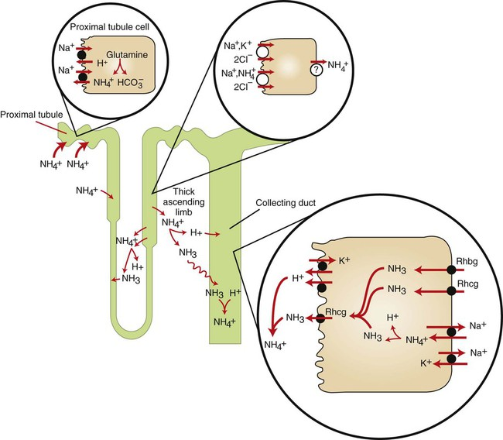
  - How can kidneys excrete an acid load despite inability to reduce urine pH below 5.0?
    - High pKa (9.2) of the NH3-NH4+ buffer pair
    - Normal animals 30-60 of the 50-100 mEq (60%) of fixed/nonvolatile acid is excreted in urine as ammonium (as chloride salt or in exchange for sodium)

Questions:

- 2/3 of renal tubular H+ secretion occurs via what transporter?
- 80% of filtered bicarbonate is reabsorbed in the _______________?
- Of the 50-100 mEq fixed/nonvolatile acid produced by metabolic processes, approximately ____% is excreted as titratable acidity (in combination with weak acid anions) and ______% is excreted in urine as ammonium.
- There is a net gain of _____ HCO₃⁻ when alpha ketoglutarate is metabolized to either CO₂ and H₂O (via the Krebs cycle) OR to glucose (via the gluconeogenesis).

Answers:

- 2/3 of renal tubular H+ secretion occurs via what transporter?
  - Luminal Na+-H+ antiporter (NHE3)
- 80% of filtered bicarbonate is reabsorbed in the _______________?
  - Proximal tubule
- Of the 50-100 mEq fixed/nonvolatile acid produced by metabolic processes, approximately ____% is excreted as titratable acidity (in combination with weak acid anions) and ______% is excreted in urine as ammonium.
  - 40%, 60%
- There is a net gain of _____ HCO₃⁻ when alpha ketoglutarate is metabolized to either CO₂ and H₂O (via the Krebs cycle) OR to glucose (via the gluconeogenesis).
  - 2

