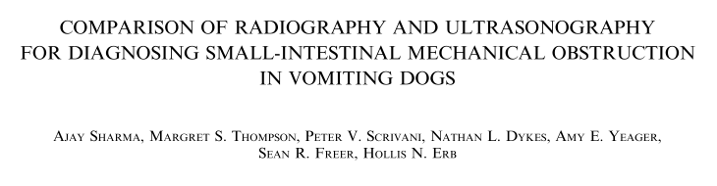
- Study Aims:
  - To compare the accuracy of radiography and ultrasonography to diagnose small- intestinal mechanical obstruction in acutely vomiting dogs
  - To evaluate several individual radiographic and ultrasonographic signs to identify their contribution to the final diagnosis of SI mechanical obstruction in acutely vomiting dogs
- Study Design:
  - Cross sectional study
- Methods
  - 82 client owned dogs
  - 4mo+, admitted for acute vomiting in which sx may be needed
  - ‘Acute vomiting’: clinical signs noted for less than 5 days or a minimum of three vomiting episodes within 24h
  - AxR (3-view) and AUS within 24h
    - Blinded imagers and interpreters
  - Laparotomy or necropsy within 48h, or follow up phone call at 1 month post discharge
  - Small-intestinal obstruction was defined, subjectively, based on identification of an obstructing lesion, segmental intestinal dilatation, or plication and was scored using five categories (i.e., definitely detected, questionably detected, indeterminate, questionably not detected, or definitely not detected)
    - An obstructing lesion was defined as the presence of an intraluminal foreign object or lesion associated with gross signs of intestinal wall edema or inflammation
  - Parameters evaluated:
    - Determination of small-intestinal mechanical obstruction
    - Height of the fifth lumbar vertebral body (L5)
    - Maximal small-intestinal diameter
    - Pattern of small-intestinal dilatation
- Results
  - Small-intestinal mechanical obstruction was confirmed in 27/82 (33%) dogs by surgery (n=26) or necropsy (n=1)
  - In all dogs, small-intestinal obstruction was caused by a foreign body

  - Ultrasonography was more accurate than radiography for diagnosing small- intestinal obstruction
  - Agreement between three-view abdominal radiography and abdominal ultrasonography for diagnosing small- intestinal mechanical obstruction was moderate
    - The exact same result for both radiography and ultrasonography was produced 52/82 times
    - Confident results (definitely not obstructed, definitely obstructed) were produced more often during ultrasonography (n=80) than radiography (n=58)
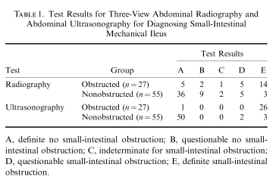
    - Intermediate or equivocal results (questionably not obstructed, indeterminate, questionably obstructed) were produced more often during radiography (n=24) than ultrasonography (n=2)
  - During radiography, the mean SI:L5 ratio for the obstructed group was 2.2 and for the nonobstructed group was 1.5
    - About half the dogs with small-intestinal mechanical obstruction had severe segmental dilatation of the small intestine and about half the dogs without obstruction had no dilatation. About a third of dogs with obstruction, however, also had no dilatation
  - The number of gastric or small-intestinal contractions varied greatly from hypomotile to hypermotile in dogs with or without small-intestinal mechanical obstruction and did not appear to be a distinguishing feature of obstruction
  - During radiography definitive detection of a potentially obstructive lesion occurred in only 52% of patients
  - During ultrasonography, definitive detection of a potentially obstructive gastrointestinal lesion resulted in the correct clinical decision in 96% of patients

Questions
- T/F: AUS did not result in false positive results for SI obstruction (in this study)
- Which of the following may be used to determine if a dog has a SI obstruction
  - Gastric motility
  - SI motility
  - SI:L5 ratio
  - Segmental dilation of the SI
- T/F: Based on these findings, in all cases of possible SI obstruction, the most reasonable first step for imaging is AUS.

ANSWERS
- T/F: AUS did not result in false positive results for SI obstruction (in this study)
- Which of the following may be used to determine if a dog has a SI obstruction
  - Gastric motility
  - SI motility
  - SI:L5 ratio
  - Segmental dilation of the SI
- T/F: Based on these findings, in all cases of possible SI obstruction, the most reasonable first step for imaging is AUS.

