High Rate Sedimentation, Fall 2015
Oge Anyene, Larry Ge, Yuqi Yu
December 6, 2015

Abstract
The Fall 2015 High Rate Sedimentation team aims to design a new sedimentation tank that will allow the tank upflow velocity to be significantly increased (by a factor of 2 to 10), without sacrificing particle removal performance (no increases in effluent turbidity). The motivating factors behind this velocity increase would be to decrease the plan view area of the sedimentation tanks, leading to smaller plants and lower construction costs, and to decrease the overall hydraulic retention time of the plant. One of the primary objectives of the new sedimentation tank design will be to maintain a consistent floc blanket (i.e. one that allows for excess floc drainage into a floc hopper) similar to the ones found in current AguaClara plants, even with the increased upflow velocity. In order to achieve this goal our proposed design will feature two sets of plate settlers, one set near the bottom of the tank that will be suspended within the floc blanket, and one above them to capture finer particles. To test the feasibility of such a design, several small-scale experiments will be run in the lab. Such experiments will prove to demonstrate whether or not it is possible to maintain a fluidized bed within plate settlers and what the bulk flow of flocs will look like for a floc blanket maintained within plate settlers.

Table of Contents
Abstract
Table of Contents
Task List
Task Map
Task Details
Introduction
Literature Review
Methods
Results & Discussion
Analysis
Future Work
References

Task List

Task Map
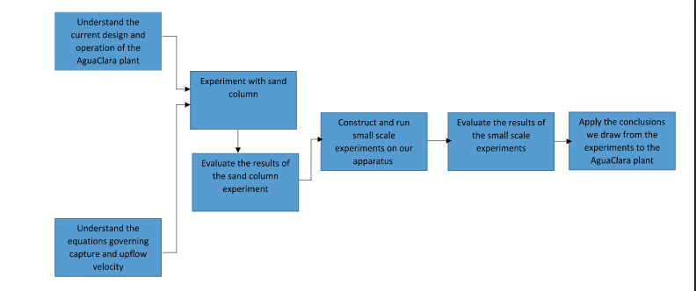

Task List
Week | Goal | Tasks
3 | Understand the current design and operation of AguaClara sedimentation tanks | -Review “How Water Flows Through a Plant”  -Read through the Sedimentation slideshow to understand the geometry and physics that governs the current Sedimentation tasks  -Read thesis by Matthew Hurst  -Speak with Monroe and Casey to establish where current sedimentation research is happening and how our project is different
4 | Understand the equations governing capture velocity and upflow velocity | Monday, September 14  -New members (Oge and Yuqi) create an individual wiki page  -Update High Rate Sedimentation wiki page
4 |  | -Plug in the current values and parameters of the sedimentation tank to determine its feasibility on a small scale
5 | Experiment with a sand column | Friday, September 25  -Research Report Due
5 | Experiment with a sand column | -Demonstrate that the fluidized bed height will decrease in a slanted column if you are backwashing a sand column  -Look for the similarities between what happens in the sand column and what would happen on a plate settler with a floc blanket
6-9 | Construct and run small scale experiments on our apparatus | Friday, October 9 (Week 7)  -Research Report Due  Monday, October 19- Wednesday, October 21 (Week 9)  -Symposiums  Friday, October 23 (Week 9)  -Midterm Peer Evaluation Due  -Update Individual Contributions Page
6-9 | Construct and run small scale experiments on our apparatus | -The small scale apparatus should mirror what would happen in an AguaClara sedimentation tank  -Vary the upflow velocity (perhaps a target upflow velocity could be 5 mm/s)  -Determine/sketch the possible geometries for the plate settlers in the floc blanket  -Determine/sketch possible geometries for the sedimentation tank
10-15 | Evaluate results from the small scale experiments and adapt the small scale experiment accordingly | Friday, November 6 (Week 11)  -Research Report Due  Friday, November 20 (Week 13)  -Research Report Due  Friday, December 4 (Week 15)  -Final Report Draft Due  Wednesday, December 9  -Final Report Due
10-15 |  | - Address feasibility of having secondary set of plate settlers at least partially submerged in the floc blanket based on lab model  -Sketch/Draw new high-rate sed tank, indicating plate settler locations and how to deal with sludge wasting (new floc hopper design?)

Introduction
Sedimentation is a crucial step in the AguaClara drinking water treatment process; well performing sedimentation tanks result in low turbidity, high quality drinking water. However, in the current AguaClara designed plants, sedimentation is also the slowest of the unit processes, with a residence time that is three times longer than the flocculator, and twenty four times longer than the rapid sand filters (Residence times based off 20 L/s plant design).
AguaClara utilizes vertical flow sedimentation tanks with inclined plate settlers in their designs. This allows for several key advantages;
- Vertical flow tanks allow for the implementation of a floc blanket, which is a fluidized bed of flocs located at the bottom of the sedimentation tank that acts as a flocculator and/or filter
- Vertical flow tanks are inherently self desludging, and need to be taken out of operation less frequently for cleaning and maintenance
- Inclined plate settlers increase surface area for flocs to settle and roll down while also decreasing the residence time for traditional sedimentation tanks
However vertical flow tanks traditionally have lower velocities, which leads to large plan view areas, and higher construction costs. Because of the larger plan view area, higher cost and longer residence time, it makes a lot of sense to research and design vertical flow sedimentation tanks that run at increased upflow velocities.
The current design sedimentation tank upflow velocity was set at 1 mm/s prior to 2010. This speed was set because at the time, the StaRS had not been implemented yet and the spacing between settlers was set by what is now thought to be an overly cautious ratio of spacing to plate settler height. However, it was found that this upflow velocity was also conducive to the development of floc blankets. Since floc blankets are a desirable feature for a high functioning sedimentation tank, one of the greatest challenges in increasing the upflow velocity would be preserving the floc blanket.

Literature Review
The current model of the AguaClara sedimentation tank has a residence time of approximately 24 minutes, making it the rate limiting step of the water filtration plant. There is some research about the effect of upflow velocity on the floc blanket. In Matt Hurst’s thesis, “Parameters affecting steady-state floc blanket performance” he analyzes the correlation between floc blanket performance and the upflow velocity of the tank. The findings of Hurst’s experiments will be applied to our current findings of the sand column experiment. A copy of Hurst’s thesis can be found at the link below, or in this subteam’s folder in the AguaClara Google Drive :
https://ecommons.cornell.edu/bitstream/handle/1813/14755/Hurst,%20Matthew.pdf?sequence=1

Methods
Sand Column Experiment
In order to accomplish this subteam’s goals, a deeper understanding of the mechanics of the sedimentation tank, particularly the functionality of the plate settlers under various upflow velocity measurements, is needed. Currently, a sand column experiment is being run to evaluate the correlation between a slanted sand column that is being backwashed and the fluidized bed height.
Before running the experiment, there were a few parameters that had to be calculated; the governing equations for the fluid mechanics of the sedimentation tank and the tubing were used. Using MathCAD, the 0.41656 cm tubing diameter was the minimum size needed to have a major head loss of less than 1 m. This amount of headloss was suggested by Monroe based off of past experience, and seemed to work well enough.
The rotations per minute (RPM) at which the Peristaltic Pump would have to operate in order to achieve a fluidized sand bed was calculated. The following equations and values were used in MathCAD:
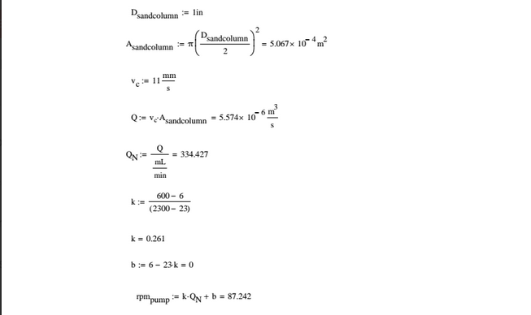
Nomenclature:
${D_{sandcolumn}=Diameter of the sand column }^{}$
${A_{sandcolumn}=Cross sectional area of the sand column }^{}$
${v_{c}=Capture velocity }^{}$
$Q=flow rate$
${{rpm}_{pump}=Rotations per minute of the Peristaltic Pump }^{}$
The procedure that was followed to perform this preliminary experiment is below:
- Using ⅜ “ inner diameter (ID) tubing the water source was connected to the 600 RPM Peristaltic Pump and then from the 600 RPM Peristaltic Pump to the bottom of the sand column. ¼ “ ID tubing was connected to a ¼ “ tube ⅜ “ tube connector to transition from the ¼ “ ID tubing to ⅜ “ ID tubing. The ⅜ “ ID tubing was then connected to the water retrieval source.
- The sand column was filled approximately one-third of the way with sand. The water valve was turned on so that the entire sand column would be filled with water and sand. The sand was allowed to settle so that there was a visible divide between the sand bed below and the water above.
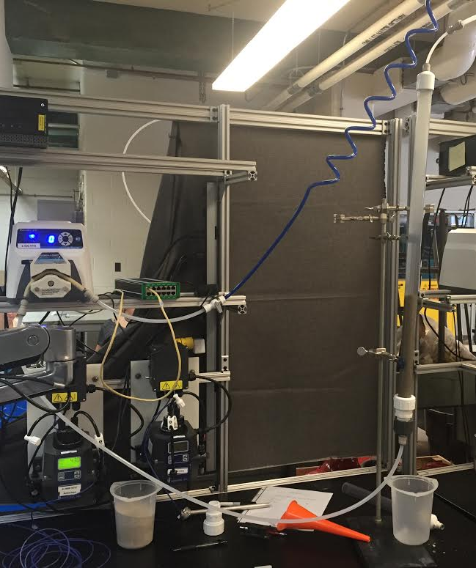
(Figure 1.) The setup for the sand column experiment. Note the 600 RPM Peristaltic Pump on the left, which is hooked up to the upflow sand column on the right
- The wet sand bed height was measured at 25 cm.
- The 600 RPM Peristaltic Pump was slowly increased from 0 RPM to 90 RPM. The sand bed was closely evaluated as the RPM was increased. At around 90 RPM, the sand bed became visibly fluidized. The height of the fluidized sand bed was approximately 34cm. This result corresponds with literature that states that an approximate 30% increase in sand bed height indicates that the sand bed is fluidized.
- After the sand bed became fluidized the angle of the sand column was varied to observe the changes in the velocity profile and height of the fluidized sand bed.
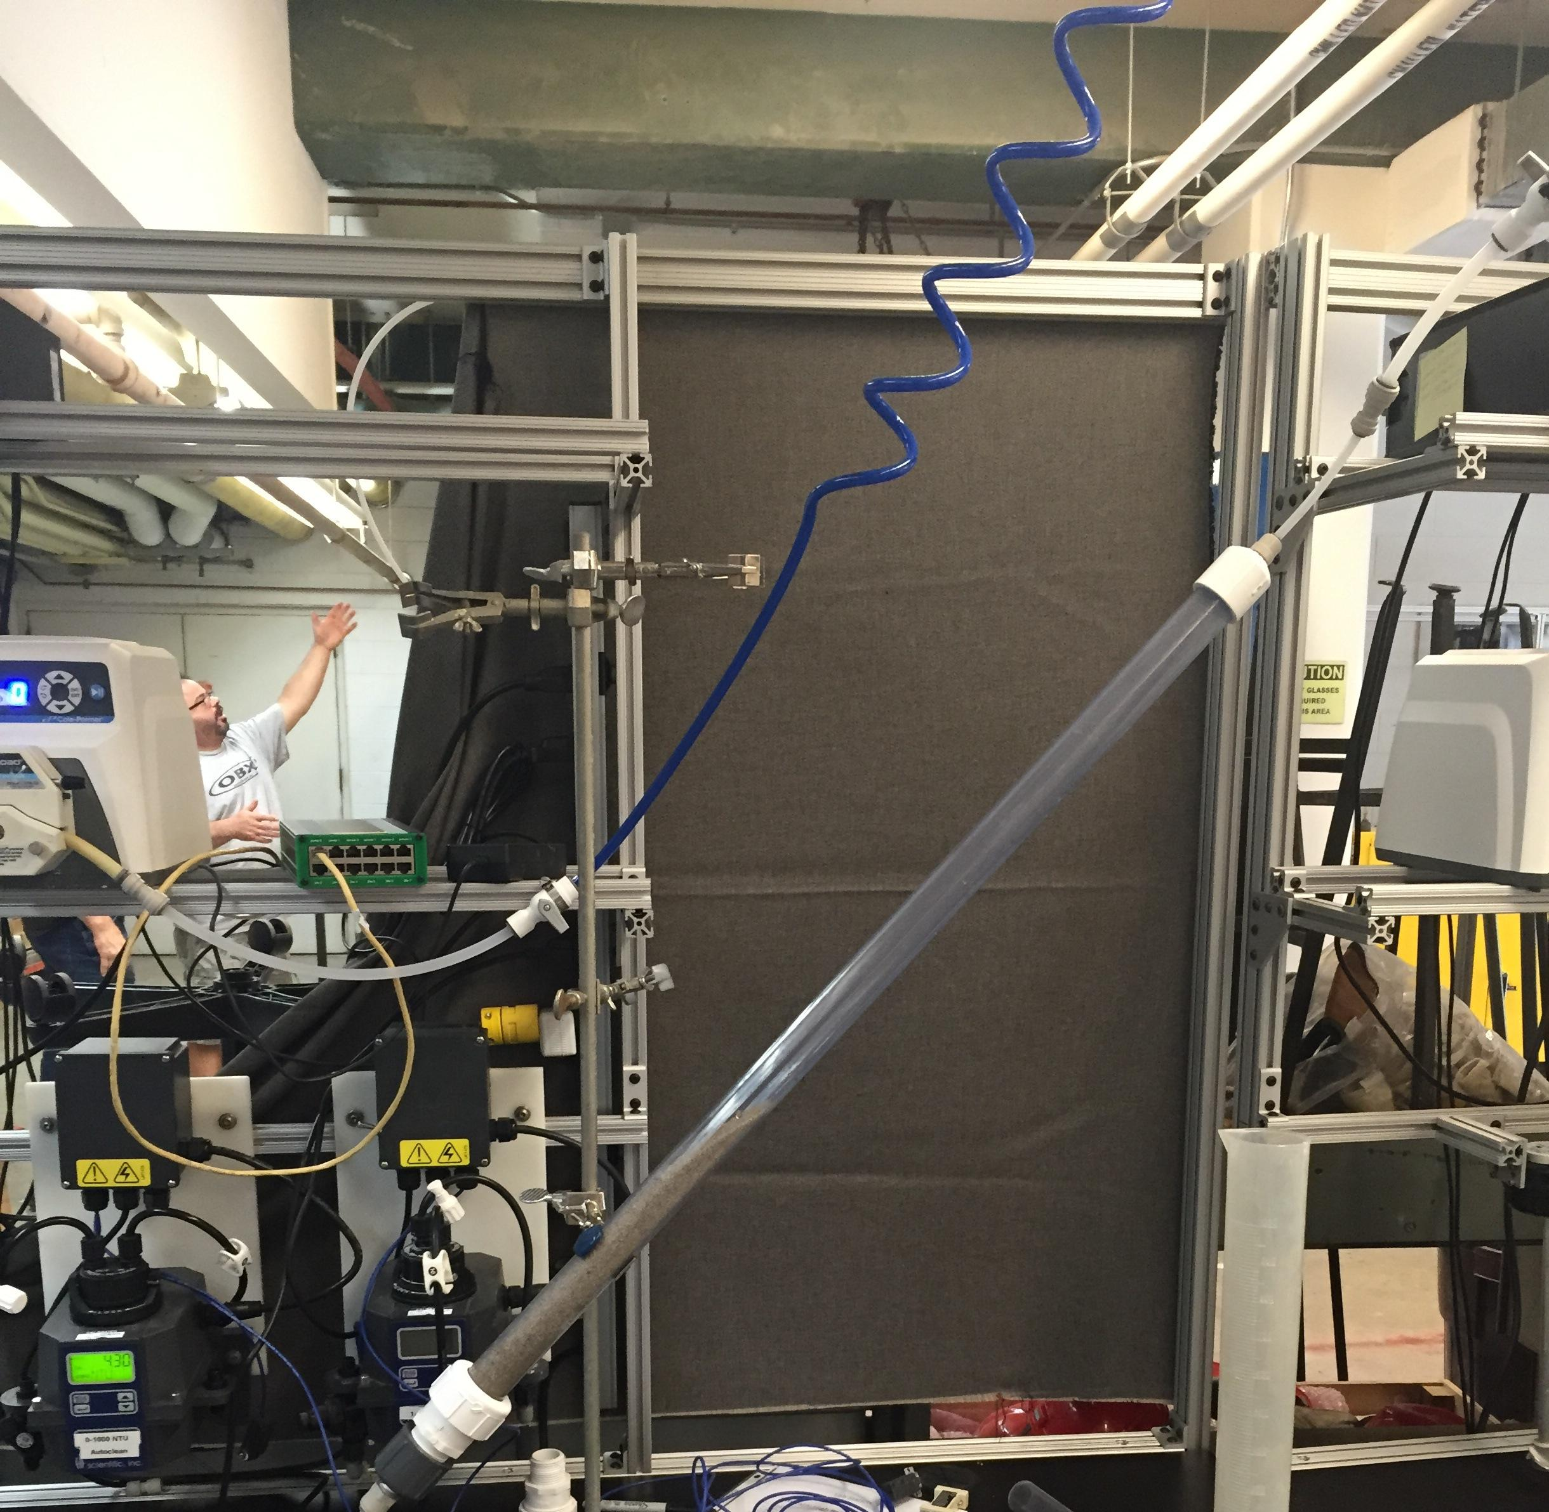
(Figure 2.) One of the configurations for the slanted sand column.

After this preliminary qualitative testing, a more quantitative experiment was run. In addition to the aforementioned methods, a protractor was traced onto a large piece of cardboard and was placed behind the sand column in order to measure the angle from the horizontal (0°). At the angles explicitly drawn on the cardboard protractor (30°, 45°, 60°, and 90°) the vertical sand bed height was measured directly or calculated using geometry while increasing the RPM of the Peristaltic Pump in increments of 25.

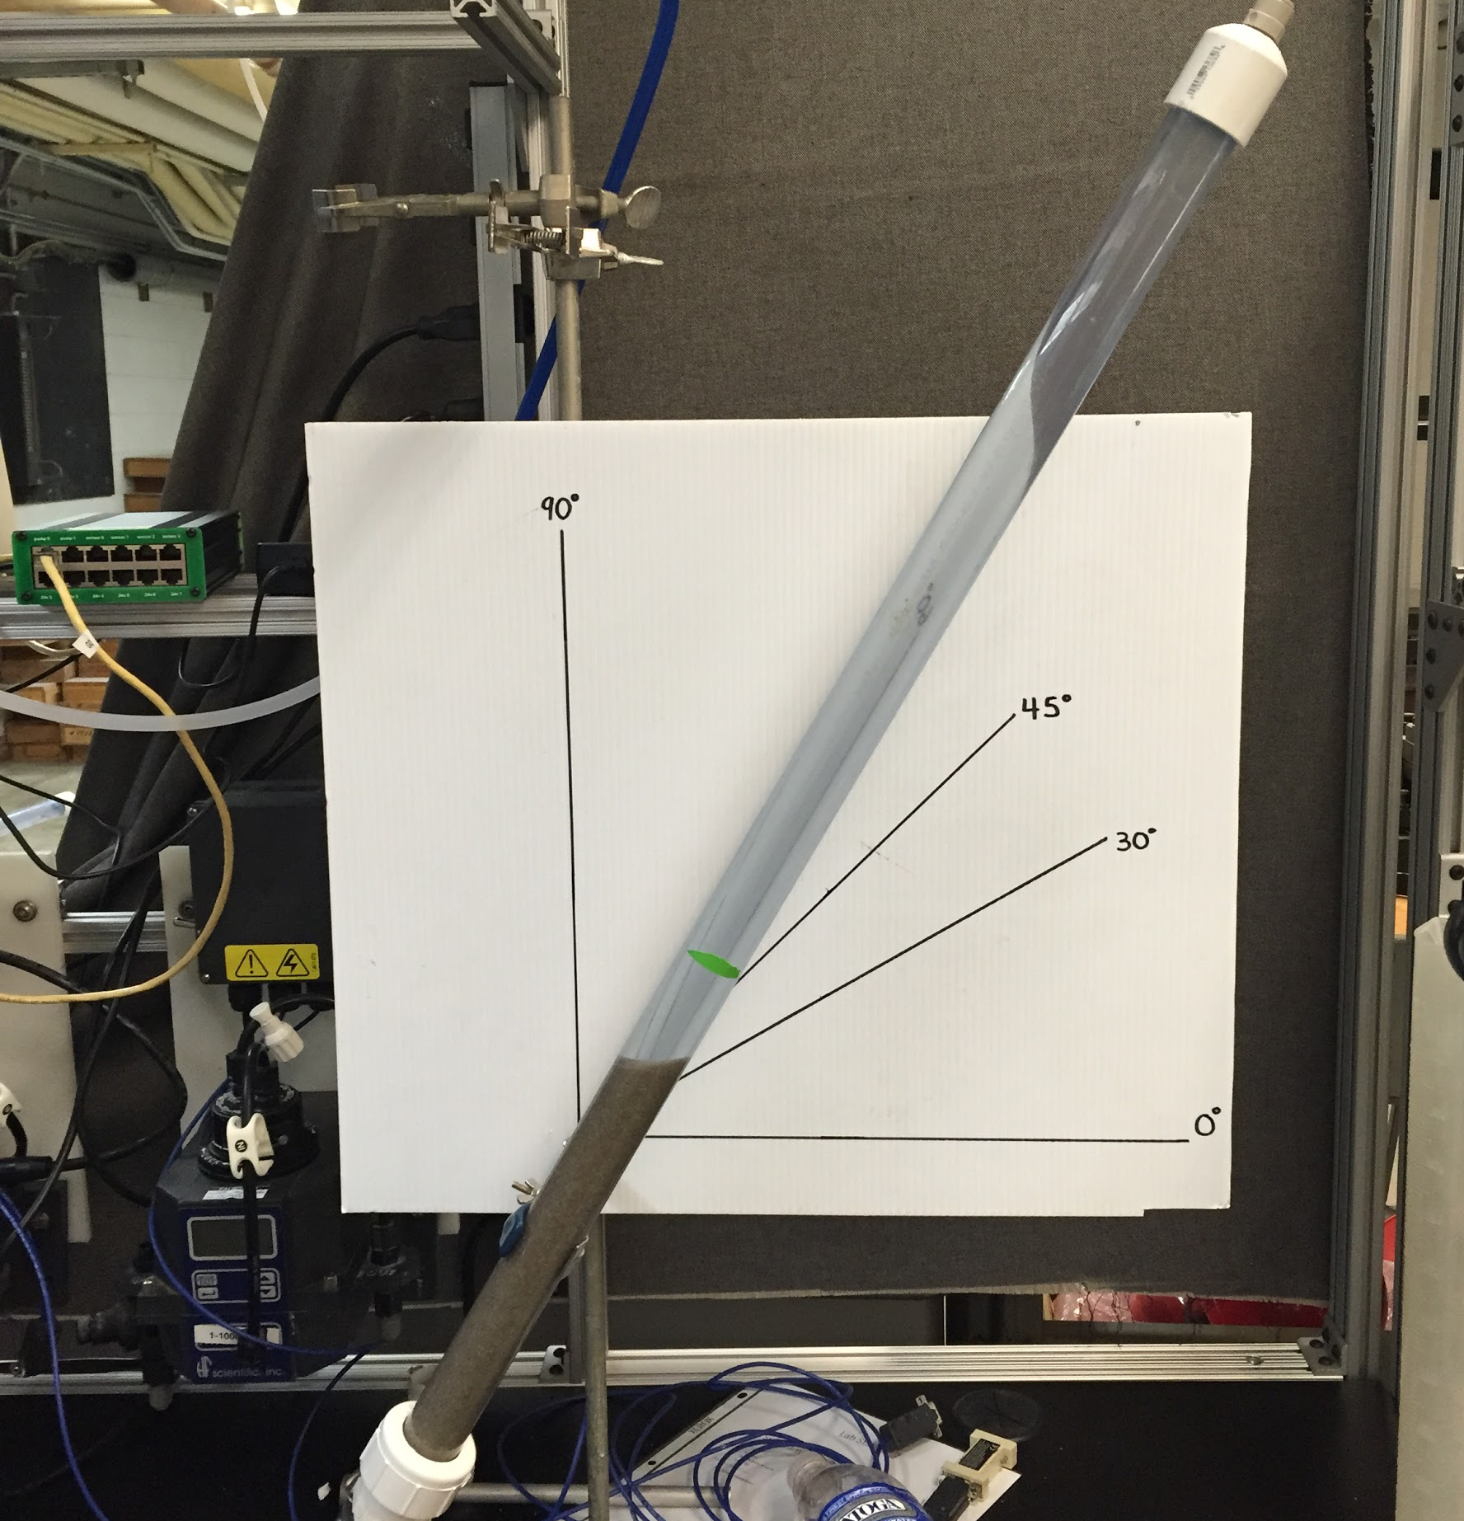
(Figure 3.) The setup for the quantitative Sand Column Experiment

Initial Tank in a Pipe Experiment
This experiment will help our subteam gain a better understanding about the feasibility of a new geometry of the sedimentation tank. Currently, we are investigating if it is possible to have a second set of plate settlers in the floc blanket. In the experiment being run right now, we have inserted a makeshift plate settler into a pipe column and attached a floc hopper at a 90° angle. It is our belief that there will be two velocity profiles in the column due to the plate settler.
The procedure used for this experiment thus far is as follows:
- A 20cm x 1” strip of PVC sheeting was cut. It serves as the plate settler that will be inserted into the 1” ID pipe column. The length of the plate settler was determined using the governing MathCAD equations. A small hole was drilled into the bottom of the plate settler and small tubing was tied through the hole for easy removal from the pipe column.
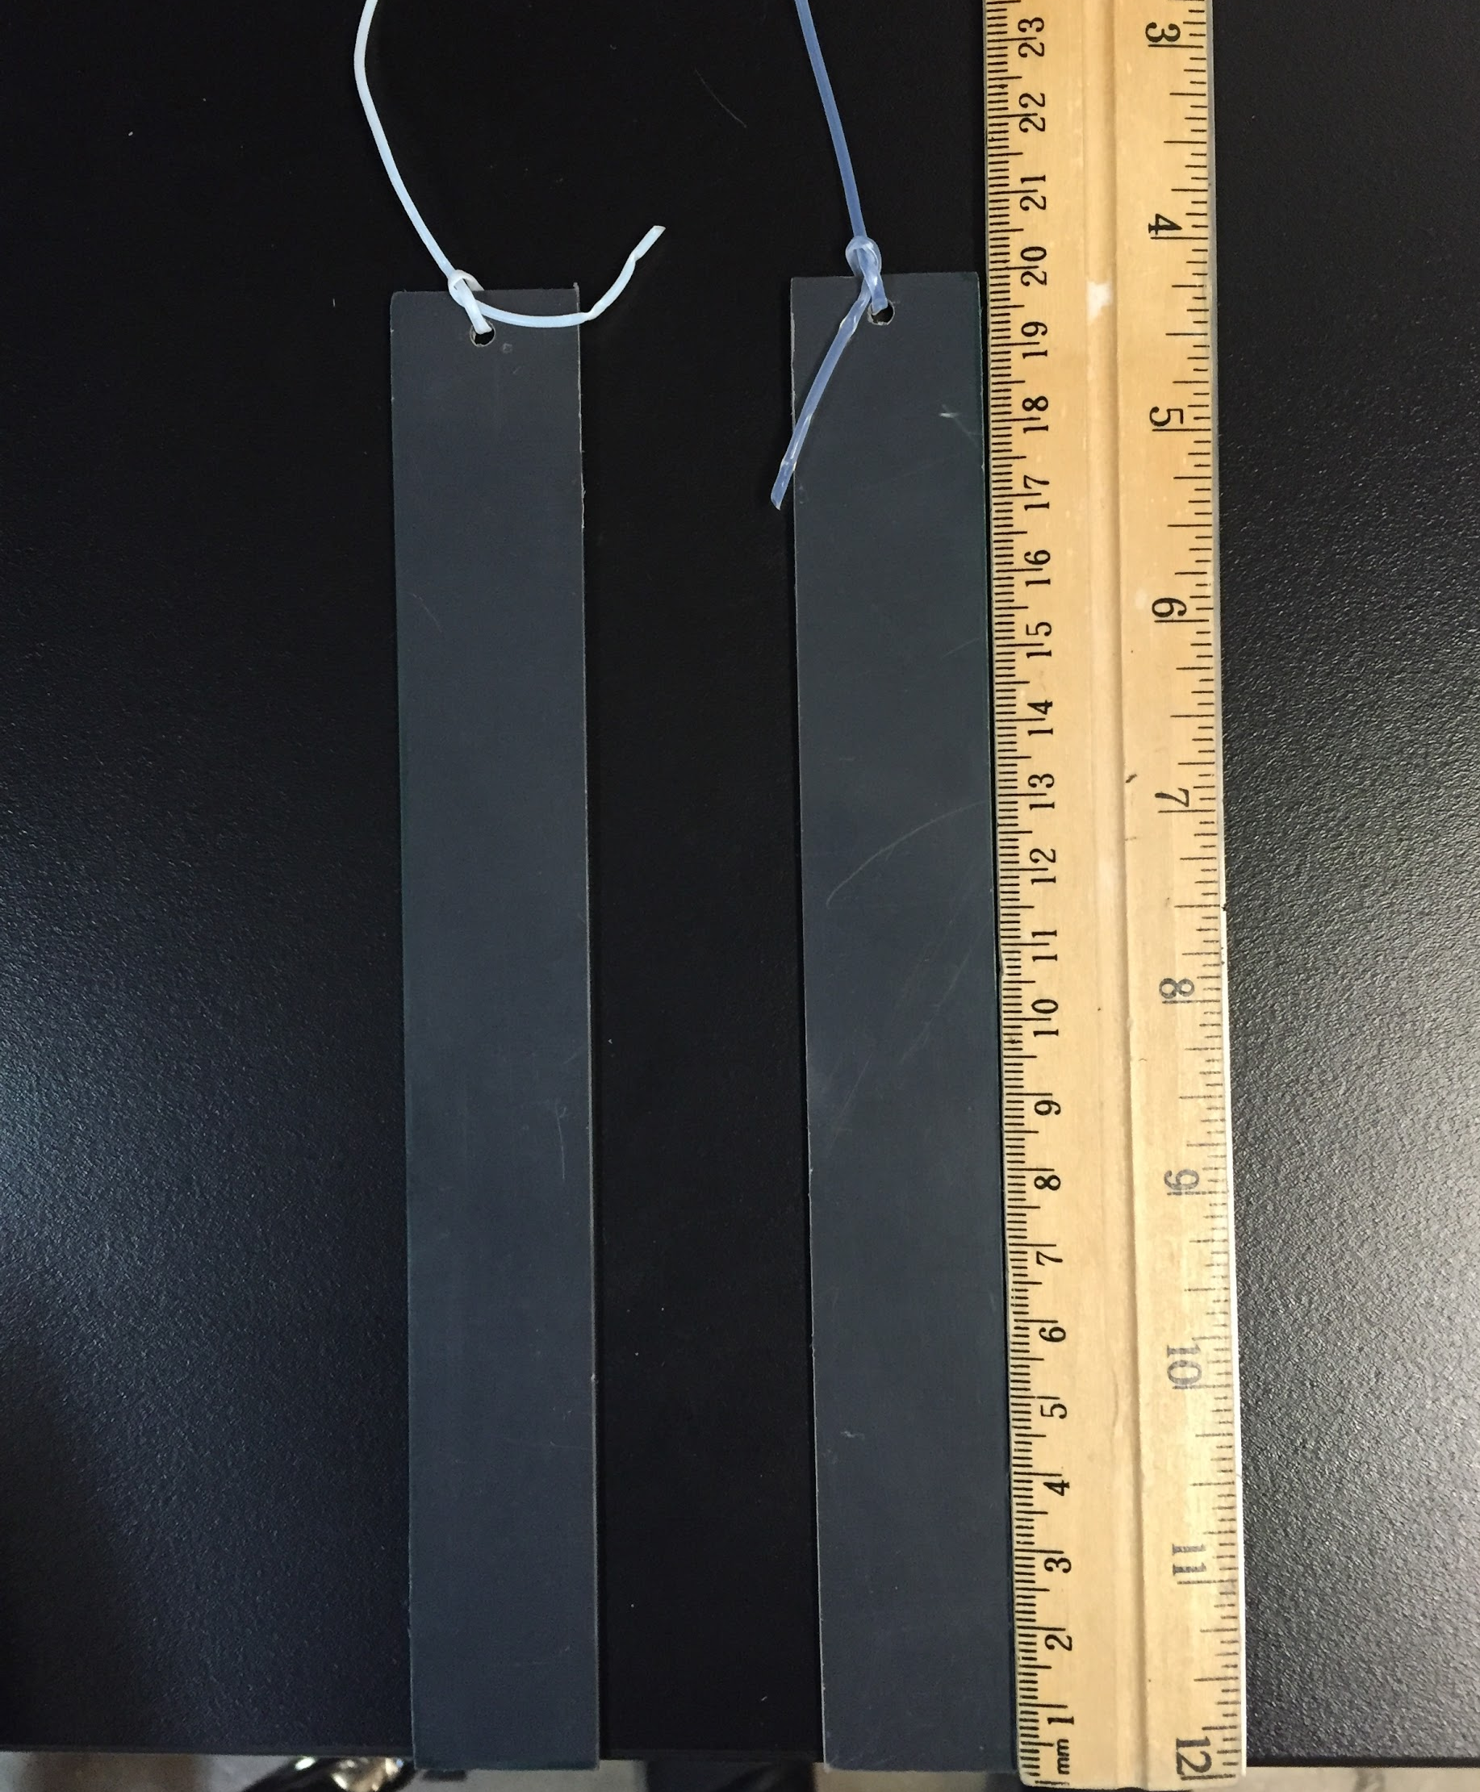
(Figure 4.) Plate settler used in the pipe column
- A ⅝” hole was drilled into the side of the 1” ID pipe column- approximately 30 cm above the bottom of the pipe.
- A 30 cm, ⅝” outer diameter (OD)/ 0.5” ID pipe column was inserted into the hole drilled into the 1” ID pipe column at a 90° angle. This floc hopper pipe will aid in the wasting of sand. To our subteam’s understanding the length of the floc hopper will not matter.
- The 20 cm plate settler was inserted to into the 1” ID pipe column. Hot glue was put on the sides of the plate settler to ensure that the placement of the plate settler would be secure and able to withstand high upflow velocities. The top of the plate settler was aligned with the top of the floc hopper pipe. 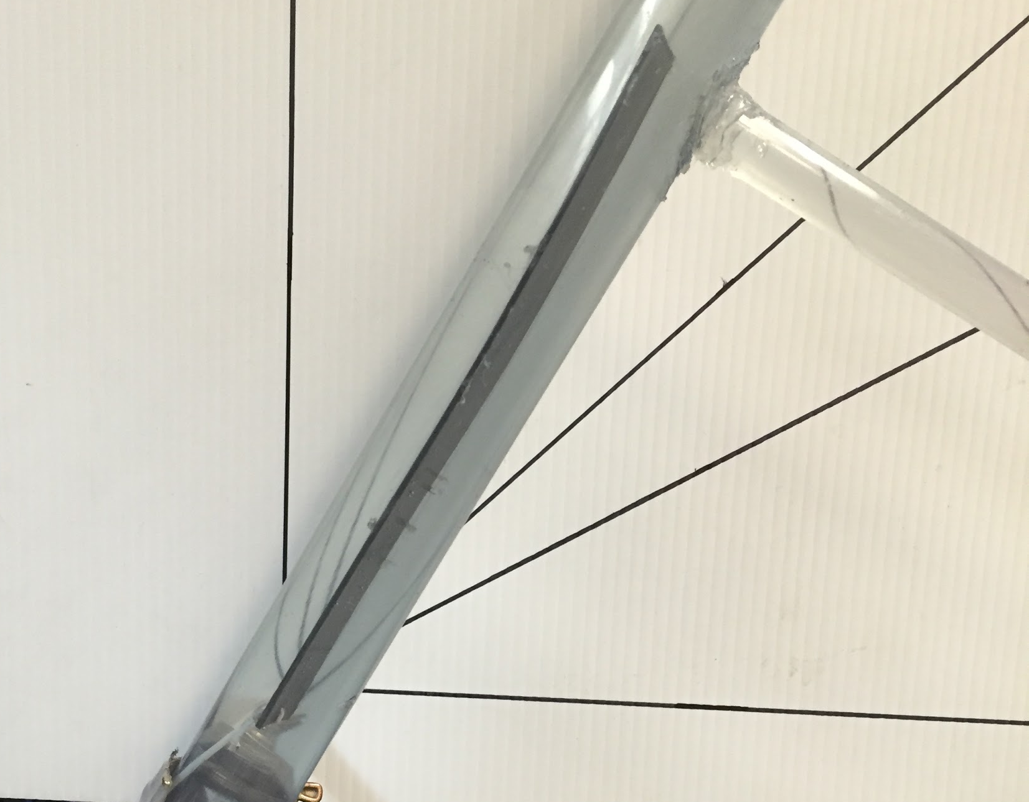
(Figure 4. Pipe column at a 60° angle)
- Sand was put into the pipe column and the column was filled with water until there was a bed of sand at the bottom and water in the remainder of the column. The 600-RPM Peristaltic Pump was turned on and the RPM was slowly increased as we observed the behavior of the sand column.
Revised Tank in a Pipe Experiment
This new experimental setup addresses some of the flaws of the Initial Tank in a Pipe Experiment:
- There are now two distinct sections- one with a completely vertical upflow velocity and the other at an angle, mimicking the plate settlers in the current AguaClara tanks. This correction should tackle the issues we ran into with sand redistribution and flow distribution.
- Flocs, rather than sand, is used in the pipe column. As observed from the previous experiments, sand is too heavy to achieve the desired fluidized bed.
The procedure for the Revised Tank in a Pipe Experiment is as follows:
Pipe Column
- Connect a 34 cm pipe to the pipe used in the previous experiment with a 45° angle elbow connector, as shown below. This is the new assembly of the pipe that was used for the revised experiment.
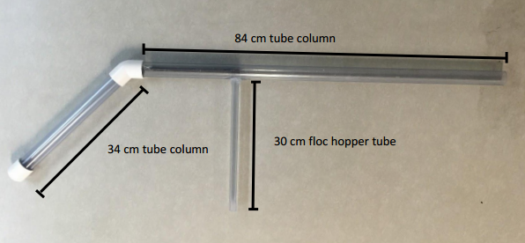
(Figure 5.) New assembly of the pipe column in the Revised Tank in a Pipe Experiment

Flocculator
- Using the governing equations in MathCAD, the required concentrations of the coagulant, polyaluminum chloride (PAC) and clay, the RPM that the 100- and 600-RPM Peristaltic Pumps should be run at. The concentrations of the coagulant and clay concentrations were chosen such that the desired amount of flocs would still be able to be formed with a higher upflow velocity and more importantly, such that the coagulant and clay solutions could be pumped at the same RPM- the tubing for the coagulant and clay solutions are attached the same 100- RPM Peristaltic Pump. Also, determining the correct concentrations of the coagulant and clay would allow for a floc blanket to form on the plate settler. The minimum length of the tubing required for the flocculator to achieve at least 100 NTU was also determined using the governing MathCAD equations. All of these calculations are in a MathCAD file on the AguaClara- High Rate Sedimentation Drive.
- 6 grams of clay were put into a bottle filled with 3 liters of water. A mixing arm was put into the clay bottle to mix the water and clay solution for turbidity. Size 16 tubing was connected from the clay bottle through the 100-RPM Peristaltic Pump and to a T-connector that eventually combines the flows of the PAC, clay water and water from the water source. The size 16 tubing was large enough to allow the clay particles to flow through to the flocculator tubing but not too large to be a hassle to work with and connect.
- 1.11 mL of 69.4 mg/L stock solution of PAC was put into another bottle filled with 1 liter of water. Size 13 tubing was connected from the PAC bottle through the 100-RPM Peristaltic Pump and to a T-connector that serves the same purpose as the aforementioned connector. The size 13 tubing was used because it was both readily available in the lab and could easily carry the coagulant solution from the bottle to the flocculator tube.
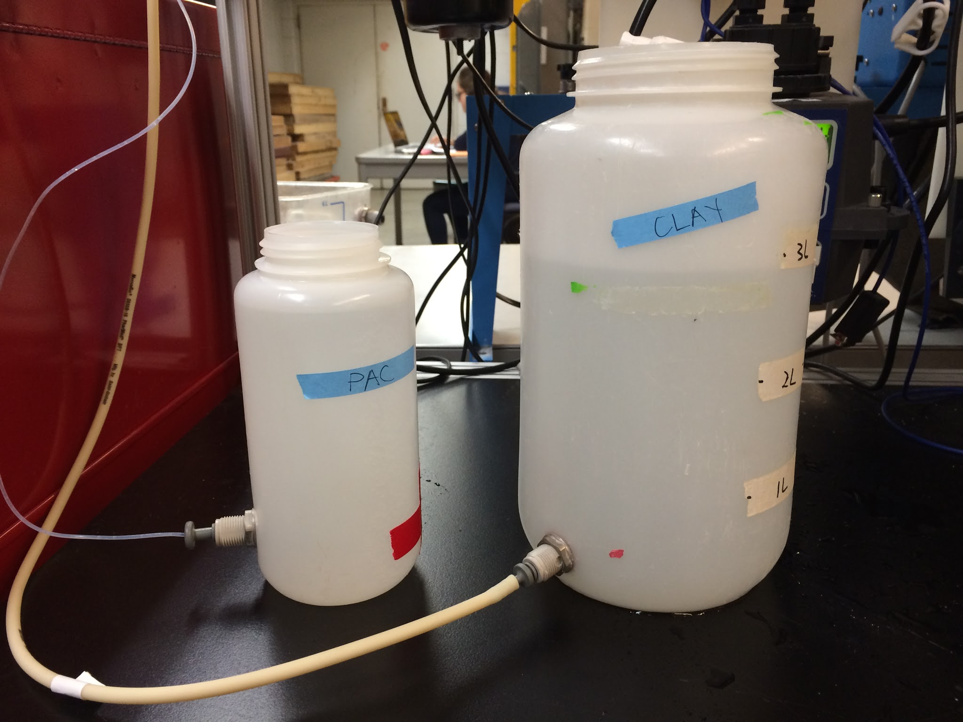
(Figure 6.) The bottles containing the PAC and clay solutions.
- The water source was connected to tubing through the 600-RPM Peristaltic Pump and its flow was combined with the flows of the PAC and the clay water as shown in the figure below.

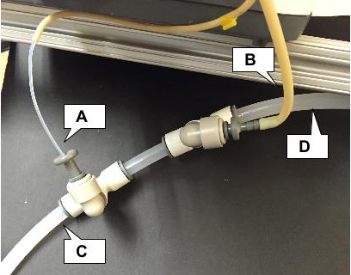
(Figure 7.) A: Contains the PAC solution. B: Contains the clay water solution. C: Contains the PAC solution, the clay and water solution and the water from the water source. D: Contains the water from the water source.

- The ⅜” ID tubing that contained the flows of the water from the water source, the PAC and the clay water was connected to one end of the flocculator tubing and the other end of the flocculator tubing was connected to the bottom of the Pipe column; the flocs will be fed into the Pipe column here. (Figure 8)
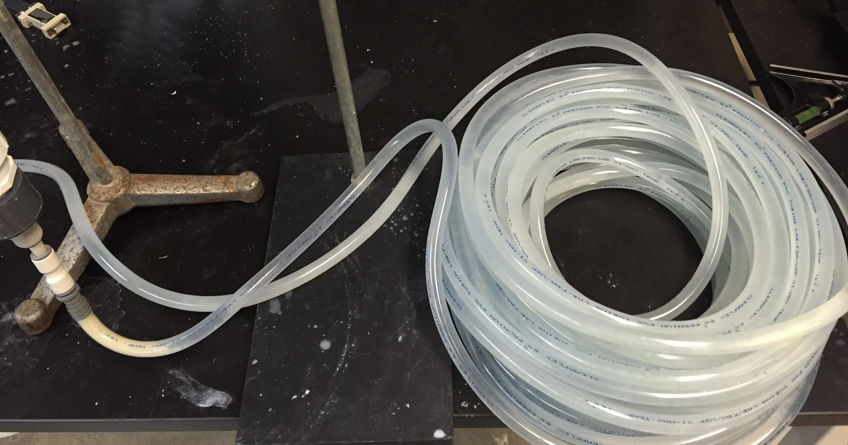
(Figure 8.) The flocculator tubing on the right side of the figure above is connected to the bottom of the Pipe column, as pictured on the bottom left side of the figure above.

- The 100-RPM Peristaltic Pump was run at 16 RPM; it pumped the clay and coagulant solutions. The 600-RPM Peristaltic Pump was run at 32 RPM; it pumped the water from the water source.

Plate Settlers at the Top of the Pipe Column
- 14 of the 50 cm long, 0.225” ID plate settlers made of plastic drinking straws in Figure 9 were inserted in the top of the Pipe column; calculations using the governing MathCAD equations allowed us to determine the required length of the plate settlers. No glue was used to hold them together; rather, as many plate settlers as possible were tightly packed into the pipe column so they wouldn’t move around (Figure 10). These purpose of these plate settlers at the top of the pipe column is to capture the smaller flocs that were not able to be captured by the plate settler below (Figure 11). It is assumed that the capture velocity of the smaller plate settlers at the top are 0.12 mm/s, in comparison to the larger capture velocity of the plate settler at the bottom, 1.0 mm/s. This is because the spacing between the top plate settlers (0.225”) is smaller than the spacing between the bottom plate settler (0.5”).
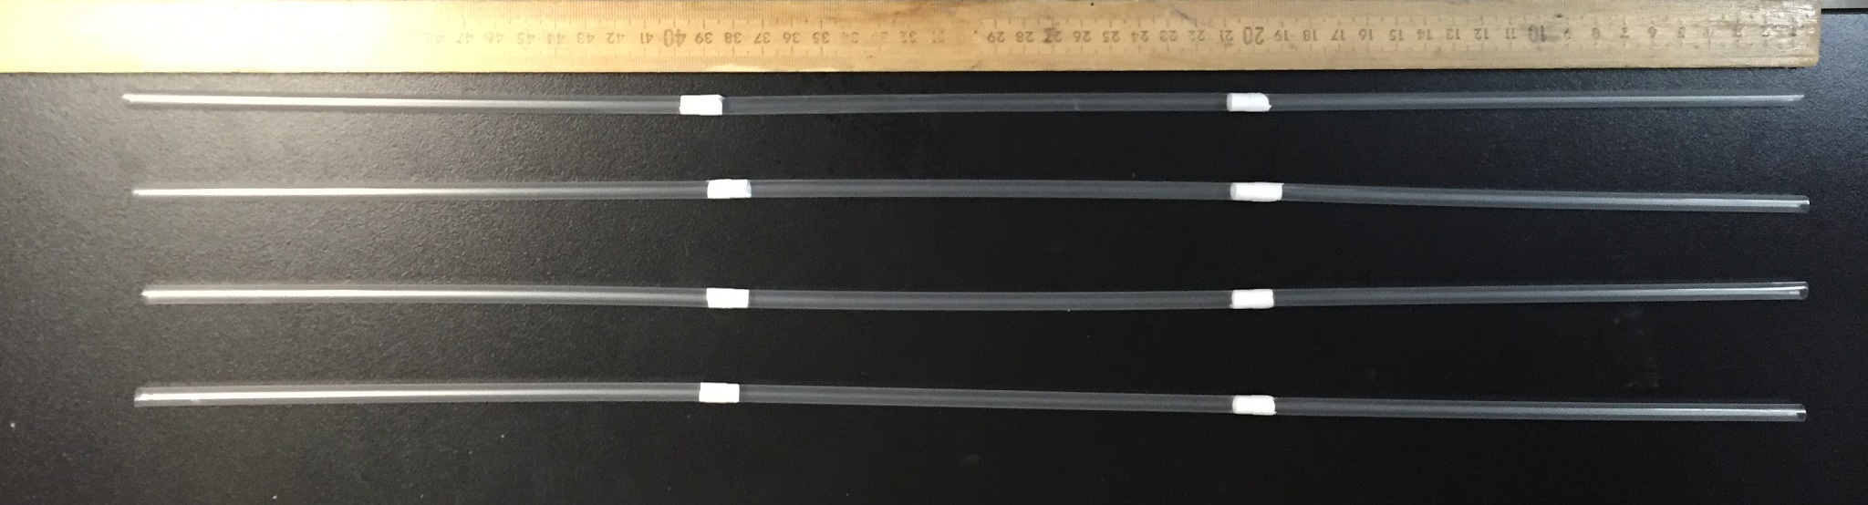
(Figure 9.) 50 cm plate settlers that are at the top of the pipe column.

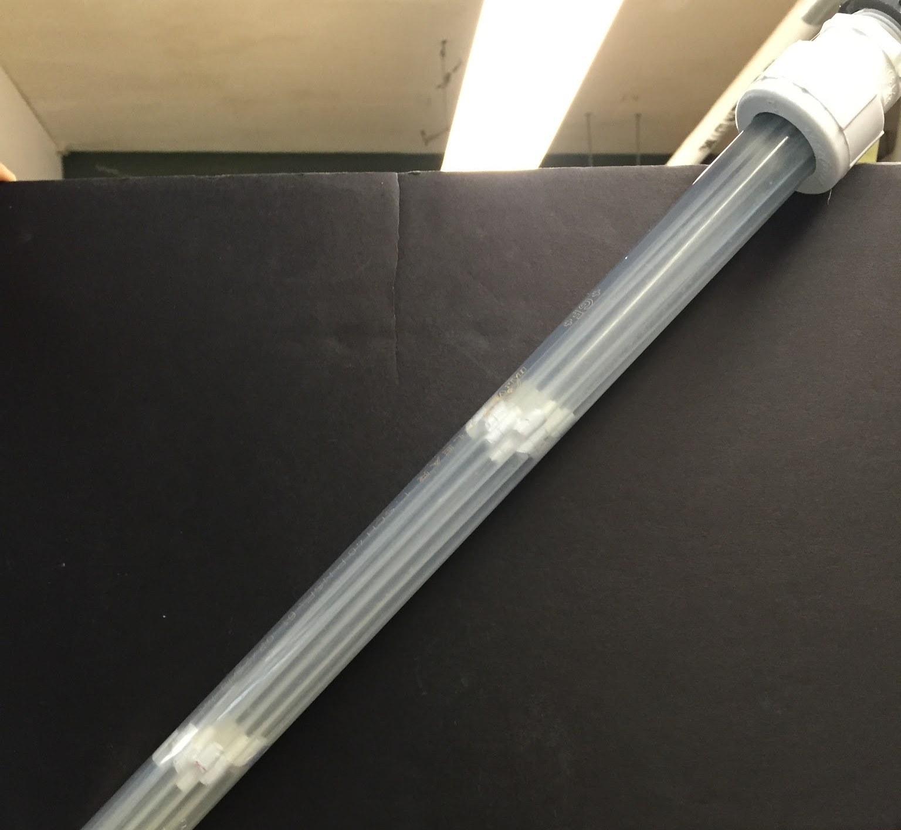
(Figure 10.) Plate settlers in the top of the pipe column.
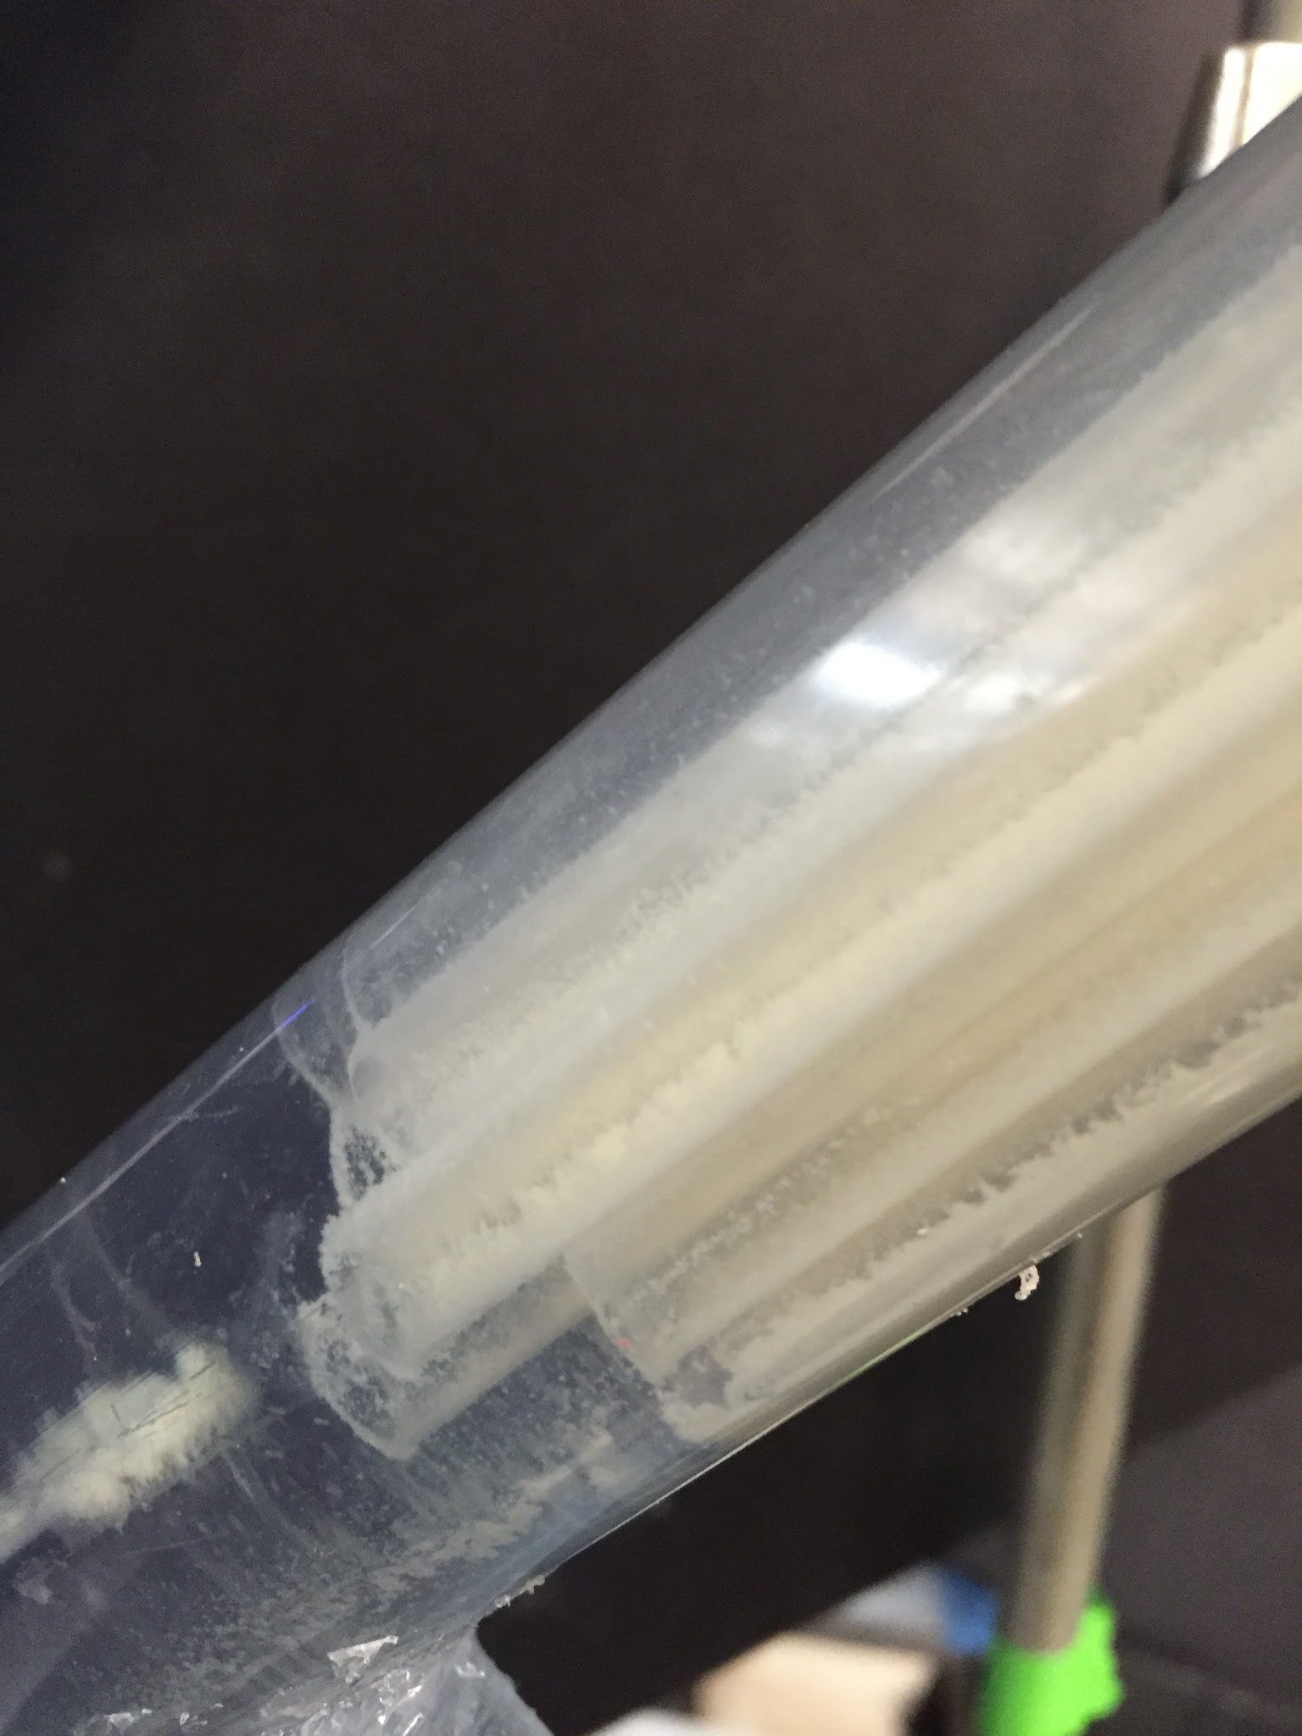
(Figure 11.) Flocs being captured by the long plate settlers at the top of the pipe column.
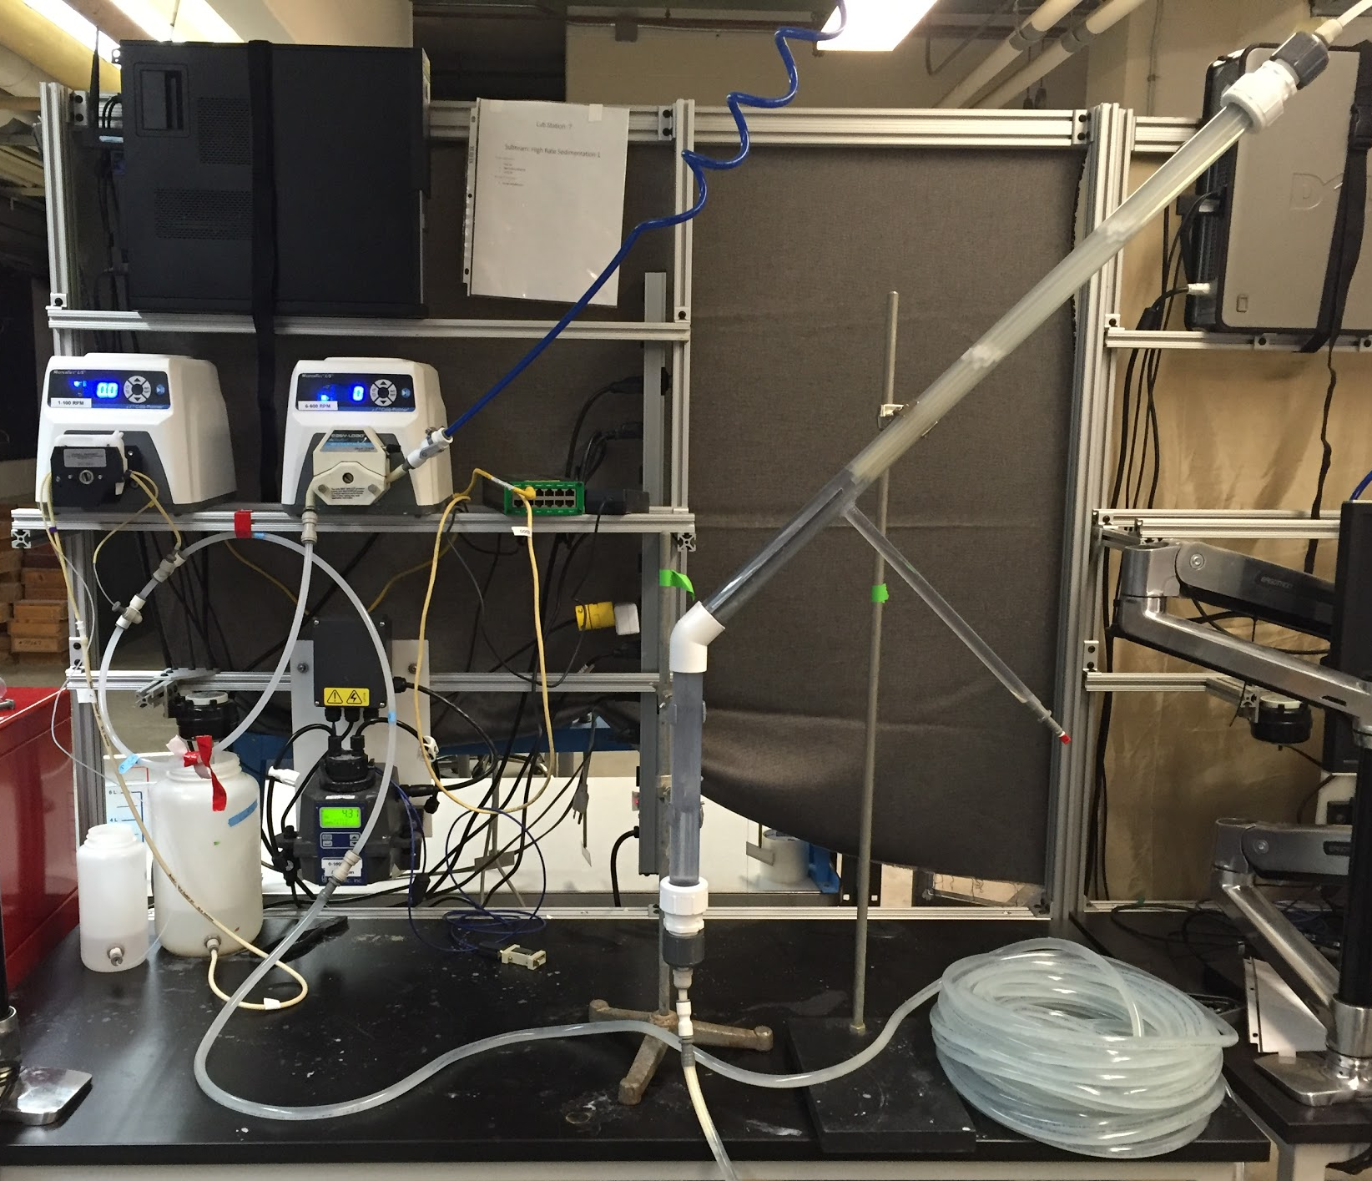
(Figure 12.) The bench scale setup for the Tank in a Pipe Experiment.

Analysis

Upon completion of the tube flocculator the behaviour of flocs in the system at varying flow rates and coagulant concentrations was observed. The primary goal was the determination of whether or not a floc blanket would form and sustain at higher flow rates, and if so where in the system it formed. The experiment was run at various sets of coagulant and flow rate conditions, each yielding distinct results, which are described below.
- Low Flow Rate, High Coagulant Dose
This was the first test condition upon completing the flocculator. A clay concentration of 2 g/L and a coagulant concentration of 0.5 mg/L PAC were used. Initially the RPMs of the pumps were set at 16 and 32 RPM for the clay/coagulant and water respectively.
After about a period of 20 minutes large flocs appeared in both the flocculator and the bottom part of the experimental setup (Figure 13.). The setup was left running for an extended period of time and a dense region of large flocs was observed in the bottom of the setup (Figure 14.). There was a fairly low concentration of flocs in the angled region of our setup, and the flocs that were in that region were noticeable smaller and settled on the large plate settler or bottom of the angled pipe.
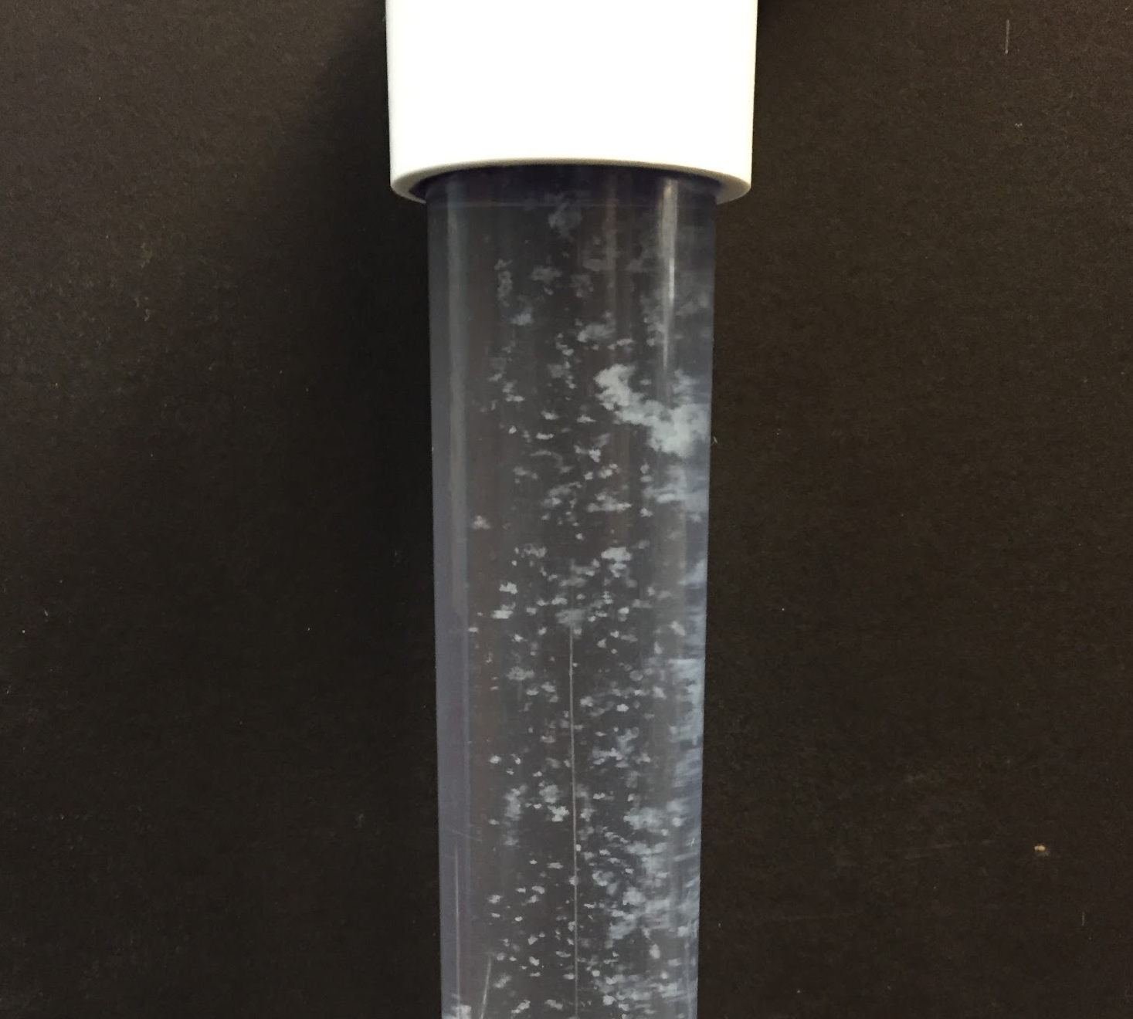
(Figure 13.) Initial formation of large flocs

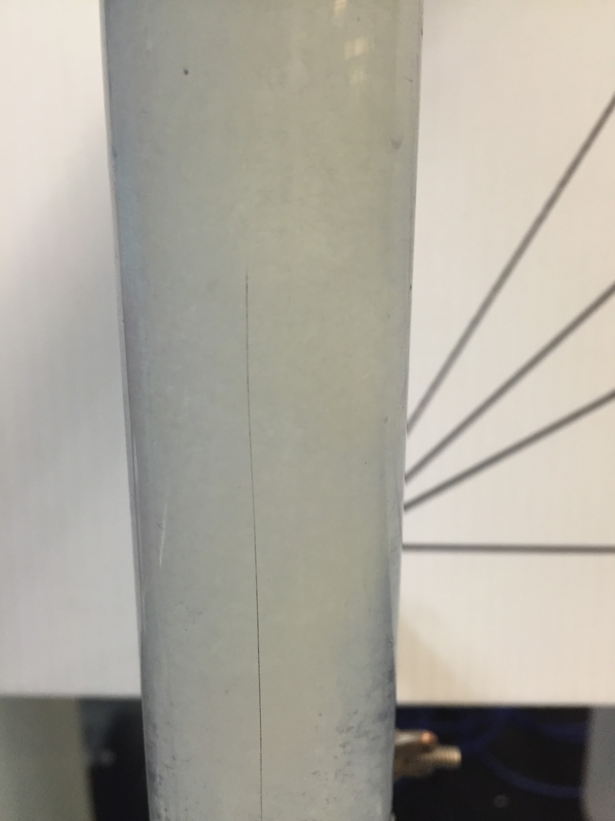
(Figure 14.) Floc Blanket forming in un-angled region of setup

- High Flow Rate, High Coagulant Dose
After observing the results of the experiment at 32 RPM we decided to increase the RPM while keeping the clay and coagulant doses constant in order to see if we could shift the floc blanket from the straight portion of the setup to the angled portion. The RPM of the water pump was increased to 46 RPM and the experiment was left to run for 2-3 hours.
After having run for a while, it was observed that there were a greater number of flocs in the angled region than in Experiment 1, however the behavior of the flocs did not resemble a floc blanket. There was no fluidization of a mass of flocs or floc recirculation, instead the larger flocs had settled onto the plate settler and bottom of the tube and were static, the flocs seemed to be stuck to the plate settler and were not sliding down. (Figure 15.) A video of the phenomena is linked can be found here: (Video of Floc Activity in Experiment 2).
It was later suggested by Monroe in an email that a possible explanation for this floc behavior was that the flocs were too large and “sticky”. He suggested developing a floc blanket by “reducing the coagulant dose so that the flocs aren't so sticky so that they slide back down off of the plate settlers”.

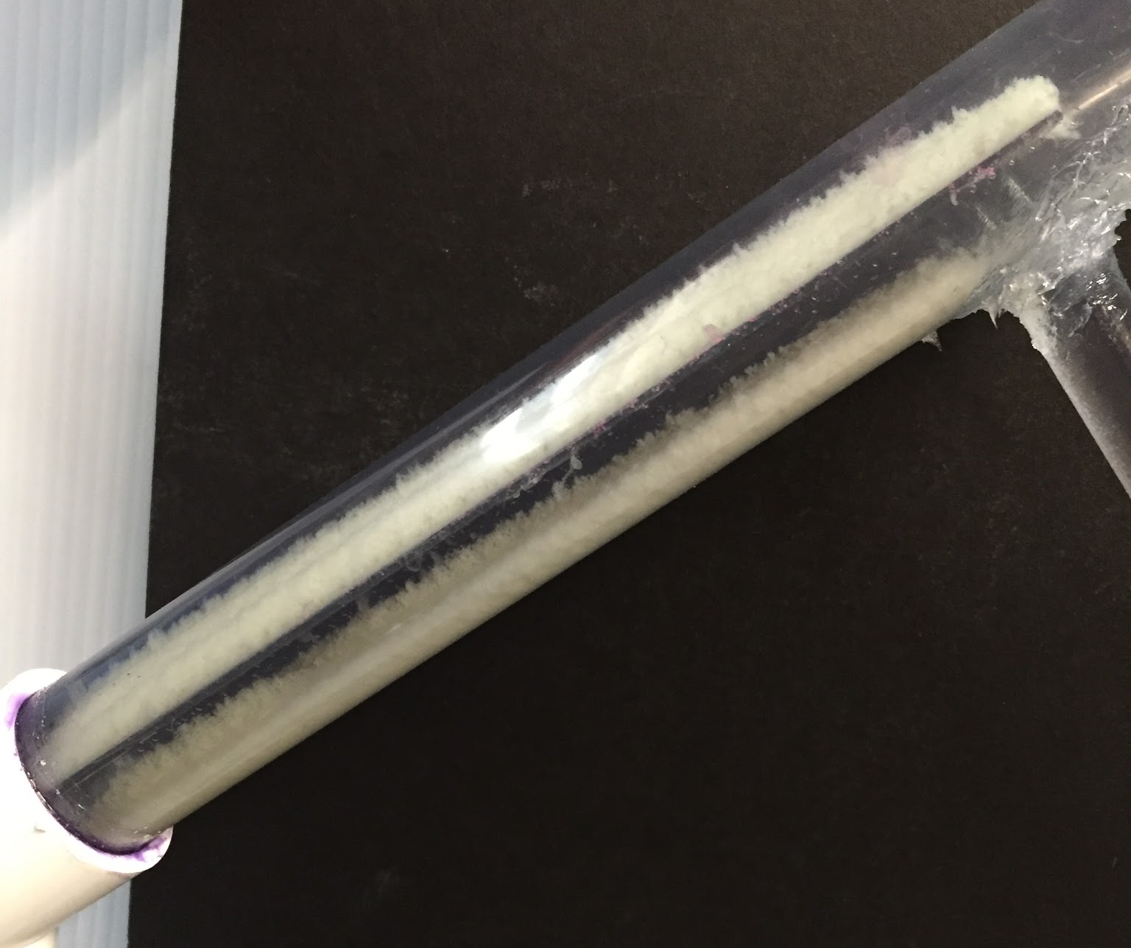
(Figure 15.) Static flocs, flocs seemed to be stuck to plate settler and pipe

- High Flow Rate, Low Coagulant Dose
Based off of Monroe’s suggestion, this third experiment was run at a lower coagulant concentration (0.25 mg/L versus 0.5 mg/L previously). The clay concentration (2 g/L) and RPM (46 and 23 RPM) were held constant.
Out of the experiments run, these conditions seemed to be most conducive to developing a floc blanket in the angled region. The lower coagulant dose resulted in smaller flocs, which were less likely to be held in the bottom part of the system. Instead, a dense area of flocs formed around the bend, and in the large plate settler itself. This can be seen in this video: (Video of Floc Activity in Experiment 3) or in Figure 16.
Additionally, the lower coagulant dose seems to have resulted in less sticky flocs. As a results, flocs were continually sliding down the plate settlers and reintegrating into the floc blanket. A video of this activity can be seen here: (Video of Flocs Rolling Down Plate Settler in Experiment 3)

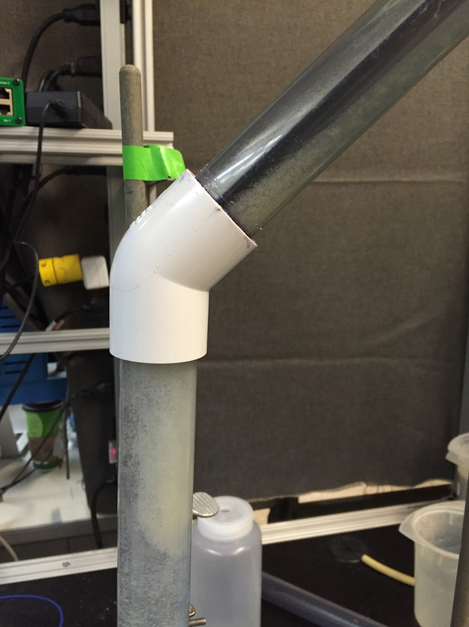
(Figure 16.) Floc blanket forming in bend

Future Work
- Build larger apparatus to avoid issues with plate settler spacing and floc rollup
- Use a 60 degree angle instead of a 45 degree one
- Place floc drain in correct location to determine self sustaining floc blanket is possible given proper draining
- Run both influent and effluent through turbidimeter to determine particle remove effectiveness

References
Hurst, M., Weber-Shirk, M., & W. Lion, L. (2010). Parameters affecting steady-state floc blanket performance. Journal of Water Supply: Research and Technology, (59.5), 312-323.

