Non-Steroidal Anti-Inflammatory Drugs
Physiology of Arachidonic Acid
- Arachidonic acid is released from cell membranes by phospholipase A₂
- Products of Arachidonic acid are acted upon by cycloxygenase (COX) or lipoxygenase (LOX) to form eicosanoids
  - Prostanoids (COX): generate inflammatory and immunological responses, physiological functions
    - Prostaglandin: PGD₂, PGF₂α (COX-1), PGE₂ (COX-2)
    - Prostacyclin: PGI₂ (COX-2)
    - Thromboxane: TXA₂ (COX-1)
  - Leukotrienes (LOX): responsible for inflammation
- COX-1: normally expressed in tissues for physiological functions, produce PGE₂, produce mucosal bicarbonate
- COX-2: inducible by macrophages and inflammatory cells
- COX-3: variant of COX-1 (canine brain, human brain and heart) – acetaminophen inhibits COX-3
- Nuclear Factor kappa-B NF-κB: inhibition by NSAIDs as an alternate mechanism of action
- Canine stomach has COX-1 primarily but also COX-2 which is upregulated when there is exposure to irritants

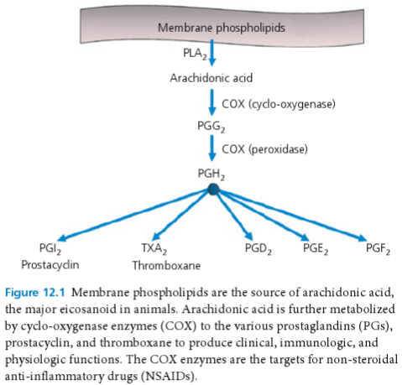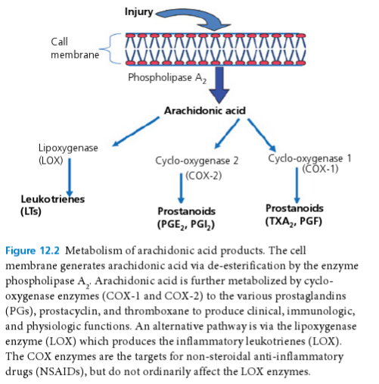

Pharmacokinetics
- Highly protein bound >90%
- Weak acids, high lipophilicity at physiologic tissue pH
- LogP (logarithm of the partition coefficient): greater or near 2
*If LogP is close or above 2, diffusion across biological mb is favored
- Biotransformed by hepatic mechanisms
- Clearance 0.4/L/kg/h
- GI absorption is close to 100% (exception firocoxib 38%)

Adverse Effects
- Gastrointestinal injury
  - Vomiting, diarrhea, inappetence, ulceration
  - Mechanism of injury:
    - Direct mucosal irritation: acidic NSAIDs become more lipophilic in stomach acid and diffuse into the gastric mucosa and into intestinal villi – causing injury
    - Prostaglandin inhibition: results in decreased cytoprotection, diminished blood flow, decreased synthesis of protective mucus and inhibition of mucosal cell turnover and repair
  - Predisposing factors:
    - Concurrent steroid administration
    - Concurrent GI disease
    - Concurrent liver disease
    - Genetic variation
  - GI adaptation and chronic administration:
    - Adaptation can occur by a rise in gastric blood flow, reduction in inflammatory cell infiltration, increase in mucosal regeneration and mucosal content of epidermal growth factor (has only been evidenced with chronic aspirin use in dogs)
- Kidney Injury
  - Decreased renal perfusion, sodium and fluid retention, azotemia, possible kidney pain
  - Mechanism of injury:
    - Inhibition of renal prostaglandin synthesis
  - Predisposing factors (decreased renal perfusion):
    - Dehydration
    - Anesthesia
    - Shock
    - Pre-existing renal disease
    - Concurrent steroid administration
- Hepatic Injury
  - Undergo hepatic metabolism
  - Idiosyncratic
  - Vomiting, inappetence, icteric with high liver and bilirubin
  - Carprofen induced hepatotoxicity resolved with cessation of carprofen administration

- Cartilage Injury
  - May accelerate articular cartilage lesion in arthritic joints at high doses (in vitro)
- Platelet Inhibition
  - Inhibition of COX-1 leads to decreased Thromboxane (TXA₂) in platelets and decrease platelet function
  - Aspirin, specific COX-1 inhibitor – irreversible inhibition of COX in platelets
  - Non-acetylated NSAIDs only inhibit platelets when their concentrations are maintained at inhibitory levels

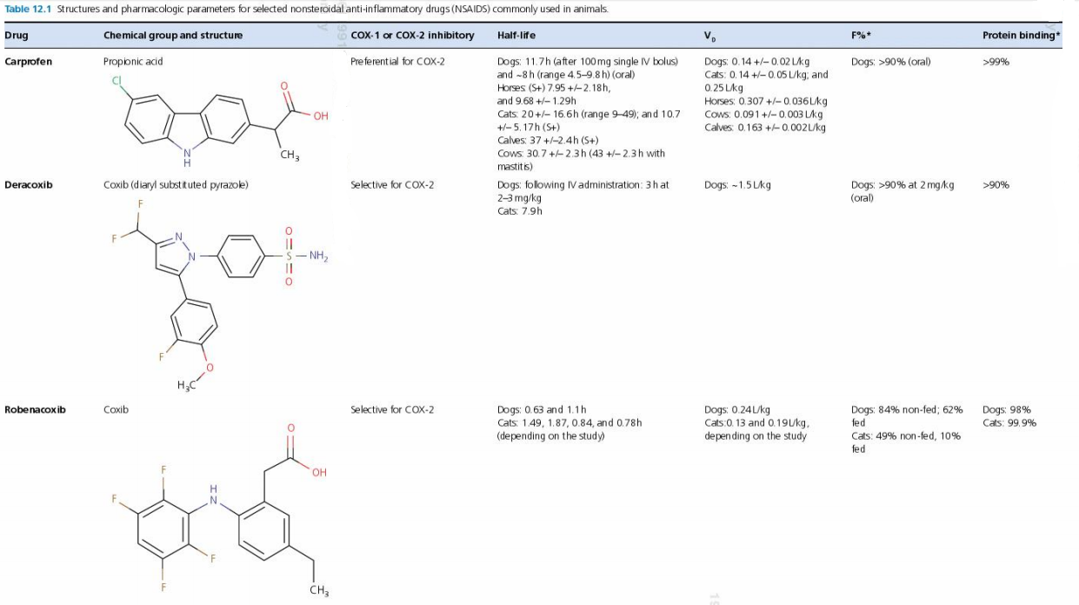
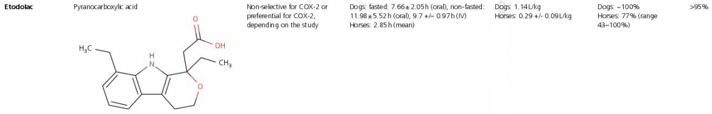
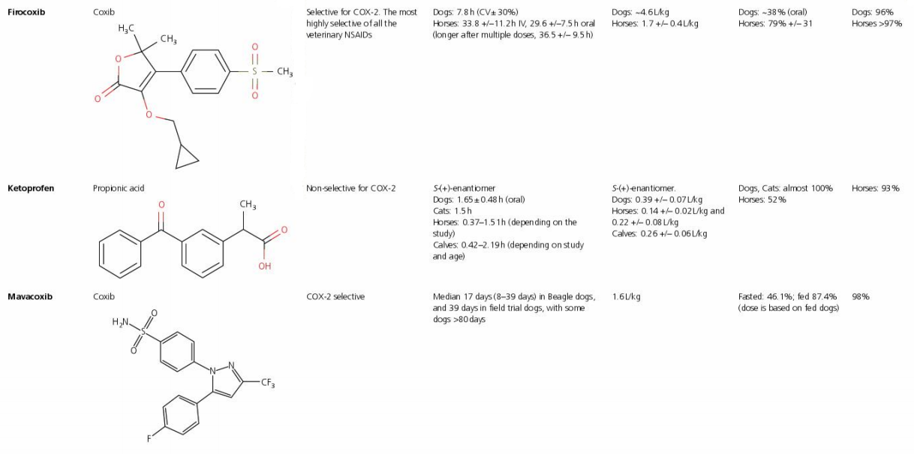
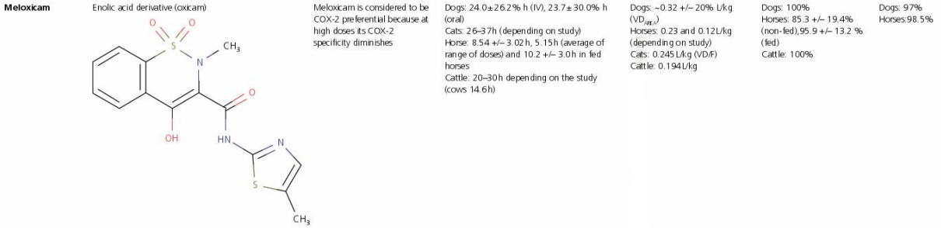

Questions
- Explain the mechanism of action of the following adverse effects of NSAIDs

- GI injury
- Liver injury
- Acute kidney injury
- Platelet inhibition

- T or F: Chronic administration of carprofen in dogs can lead to gastrointestinal adaptation and decreased risk of injury due to an increase of gastric blood flow, mucosal regeneration and reduced inflammatory cell infiltration.

Answers
- Explain the mechanism of action of the following adverse effects of NSAIDs

- GI injury - Direct mucosal irritation, Prostaglandin inhibition
- Liver injury – Idiosyncratic
- Acute kidney injury - Inhibition of renal prostaglandin synthesis
- Platelet inhibition - decreased Thromboxane (TXA₂) production in platelets and decrease platelet function (irreversible binding with Aspirin)

- T or F: Chronic administration of carprofen in dogs can lead to gastrointestinal adaptation and decreased risk of injury due to an increase of gastric blood flow, mucosal regeneration and reduced inflammatory cell infiltration. ASPIRIN

