PANCREAS
Necrosis and Inflammation: Feline p.821-829

QUESTIONS
- Please describe the difference in pancreaticobiliary anatomy between cats and dogs.

- Which of the following have known associations with the development of acute necrotizing pancreatitis in the cat?
  - Cholangitis & high-fat feedings
  - Organophosphates & glucocorticoid
  - IBD & trauma
  - Pancreatic ductal obstruction & obesity

- What are the most frequently reported clinical signs in cats with acute pancreatitis?
  - Vomiting & Diarrhea
  - Vomiting & Weight loss
  - Vomiting & Anorexia
  - Anorexia & Lethargy
  - Lethargy & Weight loss

- In dogs and cats affected with pancreatitis, leukocytosis is a more important clinical finding in _______________________ (dog vs cat) and hypocalcemia is more frequent in ________________________ (dog vs cat).

- Please name four possible complications of acute necrotizing pancreatitis.

QUESTIONS&ANSWERS

- Please describe the difference in pancreaticobiliary anatomy between cats and dogs.
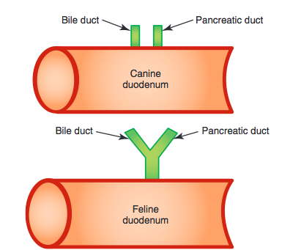
Pancreatic and bile ducts have separate channels of entry in the canine duodenum, whereas these ducts merge prior to their entry in the feline duodenum (feline pancreaticobiliary sphincter is a common physiologic and anatomic channel at the duodenal papilla). Mechanical or functional obstruction to this common duct readily permits bile reflux into the pancreatic ductal system.

- Which of the following have known associations with the development of acute necrotizing pancreatitis in the cat?
  - Cholangitis & high-fat feedings
  - Organophosphates & glucocorticoid
  - IBD & trauma
  - Pancreatic ductal obstruction & obesity

- What are the most frequently reported clinical signs in cats with acute pancreatitis?
  - Vomiting & Diarrhea
  - Vomiting & Weight loss
  - Vomiting & Anorexia
  - Anorexia & Lethargy
  - Lethargy & Weight loss

- In dogs and cats affected with pancreatitis, leukocytosis is a more important clinical finding in dogs and hypocalcemia is more frequent in cats.

- Please name four possible complications of acute necrotizing pancreatitis.
Chronic nonsuppurative pancreatitis
Exocrine pancreatic insufficiency
Diabetes mellitus
Hepatic lipidosis

