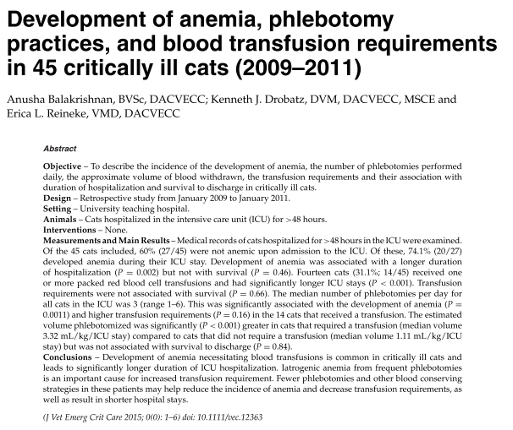
# of phlebotomies associated with higher transfusion requirements P = 0.016 (not 0.16)
- In people, development of anemia in ICU and need for blood transfusions = independently associated with worse clinical outcome.
- Development of anemia – likely multifactorial:
hemodilution, frequent blood sampling, oxidative damage, blood loss, poor regenerative response
- Anemia defined as PCV <30%
- 84% of cats were anemic at some point (47% at admission/in ER; 52% developed anemia in ICU)
- 31% cats required blood transfusion
- Approximation of blood volume drawn; likely underestimation
- Did not evaluate severity of disease/no illness severity score
- Blood conservation strategies should be considered

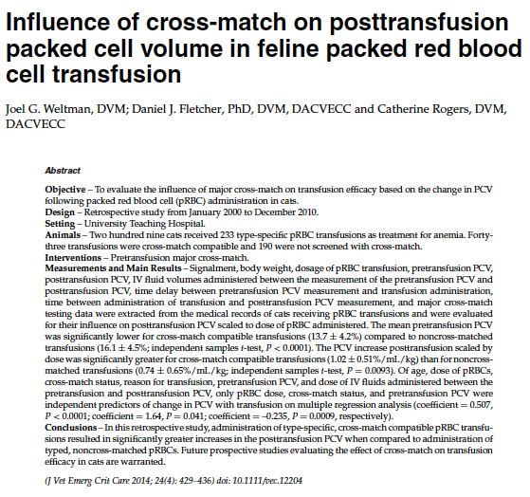
- Identification of novel RBC antigen Mik (Mik-negative cats have anti-Mik antibodies and can have adverse transfusion reaction if transfused with blood from Mik-positive cats)
- 91 cross-match procedures were performed: 15 were incompatible
- Significantly greater delay between measurement of pretransfusion PCV and start of transfusion for CM+ transfusions

QUESTIONS

- The authors of a 2015 retrospective study evaluating the development of anemia, phlebotomy practices, and blood transfusion requirements in critically ill cats found that…
- anemic cats had a worse survival rate than non anemic cats
- anemic cats stayed for a longer period of time in the hospital compared to non anemic cats
- cats that received a transfusion had a worse survival rate that non anemic cats
- cats from which a larger volume of blood was sampled during their hospital stay had a worse survival rate

- Based on the findings of the authors of a 2014 retrospective study evaluating the influence of cross-match on post-transfusion PCV in cats transfused with pRBCs, which of these parameters is expected to have an effect on the increase in PCV post-transfusion?
- Cross-match status
- Age of the unit
- Reason for transfusion
- Speed of transfusion

- Based on the findings of the 2 studies described above, which modifications could be applied to your management of critically ill cats (with regard to development of anemia and blood transfusion practices)?

QUESTIONS WITH ANSWERS

- The authors of a 2015 retrospective study evaluating the development of anemia, phlebotomy practices, and blood transfusion requirements in critically ill cats found that…
- anemic cats had a worse survival rate than non anemic cats
- anemic cats stayed for a longer period of time in the hospital compared to non anemic cats
- cats that received a transfusion had a worse survival rate that non anemic cats
- cats from which a larger volume of blood was sampled during their hospital stay had a worse survival rate - more transfusions but did not affect survival

- Based on the findings of the authors of a 2014 retrospective study evaluating the influence of cross-match on post-transfusion PCV in cats transfused with pRBCs, which of these parameters is expected to have an effect on the increase in PCV post-transfusion?
- Cross-match status
- Age of the unit
- Reason for transfusion
- Speed of transfusion

- Based on the findings of the 2 studies described above, which modifications could be applied to your management of critically ill cats (with regard to development of anemia and blood transfusion practices)?
-Less phlebotomy
-Collection of the smallest volume necessary
-Cross-match

