J Vet Emerg Crit Care (San Antonio). 2013 Jan-Feb; 23(1):3-13
Prothrombotic mechanisms and anticoagulant therapy in dogs with immune-mediated hemolytic anemia

OBJECTIVE:
To review the pathophysiology of thrombosis in hemolytic disease, and the efficacy of thromboprophylaxis in dogs with immune-mediated hemolytic anemia (IMHA).

DATA SOURCES:
Computerized searches of Pubmed, INDEX VETERINARIUS, and the journal database of the Veterinary Information Network, and a manual search of bibliographies of published manuscripts.

HUMAN DATA SYNTHESIS:
Experimental data suggest that hemolysis leads to the induction of the potent procoagulant tissue factor on monocytes and endothelial cells and subsequent activation of coagulation. In addition, damaged red cells, activated platelets, and small cell-derived membrane vesicles called microparticles may contribute to coagulation by providing membrane surfaces containing exposed anionic phospholipids that serve as docking sites for prothrombinase (factor Va-factor Xa) and tenase (factor VIIIa-factor IXa) complexes of the coagulation cascade. Some microparticles also contain tissue factor, further fueling coagulation. Thromboprophylaxis for hemolytic disease in people primarily targets the coagulation cascade rather than platelets, as most thromboemboli are of venous rather than arterial origin. The use of unfractionated heparin is closely monitored to ensure therapeutic levels are reached.

VETERINARY DATA SYNTHESIS:
Thromboembolic disease is a major factor affecting survival in dogs with IMHA. It is likely that hemolysis contributes to the prothrombotic state. Thrombosis occurs in both veins and arteries, with pulmonary thromboembolism (a venous thrombus) occurring very commonly. Evidence suggests that tissue factor mediates the development of the prothrombotic state. Heparin, and the anti-platelet agents aspirin, and clopidogrel have been used for thromboprophylaxis in dogs with IMHA. However, a lack of validated therapeutic endpoints and controlled studies make it difficult to determine if survival is affected or if 1 drug is more effective than another.

CONCLUSIONS:
Prospective clinical trials comparing individually adjusted heparin or other anti-coagulant drugs to anti-platelet drugs are needed to make evidence-based recommendations for thromboprophylaxis in dogs with IMHA.
- Introduction: review of cell-based model of coagulation
Pathophysiology of Thrombosis in IMHA
- Distinction between arterial (high-flow, platelet-rich; Tx: antiplatelet drugs) vs venous thrombus (low-flow, fibrin rich; Tx: anticoagulant drugs)
- PTE in canine IMHA: released from venous emboli; other thrombi: splenic, myocardial, renal, iliac, mesentery artery, pituitary thromboembolism also been described
  - IMHA may cause generalized thromboembolic disease (venous and arterial); PTE very common (So: dysregulation of both coagulation and platelets)
    - Generalized hypercoagulable state; many dogs meet DIC criteria
- TF expression, microparticles (PS, TF), activated endothelium, activated platelets, decreased AT (other anticoagulants?), impaired fibrinolysis (?)
  - It is possible that inflammatory cytokines, activated monocytes, and free hemoglobin induce endothelial cell TF expression, and that TF expressing MPs derived from monocytes bind to endothelium thrombosis in IMHA
  - MPs are cleared by phagocytosis; it is possible that Tx (immunomodulation and immunosuppression directed at inhibition of phagocytosis) of IMHA increased concentration of MPs
- Free hemoglobin scavenging of NO increased TF expression, increased platelet aggregation
- Exposed PS on senile RBCs (also reticulocytes), activated platelets, MPs
- Use of GC or cyclosporine prothrombotic in dogs with IMHA?
- IV catheter

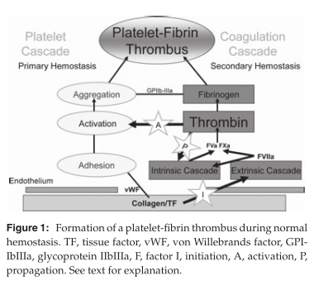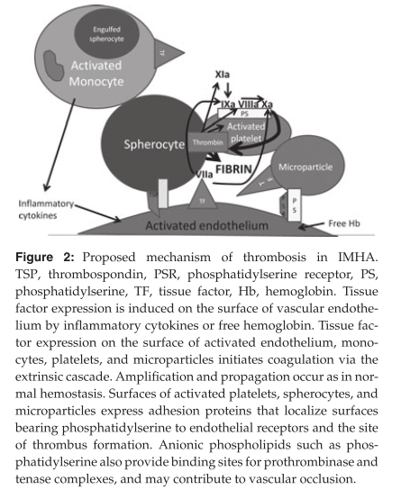

Thromboprophylaxis in IMHA
 | UFH | LMWH | Clopidogrel | Aspirin
Mechanism of Action | 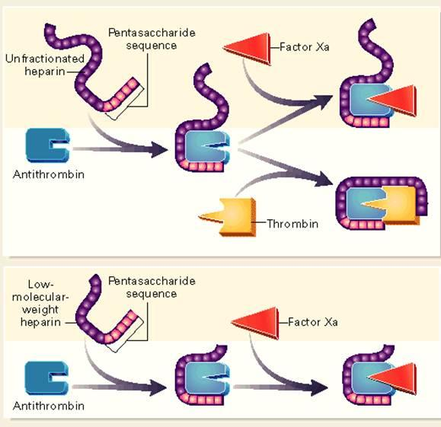  - UFH facilitates AT-mediated inactivation of factors II, Xa, IXa, XIa, VIIa, and XIIa  - Heparin facilitates release of TFPI, inhibits complement |  | 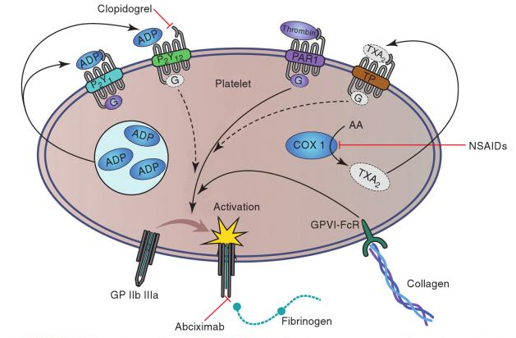Clopidogrel: irreversible inhibition of P2Y12 ADP receptor  Aspirin: cycloxygenase inhibitor; inhibits platelet thromboxane A2 production while preserving COX-1 dependent prostacyclin (which is antithrombotic) production from endothelial cells
Dose | 150-300 U/kg SC q8h  30-50 U/kg/hr IV CRI  500 U/kg SC q8-12h | Dalteparin 100-175 U/kg SC q12h;  Enoxaparin 0.8 mg/kg SC q6h | 1 mg/kg q24h; 10 mg/kg (loading dose) then 2-3 mg/kg q24h | 0,5 mg/kg/day (more effective if dosed q12h?); dose needed may be variable
Monitoring | Anti-factor Xa activity or aPTT (1.5-2.5x); correlation between the 2 in people;  Dogs: range of anti-FXa activity not been established; correlation between the 2?  aPTT: can be affected by high fibrinogen, antiphospholipid Ab | Anti-factor Xa activity; reduced ability to complex with thrombin (so aPTT
Miscellaneous | Metabolized faster than LMWH;  In 1 study: APTT did not correspond to anti-fXa activity within the established therapeutic range; natural log of APTT linearly related with anti-fXa activity in another study of dogs with IMHA | PK more predictable than UFH; similar efficacy/safety as compared to IAD UFH in people |  | With prednisone: risk of ulceration? Does not appear to be common
Which one is the best? Lit review | - Weinkle TK, Center SA, Randolph JF, Warner KL, Barr SC, Erb HN. Evaluation of prognostic factors, survival rates, and treatment protocols for immune-mediated hemolytic anemia in dogs: 151 cases (1993-2002). J Am Vet Med Assoc. 2005 Jun 1;226(11):1869-80.  - Retrospective study  - Temporal bias, unequal treatment group sizes, lack of randomization, lack of blinding, non standardized treatment protocols, minimal patient follow-up  - Dogs receiving azathioprine, prednisone, and UFH had reduced survival compared to patients receiving azathioprine, prednisone, and ULDA, or patients receiving azathioprine, prednisone, UFH, and ULDA  - *The dose of UFH used in that study was 75 U-125 U/kg SQ q 6–8 h. No adjustment in the dose was made based on APTT or anti- factor Xa activity*; aspirin: 0.5 mg/kg/day  - Breuhl EL, Moore G, Brooks MB, Scott-Moncrieff JC. A prospective study of unfractionated heparin therapy in dogs with primary immune-mediated hemolytic anemia, J Am Anim Hosp Assoc. 2009 May-Jun;45(3):125-33  - Prospective study  - Dogs with IMHA treated with UFH at a dosage of 300 IU/kg SC q 6 hours. In dogs that survived beyond 40 hours, further dosage adjustments were made based on the 40-hour anti-Xa activity. If below target range (<0.35 U/mL): increased by 17% to 25%. If within target range (0.35 to 0.70 U/mL): no dosage adjustment. If anti-Xa activity above target range (>0.70 U/mL): decreased by 25% to 50%  - Dogs in this study were relatively resistant to UFH at a dosage of 300 IU/kg q 6 hours; this dose inadequate to attain an anti-Xa activity >0.35 U/mL within the first 2 days of therapy for 10 of 18 dogs with IMHA.  - Helmond SE, Polzin DJ, Armstrong PJ, Finke M, Smith SA. Treatment of immune-mediated hemolytic anemia with individually adjusted heparin dosing in dogs. J Vet Intern Med. 2010 May-Jun;24(3):597-605  - Prospective, randomized, controlled, clinical trial  - Dogs with IMHA received either constant dose (150 U/kg SC) or individually adjusted dose of UFH, monitored via an anti-Xa chromogenic assay.  - In the IAD group, the dose varied between 150 and 712 U/kg. The dose associated with therapeutic anti-Xa activity (0.35–0.7 U/mL) varied between 150 and 566 U/kg, with a median of 360 U/kg.  - Median survival time was >180 days for the IAD group, and 68 days for the CD group. Kaplan-Meier survival curves for the 2 groups were significantly different (P= .01) by the log-rank test.  - Mellett AM, Nakamura RK, Bianco D. A prospective study of clopidogrel therapy in dogs with primary immune-mediated hemolytic anemia. J Vet Intern Med. 2011 Jan-Feb;25(1):71-5  - Prospective, positive-controlled clinical trial  - Dogs with IMHA either received aspirin (0.5 mg/kg/day) , clopidogrel (loading dose 10 mg/kg then 2-3 mg/kg q24h) or aspirin + clopidogrel  - NSD between group in survival (at discharge and 90 day)

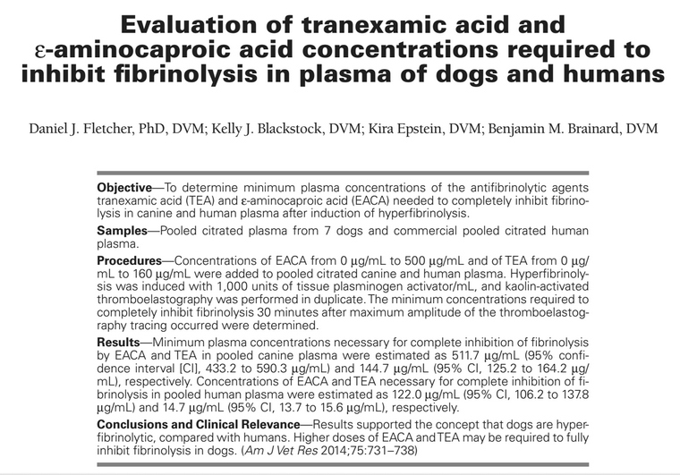
- EACA and TEA inhibit fibrinolysis by blocking the lysine binding site of plasminogen
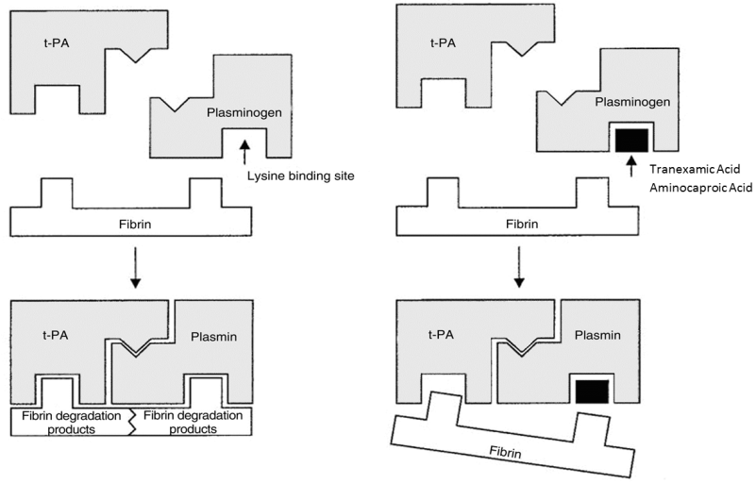
- Dogs: stronger fibrinolytic response, likely required higher dose of EACA/TXA (25% more tPA)
- Methods/Results
  - n=7 dogs /citrated pooled plasma ; commercial pooled human plasma
  - Kaolin-activated TEG; identify the concentration of tPA to use (1000 U/ml)
    - Canine plasma appears hypercoagulable compared to human plasma: shorter R and K; steeper alpha angle, higher MRTG, shorter TMRTG
    - They chose this dose of tPA because TEG curves were similar in both species and this dose allowed direction comparison with the findings from literature.
    - Without tPA neither dog nor human had fibrinolysis w/in 30 min of MA.
  - Kaolin-activated TEG with 1000 U/ml tPA; various concentrations of EACA and TXA
Plasma concentrations of EACA and TEA for
complete inhibition of fibrinolysis at 30 minutes
 | EACA | TXA
Dog | 511.7 µg/mL | 144.7 µg/mL
Human | 122.0 µg/mL | 14.7 µg/mL
  - Dogs had a greater decrease in MA, G, and MRTG with increasing concentrations of tPA compared with the decrease in human plasma
- Conclusions: dogs are hyperfibrinolytic compared to people; higher dose of EACA or TXA may be needed; IN VITRO study
QUESTIONS
- Which of the following cell-based model coagulation phases is altered in dogs with IMHA?
  - Initiation
  - Amplification
  - Propagation

- What are the differences between an arterial thrombi and a venous thrombi?

- Explain the mechanism of action of LMWH vs UFH (with a schema!)

- What is the mechanism of action of clopidogrel?

- What was the conclusion of a 2014 study evaluating the tranexamic acid and
epsilon aminocaproic acid concentrations required to inhibit fibrinolysis in plasma of dogs and humans?
  - Dogs and humans require the same concentration of antifibrinolytic agents than humans to inhibit fibrinolysis
  - Dogs require a higher concentration of antifibrinolytic agents than humans to inhibit fibrinolysis
  - Dogs require a smaller concentration of antifibrinolytic agents than humans to inhibit fibrinolysis
  - Greyhounds require a higher concentration of antifibrinolytic than other dogs to inhibit fibrinolysis

QUESTIONS & ANSWER
- Which of the following cell-based model coagulation phases is altered in dogs with IMHA?
  - Initiation
  - Amplification
  - Propagation

- What are the differences between an arterial thrombi and a venous thrombi?
Arterial: formed in high-flow; platelet rich
Venous: formed in low-flow; fibrin-rich

- Explain the mechanism of action of LMWH vs UFH (with a schema!)

- What is the mechanism of action of clopidogrel?
Clopidogrel causes irreversible inhibition of P2Y12 ADP receptor (ADP is a potent activator of platelets)

- What was the conclusion of a 2014 study evaluating the tranexamic acid and
epsilon aminocaproic acid concentrations required to inhibit fibrinolysis in plasma of dogs and humans?
  - Dogs and humans require the same concentration of antifibrinolytic agents than humans to inhibit fibrinolysis
  - Dogs require a higher concentration of antifibrinolytic agents than humans to inhibit fibrinolysis
  - Dogs require a smaller concentration of antifibrinolytic agents than humans to inhibit fibrinolysis
  - Greyhounds require a higher concentration of antifibrinolytic than other dogs to inhibit fibrinolysis

