

- Retrospective study
- 28 dogs with a histological diagnosis of splenic lymphoma and treated by splenectomy

- Dogs with splenic lymphoma treated by splenectomy had a 1-year survival rate of 58.8%
  - After which no animals died of their disease.
- B cell lymphoma held a better prognosis for survival than other variants of splenic lymphoma
- Marginal zone lymphoma and mantle cell lymphoma were the most common B cell lymphoma subtypes
- There was no significant difference in survival between cases diagnosed with MZL and MCL

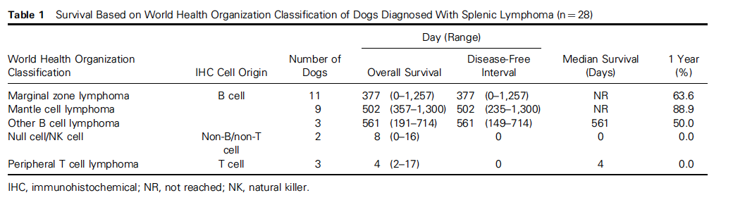

- Poor prognostic indicators: Hemoabdomen and clinical signs related to splenic lymphoma, including abdominal distention, lethargy, and anorexia
- Disease involving the peripheral lymph nodes and intestines was a poor prognostic indicator
- Hepatosplenic lymphoma carried the worst prognosis
  - 0% 1-year survival rate, with a median survival time of 155 days
- Disease confined to the spleen was a positive prognostic indicator.

- Pre- or postoperative adjuvant chemotherapy did not provide a survival benefit
- Protocols used in 15 dogs receiving chemotherapy varied (see below)

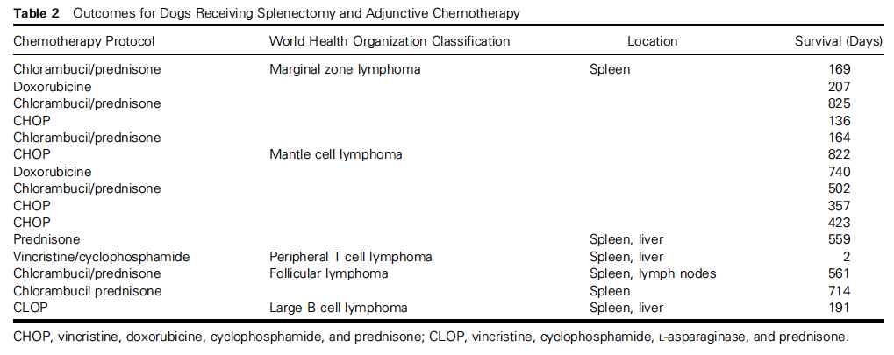

Conclusion: Based on sample population, splenectomy alone was an effective treatment for splenic lymphoma in cases with disease confined to the spleen. Chemotherapy may not improve survival in cases of lymphoma restricted to spleen

