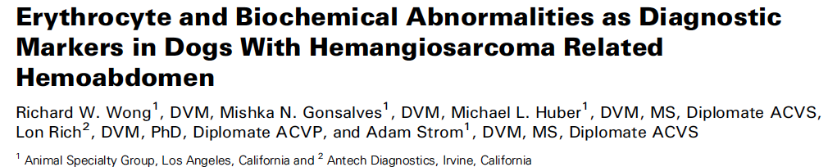

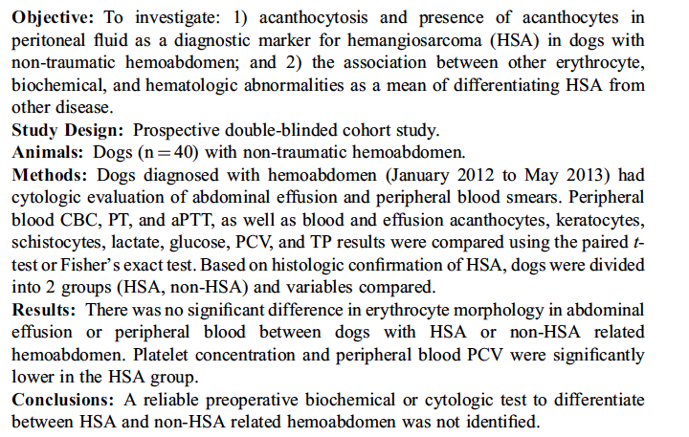

Background – Keratocytes and schistocytes are other poikilocytes that are commonly associated with disseminated intravascular coagulation (DIC) and other microangiopathies.
Presence of acanthocytes in canine peripheral blood has been associated with various disorders including HSA

Results
1. There was no significant difference in erythrocyte morphology in abdominal effusion or peripheral blood between dogs with HSA or non-HSA related hemoabdomen.

2. Significant differences between groups were only identified for peripheral blood PCV (lower in HSA), platelet count (lower in HSA), and aPTT (longer in non-HAS).

- A cutoff value of ≤83,000 platelets/mL resulted in a diagnosis of HSA with a positive predictive value (PPV) of 1.00 and a maximal specificity of 100.0%.
- For peripheral PCV, a cutoff value of ≤ 24% resulted in a diagnosis of HSA with a PPV of 0.92 and specificity of 92.3%.
- A cutoff value of ≤ 8 seconds for aPTT resulted in a diagnosis of HSA with a PPV of 0.93 and specificity of 92.3%.

3. Recommended that thrombocytopenia be considered as a potential prognostic indicator for HSA but a blood smear should be performed in all cases of non-traumatic hemoabdomen to rule out platelet clumps.

Limitations - included small sample size and low yield of acanthocytes, which may have skewed the results.

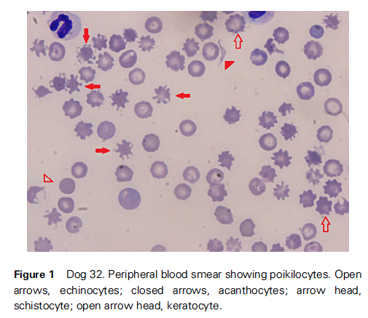

Nothing relevant in NEJM. Found this through an NEJM editorial in August

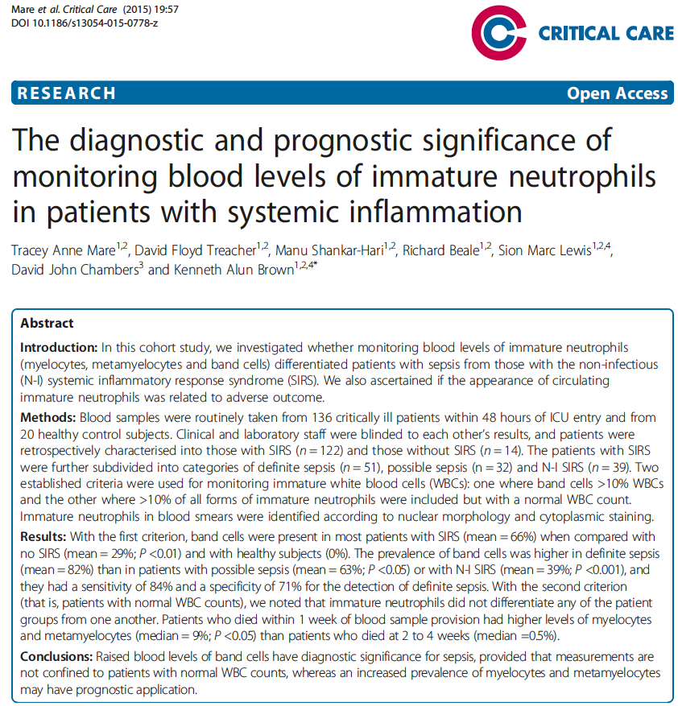

Investigated the relative merits of the WBC criteria of Bone et al. [2] and of Levy et al. [3] in identifying patients with SIRS and whether monitoring levels of all forms of immature neutrophils could help in differentiating patients with non-infectious SIRS from those with sepsis

Conclusions
Increased prevalence of band cells in the circulation is mainly a feature of sepsis rather than non-infectious SIRS.
- Increased levels of circulating band cells were more prevalent in patients with sepsis than in patients with non-infectious SIRS

High blood levels of myelocytes and metamyelocytes may be indicative of poor patient outcome.
- Blood levels of myelocytes and metamyelocytes were elevated in patients who died within the first week of ICU stay, and their appearance in the circulation may be associated with increased mortality.

SIRS/Sepsis Criteria used
Patients were defined as having SIRS if they satisfied at least two of the recognised criteria, but without reference to the number or distribution of WBCs.

The patients with SIRS were further differentiated into three groups: (1) 51 patients with definite sepsis (either microbiological documentation of an infective organism or where both consultants had a very strong clinical suspicion of infection in the absence of positive microbiology), (2) 32 patients with possible sepsis (no relevant confirmatory microbiology, but where one of the consultants had a strong clinical suspicion) and (3) 39 patients with N-I SIRS (neither clear microbiological evidence nor any clinical suspicion of infection)

