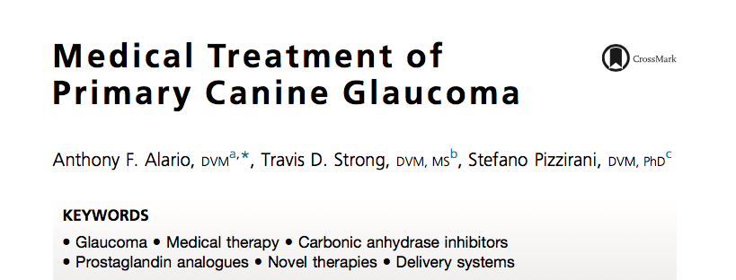

Key Points:
- Medical therapy is the predominant method of management
- Glaucoma is progressive, requiring lifelong medical therapy
  - Carbonic anhydrase inhibitors
    - Topical vs oral
    - Carbonic anhydrase results in bicarbonate production, which then leads to AH formation
    - Dorzolamide, brinzolamide
    - All forms of glaucoma
    - GI upset, malaise, increased RR (secondary to metabolic acidosis)
  - Prostaglandin analogues
    - Produce increased uveoscleral outflow
    - Latanoprost
    - Reduces IOP 22% to 40%
    - All forms of idiopathic glaucoma, some forms of secondary
    - Side effects: rare, conjunctival hyperemia
  - Osmotic agents
    - Mannitol
    - 1-2g/kg of body weight IV over 20-30minCongestive glaucoma

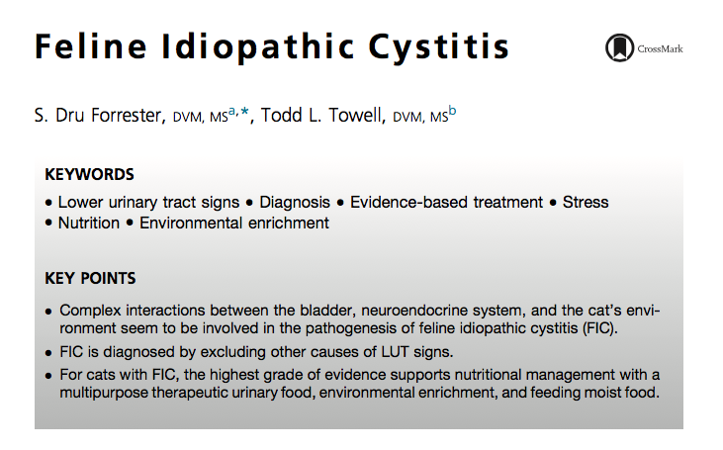

Key Points:
- In most cases of non-obstructive FIC, clinical signs resolve within 1 to 7 days without therapy
- Stress management
- Feline Facial Pheromone: insufficient evidence to support
- Supplements/therapeutic foods for stress
  - L-tryptophan or a-casozepine *If oral admin does not add to stress
- Moist food/Increased water intake: transition slowly (weeks to months)
- Therapeutic urinary food:
  - Consider if struvite disease cannot be ruled out
  - Multipurpose therapeutic urinary diet (Hills c/d multicare)
- GAGs: insufficient evidence to support oral or SC use, physiologic rationale
- Amitriptyline: Insufficient evidence for short term, though consider for long term use if recurrent episodes despite use of foods/moist diet/environmental enrichment
- Anti-inflammatories and Analgesics
  - Buprenorphnie, butorphanol, fentanyl patch
  - NSAIDs used with caution d/t reduced renal blood flow and potential for AKI

