Traumatic Elbow Luxation
- Due to rupture or avulsion of one or both collateral ligaments allows luxation of the radius and ulna
- Usually luxate laterally, large medial condyle of the humerus generally prevents medial luxation
- Non weight bearing, elbow is flexed

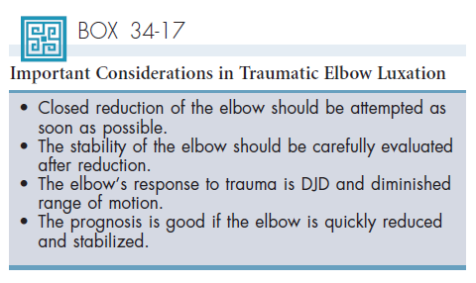
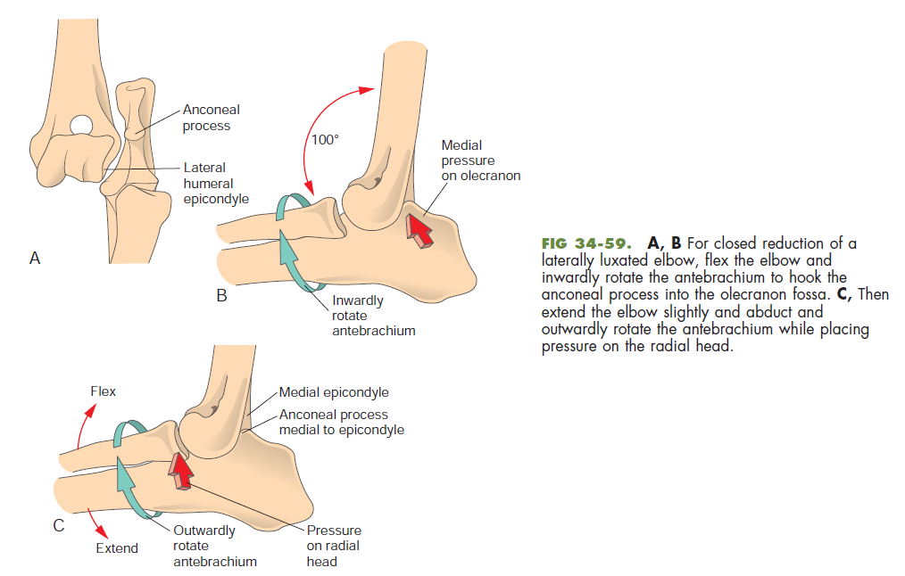
https://www.youtube.com/watch?v=7sjfNTA6D_U 3:45 min
After Reduction:

- Bandage with spica splint or cast should be with elbow in extension for 10 to 14 days
- After removal of the bandage, range of motion exercises daily
- Exercise restriction 3 to 4 weeks
- Complications: reluxation and osteoarthritis.

