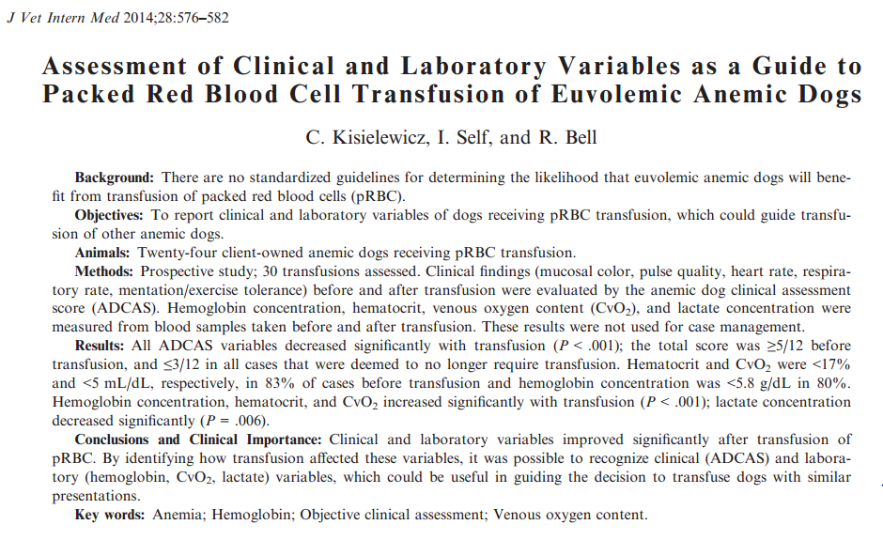
Guidelines to establish if a patient should receive a transfusion have not been established. Currently Hb concentration and clinical signs have been the factors influencing transfusion administration.
Markers of impaired oxygenation:
- Increased Lactate, due to decreased DO2 and tissue hypoxia
- Decreased DO2 (oxygen delivery)
- Decreased cellular extraction
CvO2 can be used as an approximation of DO2 in critically ill dogs, but requires central venous sampling. An increase in CvO2, in the absence of supplemental O2 and hypovolemia, would suggest improved DO2.
Study:
Clinicians made decisions about transfusion with HCT and clinical signs. Anemia (HCT <37%)
They were blinded to:
- Anemic Dog Clinical Assessment Score (ADCAS)
- Lactate
- Oxygenation values (PvO2- venous partial pressure of O2, SvO2-venous O2 saturation of Hb)
Exclusion criteria:
- Dogs on supplemental O2
- 1ary cardiorespiratory disease
- Dogs with neuromuscular or orthopedic disease affecting ambulation
- Dehydrated, hypovolemic, hyperbilirubinemic dogs
Labs were taken 1 hr before and 1 hr after transfusion:
- PCV, Lactate, PvO2, SvO2, Hb and HCT
- CvO2 calculated through: ([Hb] x SvO2/100 x 1.34) + (PvO2 x 0.003)
Results:
- Hb, HCT and CvO2 increased significantly after pRBC transfusion
- Lactate decreased in all dogs, however hyperlactatemia was noted in 53%
- PvO2 and SvO2, erratically increased or decreased
Take Home:
- No Universal Trigger for transfusion
- Clinical signs (those evaluated in ADCAS), Hb and HCT may be the most important to evaluate if a patient needs a transfusion
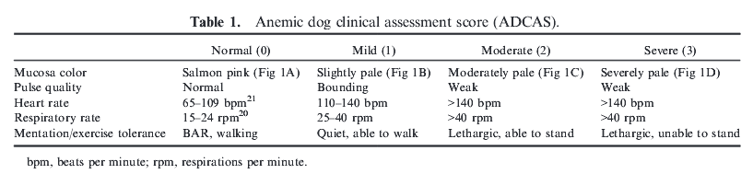
**In the paper they talk about a max score of 12?? Where do I score HR >140, RR >40, weak pulse and lethargy? 2 or 3?
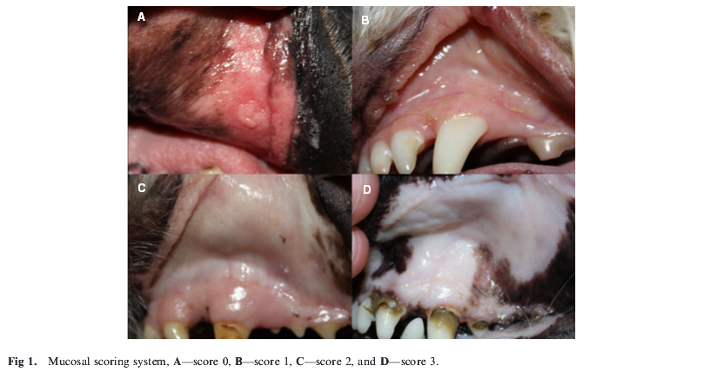
Questions:
- Name 3 markers of impaired oxygenation:

- T or F: Lactate is a valuable marker to evaluate the need of a transfusion

Questions:
- Name 3 markers of impaired oxygenation:
  - Increased Lactate, due to decreased DO2 and tissue hypoxia
  - Decreased DO2 (oxygen delivery)
  - Decreased cellular extraction

- T or F: Lactate is a valuable marker to evaluate the need of a transfusion

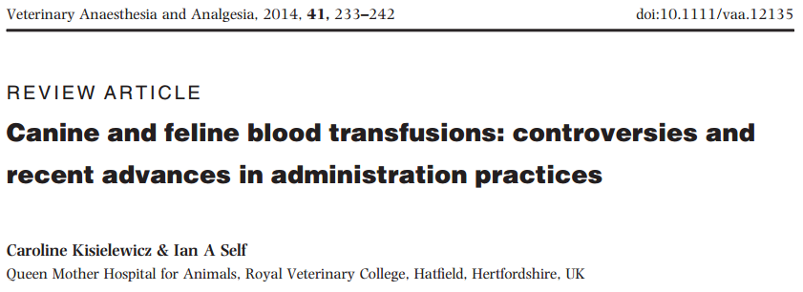
Storage Lesions:
- Stored blood pH will progressively decrease with lactic and pyruvic acid accumulation, leads to 54% reduction in 2,3 DPG within the 1st 24hr of stored blood, this may lead to reduced oxygen unloading following transfusion
- Cat rbc rely on Cl for O2 affinity, 2,3 DPG is normally low in cats, so not a big concern in felines
- ATP decreases up to 60% in stored canine rbc, ATP reduces rbc mb loss and maintains rbc morphology
- Free Hb increase due to blood hemolysis, which may lead to vasoconstriction during transfusion
- Pro-inflammatory microparticles

Leukoreduction:
- Filters blood before storage to remove leukocytes by 99.9% and platelets
- LR blood may have higher HCT and 2,3 DPG concentrations compared to non LR blood
- Despite LR, older blood may still produce inflammatory responses

Blood typing and Cross-matching:
- All animals should be typed
- All animals that have had a transfusion >3-5 days should be cross-matched

Blood Administration:
- Best administration is gravity flow, followed by peristaltic infusion pump and syringe pump being the worst
- Warming is unnecessary, may accelerate erythrocyte deterioration and promote microorganism growth
- 2 formulas have been noted to be accurate
  - Vol transfused: [(desired PCV – patient PCV)/donor blood PCV] x 90 x kg body weight
  - Vol transfused: required PCV % increase x1.5 x kg body weight
- Blood should be administered within 4 hours, max rate is dependent on patient requirement

Cell Salvage and Autologous Blood Transfusion
- Option for large volume hemorrhage, minimizing transfusion reactions
- Cell separator system is used to collect blood, then washed and returned to the patient in 6 hr
- Plasma, activated clotting factors, anticoagulants and systemic medications are removed
- Leukoreducing the blood prior to administration may reduce bacterial load, leukocytes and neoplastic cells in people
- Autologous stored blood undergoes the same storage lesions
- Acute euvolemic hemodilution involves donating blood immediately prior to anesthesia and replacing blood loss with crystalloids; this blood can then be administered fresh during highly hemorrhagic surgeries, with minimal complications

Xenotransfusion
- Several report from calf blood to dogs, lamb and calf blood to people, dog blood to cat have been reported
- May be useful in genuine emergencies where no alternative exists, rbc last less, <4 days and antibodies develop within 4-7 days
- Repeat xenotransfusion in cats with dog blood >6 days was fatal in 66%
- Oxyglobin, ultra-purified, polymerized bovine hemoglobin based oxygen carrying solution, used similarly to pRBC transfusions, short lived effect 5-9 days, may also affect biochemical tests based on colorimetric or optical assessment, no longer available

Questions:
Which of the following is NOT a storage lesion:
- lactic and pyruvic acid accumulation
- increased 2,3 DPG
- increased free Hb
- increase in pro-inflammatory microparticles
- decreased ATP

T or F: Cell salvage techniques are associated to less transfusion reactions

T or F: Leukoreduced blood tends to have a higher PCV and higher 2,3 DPG concentrations when compared to non LR blood.
Questions:
Which of the following is NOT a storage lesion:
- lactic and pyruvic acid accumulation
- increased 2,3 DPG
- increased free Hb
- increase in pro-inflammatory microparticles
- decreased ATP

T or F: Cell salvage techniques are associated to less transfusion reactions

T or F: Leukoreduced blood tends to have a higher PCV and higher 2,3 DPG concentrations when compared to non LR blood.

