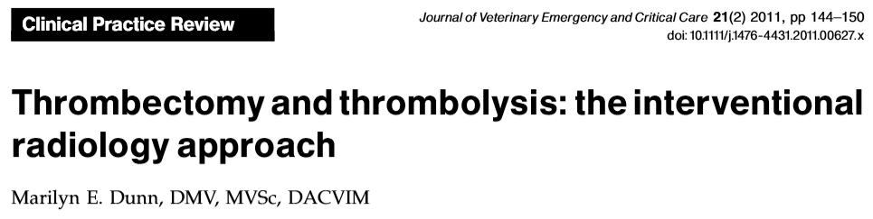
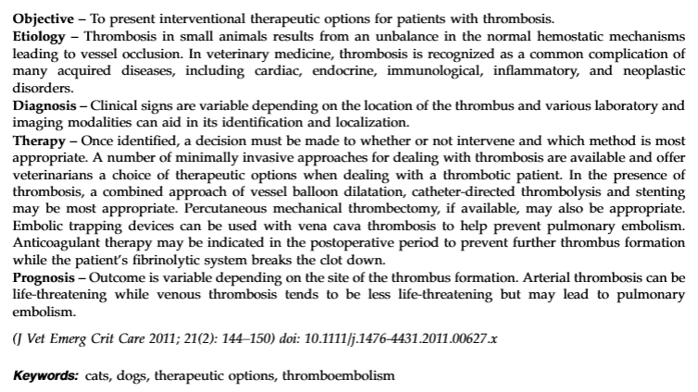
Minimally Invasive Approaches
- Catheter-directed thrombolysis uses thrombolytic drugs directly on the clot to accelerate fibrinolysis
- Side effects: bleeding, pulmonary embolism (if treating venous thromboembolism) and reperfusion injury
- This technique has better outcomes and fewer side effects in people compared to systemic administration of thrombolytic drugs
- Arterial thrombosis is an emergency, venous thrombosis may be dissolve with management of underlying disease, but may lead to pulmonary embolism as the clot breaks up.

Balloon Dilation or Angioplasty
- Plasties clot up against a vessel, restoring patency
- Used in smaller caliber vessels (femoral or popliteal veins)
- Complications: vessel may re-occlude, risk of pulmonary embolism (may use a caval filter in high risk patients)
- Anticoagulant coated balloons may reduce the occurrence of restenosis (paclitaxel)
- Requirements: vessel must be easily accesible, sufficient diameter to not become completely occluded
Vascular Stenting
- Used in arterial and venous thrombi
- Stents are non-thrombogenic and don’t appear to be associated with risk of thrombosis at the site (however used in combination with anticoagulants and thrombolytics)
- Made of a metal exoskeleton coated with polytetrafluoethylene material (impermeable to blood), can also be drug eluting stents (paclitaxel, everolimus, sirolimus)
- Can be mounted onto a balloon or self-expanding, once placed cannot be removed
- Complications: stent fracture in mobile sites, can re-stenose

Embolic Trapping Devices
- Used to trap emboli and prevent them from reaching the lungs, once trapped it can undergo fibrinolysis
- Use is indicated when anticoagulant therapy cannot be initiated, must be stopped or is insufficient to protect from pulmonary embolism
- Placed fluoroscopically into caudal vena cava under the lowest renal vein to trap emboli from femoral or popliteal veins; can also be place in the cranial vena cava.
- Can be permanent or can be retrieved once thrombotic disease is controlled
- Filters are made from stainless steel or nitinol and are non-thrombogenic
- Complications: migration, tearing or perforation of the cava
- Have not been used in vetmed yet, potential for trapping clots in adrenal tumors and PLN

Percutaneous Mechanical Thrombectomy (PMT)
- Wall contact devices
- Non-wall contact devices
  - Angiojet system: emits high velocity saline jets directed backwards from the tip of the device to outflow channels creating a localized low-pressure zone, these generate a vacuum force that draws the thrombus back into the catheter. Jet breaks the thrombus into small fragments that are propelled in to the catheter lumen and aspirated, preventing embolism. https://www.youtube.com/watch?v=ku4QuxOmxtM
  - Device must be inserted into the affected vessel and advanced until it reaches the clit, size may be restrictive, smallest available Angiojet is 4 Fr.
  - In humans instead of saline they also recommend tPA to flush, which may improve outcome
  - Evaluated in cats with ATE, reperfusion injury was reported following thrombectomy in all cats with varying severity
    - Successful thrombectomy in 5/6 cats, 50% survived to discharge (1 died 4 months later spontaneously, no cause of death was obvious on necropsy, 1 euthanized 4 months later for ATE, 1 died from CHF and CRF 2 years later)

Concurrent Anticoagulation/Antiplatelet Therapy
- If underlying disease has not been addressed, thrombosis can recur, hence anticoagulation/antiplatelet therapy should continue for as long as the underlying cause is present
- Anticoagulants and antiplatelet therapy are discontinued before these procedures, length of time required is dependent of the half-life of the drugs used

Multimodality Approach
- Use of medical management, catheter-directed thrombolysis and endovascular stents
- May result in improved morbidity and mortality

Prognosis
- Varies depending on site of thrombosis, arterial vs venous, underlying hypercoagulable condition and clinician’s ability to address the underlying condition.
- Venous are less life threatening than aortic thrombosis.
- Early identification and rapid treatment of underlying disease may improve prognosis.

Questions:
- Name 2 complications of balloon angioplasty

- What are the indications for the use of embolic trapping devices?

- T or F: Venous thrombosis is a life threatening emergency

- Indicate which of the following are the most common complications with thrombectomy techniques:
- Reperfusion injury
- Recurrence of occlusion
- New development of thrombosis
- Pulmonary embolisms
- Bleeding

Questions:
- Name 2 complications of balloon angioplasty
- Risk of re-occluding vessel
- Risk of pulmonary embolism

- What are the indications for the use of embolic trapping devices?
  - When patient is at high risk of developing pulmonary embolism
  - When anticoagulant therapy cannot be initiated, must be stopped or is insufficient to protect from pulmonary embolism

- T or F: Arterial thrombosis is a life threatening emergency

- Indicate which of the following are the most common complications with thrombectomy techniques:
- Reperfusion injury
- Recurrence of occlusion
- New development of thrombosis – Occurs due to underlying cause
- Pulmonary embolisms
- Bleeding – May occur due to thrombolysis with anticoagulation/antiplatelet therapy

