The Heart Pump
Cardiac Cycle: defined as “one complete sequence of contraction and relaxation”
- Left Pump
Ventricular diastole: see A in graph
* Mitral valve opens when LV pressure < LA pressure → Ventricular Filling
* Atrial pressure initially drops, then both ventricular and atrial pressure slowly rise together
* Atrial contraction occurs at the end of ventricular diastole by depolarization of atrial muscle cells→ P wave, this increases atrial pressure and produces additional ventricular filling, unnecessary for adequate ventricular filling, since it has reached maximum end-diastolic volume before atrial contraction (becomes very important in tachycardia, since passive filling is shorter)

Ventricular systole: see B in graph
Begins when action potential breaks the AV node and sweeps over ventricular muscle→ QRS wave, ventricular cell contraction increases intraventricular pressure to rise above atrial pressure and closes the mitral valve
LV pressure continues to rise as ventricular contraction intensifies, mitral valve is closed and aortic valve has not opened yet - Isovolumetric Contraction Phase – see C in graph
LV pressure exceeds the aortic pressure – Rapid Ejection phase. In early ejection aortic pressure rises, pressure build simultaneously in LV and aorta as ventricular contraction continues
LV and aortic pressures reach a maximum – Peak Systolic Pressure, and the ventricular contraction begins to wane, aortic pressure starts to drop as blood is leaving the aorta
Intraventricular pressure drops below aortic pressure and the aortic valve closes, blood in aorta flow backwards to fill aortic valve leaflets as they close – Incisura or Dicrotic Notch, ventricle reaches its minimum or end-systolic volume, for a brief time both aortic and mitral valve are closed this is the Isovolumetric Relaxation Phase – see D in graph
Stroke volume: end diastolic volume – end systolic volume
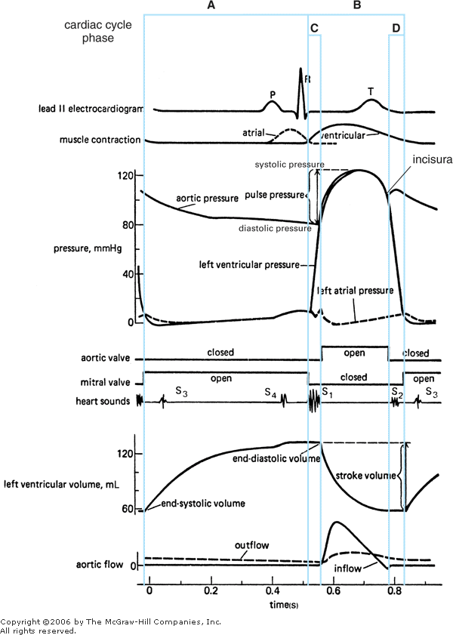

A: Diastole B: Systole C: Isovolumetric Contraction D: Isovolumetric Relaxation
*
*
*
*
*
*

- Right Pump

  - Similar mechanical events occur on the right side
  - The main difference is between the right and left pump is the magnitude of the peak systolic pressure, lungs offer less resistance, so less arterial pressure is required to drive cardiac output through the lungs
  - Pulmonary artery systolic and diastolic pressures are 24/8 mmHg
  - Atrial Pressure trace:
    - a wave: atrial contraction
    - c wave: onset of ventricular systole and is caused by an initial bulging of tricuspid valve into the right atrium, pressure drops again from atrial relaxation and a downward displacement of the tricuspid valve during ventricular emptying
    - v wave: pressure begins to increase when right atrium begins to fill from central veins

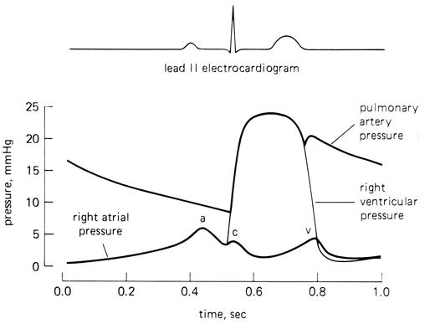

Heart Sounds
- S1: abrupt closure of AV valves (loudest over apex of heart), see C in left heart pump graph
- S2: closure of aortic and pulmonic valves, occurs during isovolumetric relaxation, and T wave, see D in left heart pump graph
- S3: usually not present, if present produces ventricular gallop rhythm
- S4: usually not present, associated to atrial contraction and rapid active ventricular filling, if present produces atrial gallop rhythm
Determinants of Cardiac Output
Influence on Stroke Volume
- Effect of Changes in Ventricular Preload: Frank-starling Law of the Heart
- Effect of changes in Ventricular Afterload
- Effect of Changes in Cardiac Muscle Contractility
Summary of Determinants of Cardiac Output
Cardiac Function Curves
Summary of Sympathetic Neural Influences in Cardiac Function
Cardiac Energetics
- Energy Sources
- Determinants of Myocardial Oxygen Consumption
Measurement of Cardiac Function
- Cardiac Output/Cardiac Index
- Cardiac Contractility Estimates
Key Concepts

