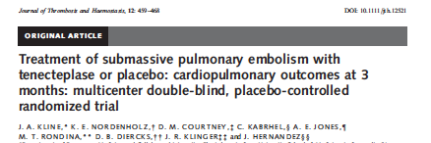

Objective: To evaluate if tenecteplase (tPA) increases probability of a favorable patient oriented outcome after submassive PE.

Multi-center (8 academic medical centers), double-blinded intention to treat, placebo-controlled, randomized controlled efficacy trial

Methods: Normotensive patients with PE and right ventricular (RV) strain (by echocardiography or biomarkers) were enrolled from eight hospitals.

Inclusion criteria:
- PE diagnosed on CT pulmonary angiography performed within 24 hours
- Normal arterial systolic blood pressure with evidence of right ventricular strain manifested by hypokinesis on echo OR elevated troponin I or T OR BNP >90pgml or NT proBNP >900pgmL not more than 6 h prior to CT angiography

All patients received LMWH (enoxaparin or dalteparin) followed by random assignment to
- Tenecteplase (40 patients) or
- Placebo group (43 patients)

Primary outcome: death, circulatory shock, intubation or major bleeding within 5 days (2) recurrent PE, poor functional capacity (RV dysfunction with dyspnea at rest or exercise intolerance) or SF36 Physical Component Summary (PCS) score <30 at 90 day follow up

Results:
Within 5 days - adverse outcomes occurred in 3 placebo treated patients: death (1), intubation (2); and 1 tenecteplase treated patient (fatal intracranial hemorrhage)
At 90 days - adverse outcomes in 13 placebo treated patients and 5 tenecteplase treated patients
Total 16 placebo patients, 6 tenecteplase patients

Treatment of patients with submassive pulmonary embolism with tenecteplase was associated with increased probability of a favorable outcome

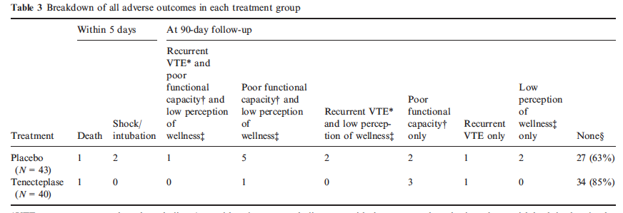

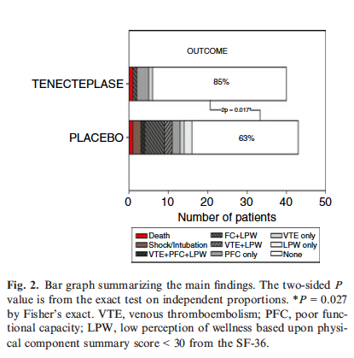

Questions
1. True or False. The adjunctive use of fibrinolysis to treat acute submassive pulmonary embolism remains controversial.

2. Define submassive PE.

3. What are therapeutic goals for PE?

Answers
1. True or False. The adjunctive use of fibrinolysis to treat acute submassive pulmonary embolism remains controversial.

2. Define submassive PE
Massive PE - acute PE with sustained hypotension, pulselessness, or persistent profound bradycardia. In patients with evidence of circulatory or respiratory compromise or moderate to severe RV dysfunction, fibrinolytic therapy is recommended

Submassive PE - acute PE without systemic hypotension but with either RV dysfunction or myocardial necrosis

Low risk PE - acute PE and the absence of clinical qualifiers of adverse prognosis that define massive or submassive PE.

It is reasonable to consider using thrombolytic therapy in a select group of cases which do not fulfill the unstable hemodynamic criteria for massive PE

3. What are therapeutic goals for PE?
Therapeutic goals for PE are: prevention of further embolization, prevention of extension of thrombi, reduction of recurrence, restoration of pulmonary artery patency, and prevention of pulmonary hypertension. An

SF-36
The SF-36 consists of eight scaled scores, which are the weighted sums of the questions in their section. Each scale is directly transformed into a 0-100 scale on the assumption that each question carries equal weight. The lower the score the more disability. The higher the score the less disability i.e., a score of zero is equivalent to maximum disability and a score of 100 is equivalent to no disability. To calculate the scores it is necessary to purchase special software. Pricing depends on the number of scores that the researcher needs to calculate.

The eight sections are:
- vitality
- physical functioning
- bodily pain
- general health perceptions
- physical role functioning
- emotional role functioning
- social role functioning
- mental health

TNKase
Distribution: approximates plasma volume
Metabolism: Primarily hepatic
Half-life elimination: Biphasic: Initial: 20–24 minutes; Terminal: 90–130 minutes
Excretion: Clearance: Plasma: 99-119 mL/minute

