Surgical Needles
The three basic components of a needle are
- Attachment end
  - Swaged: minimizes tissue trauma
  - Eyed: figure B
- Body
  - Shape: figure C
    - Straight curved: where easy hand manipulation is possible
    - Curved: needle holder
  - Size: figure C, 3/8, ½ most common in vet med
- Point
  - Taper: spreads tissue, intestine, SQ or fascia
  - Taper- cut: combination of a reverse cutting edge tip and a taper point body, tendons
  - Cutting: cutting edge on inside, skin
  - Reverse cutting: stronger than cutting, producing less “cutting out”, cutting edge on outer edge
  - Side cutting: “spatula”, ophthalmic
  - Blunt: for friable tissues, liver, kidneys

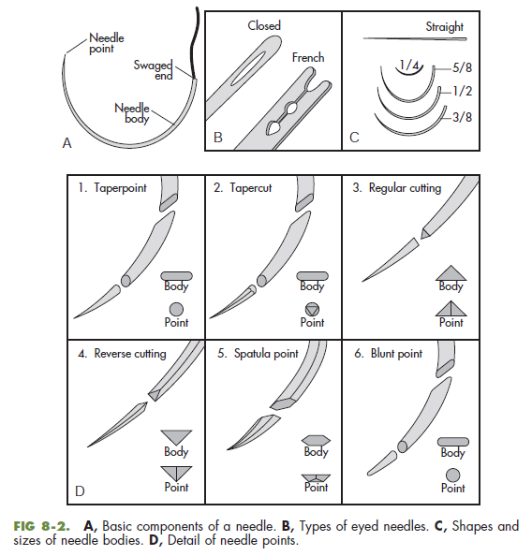
Suture Selection

Skin: monofilament non absorbable (Nylon, polypropelene), absorbable (polydioxanone, polyglyconate) should be removed since absorption requires contact with bodily fluids

Abdominal Closure: monofilament non absorbable or absorbable, one size larger if continuous pattern

Muscle and Tendon: absorbable, non-absorbable

Parenchymal Organs: monofilament absorbable

Hollow Viscous Organs (trachea, GI, bladder): monofilament absorbable

Infected or Contaminated Wounds: monofilament absorbable

Vessels and Vascular Anastomoses: monofilament absorbable for vessels, nonabsorbable for vascular anastomosis and grafts

Questions:
Select the appropriate needle and suture material for the following procedures:
- Gastrotomy and Enteroanastomosis:
- Ovariohysterectomy:
- Tendon Repair:
- Dog Bite Wounds:

Questions and Answers:
Select the appropriate needle and suture material for the following procedures:
- Gastrotomy and Enteroanastomosis: taper needle, monofilament absorbable for GI tract, , larger size for abdominal closure if continuous, monofilament absorbable/non absorbable for skin
- Ovariohysterectomy: cutting, reverse cutting needle, monofilament absorbable for ligation, larger size for abdominal closure if continuous, monofilament absorbable/non absorbable for skin
- Tendon Repair: taper-cut needle, monofilament absorbable/non absorbable and for skin
- Dog Bite Wounds: cutting, reverse cutting needle, monofilament absorbable and for skin

