Management of Pulmonary Embolism: State of the Art Treatment and Emerging Research
Esponda and Tafur, Current Treatment Options in Cardiovascular Medicine (2013)
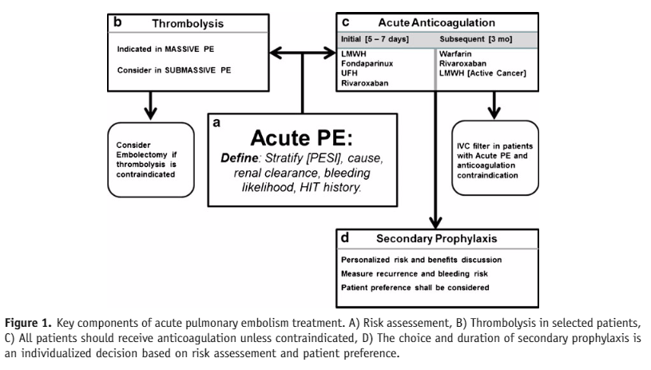
- Goals of treatment
  - Prevention of further embolization
  - Prevention of extension of thrombi
  - Reduction of recurrence
  - Restoration of pulmonary artery patency
  - Prevention of pulmonary hypertension
- Goals in regards to specific treatments
  - Anticoagulation
    - Prevention of further embolization
    - Prevention of extension of thrombi
    - Reduction of recurrence
  - Fibrinolysis
    - Restoration of pulmonary artery patency
    - Prevention of pulmonary hypertension
- Anticoagulation
  - Minimum of 3 month
    - re-evaluate risk/benefit
  - Initial therapy
    - UF heparin IV is 1st line treatment in majority of cases
    - LMWH or fondaparinux (synthetic analog of the pentasaccharide in heparins) may be alternatives
      - LMWH is preferred in cancer-caused PTE
  - Unfractionated Heparin
    - Dose to aPTT between 1.5-2.5 x baseline or Xa level of 0.3-0.7 IU/L
    - Main side effect is bleeding
    - Cleared by kidneys
  - Fondaparinux
    - Synthetic analog of the pentasaccharide in heparins (increased AT activity)
    - Cleared by kidneys
    - Long half-life in people
  - Direct Thrombin Inhibitors
      - Argatroban
      - Lepirudin
      - Bivalirudin
    - Side effects
      - Can accumulate in body and cause bleeding
    - Monitored with aPTT
      - 1.5-3x baseline is goal
    - Expensive!!!!
      - 5 days for 70kg human is $5,400
  - Warfarin
    - Monitoring often precludes use in vet med
  - Factor Xa inhibitors
    - Rivaroxaban
      - ‘Not inferior’ to standard therapy
      - not a lot of info at the time of publication of this paper
- Thrombolytic therapy
  - Usually not necessary. Reserved for patients with
    - hypotension associated with TE and not at risk of bleeding
  - Urokinase, Streptokinase, tPA, reteplase, tenecteplase have all been used
    - not enough info to show which is superior
  - Complications
    - Non-major bleeding
      - 22% of human patients
    - Intracranial bleeding
      - uncommon
    - Major bleeding
  - Costly
  - targeted intrapulmonary infusion of tPA has not shown benefit
- Inferior vena cava filter
  - Requires specialized equipment
  - Meant to prevent PTE from lower half of body (people most often get them for deep vein thrombosis in legs)
- Surgery
  - Embolectomy
    - Very high risk
    - Indicated for critically ill patients from PTE who cannot have thrombolysis
- Peripheral extracorporeal membrane oxygenation
  - being explored

Questions:

There are many goals of treatment of pulmonary thromboembolism. All of the following are PRIMARY goals of treatment EXCEPT:
- Prevention of further embolization
- Prevention of extension of thrombi
- Increase right ventricular preload
- Restoration of pulmonary artery patency
- Prevention of pulmonary hypertension

The anticoagulation mechanism of action of rivaroxaban is __________

The common domain of low molecular weight heparin, unfractionated heparin, and fondaparinux is a __________ which binds to and potentiates ___________

There are many goals of treatment of pulmonary thromboembolism. All of the following are PRIMARY goals of treatment EXCEPT:
- Prevention of further embolization
- Prevention of extension of thrombi
- Increase right ventricular preload
- Restoration of pulmonary artery patency
- Prevention of pulmonary hypertension

The anticoagulation mechanism of action of rivaroxaban is factor Xa inhibition

The common domain of low molecular weight heparin, unfractionated heparin, and fondaparinux is a pentasaccharide which binds to and potentiates antithrombin

