Diagnosis and treatment of disseminated intravascular coagulation (DIC) according to four DIC guidelines
- Three main types of DIC
  - Bleeding Type
    - Fibrinolysis is the predominant feature
  - Organ Failure Type
    - Coagulation without Fibrinolysis is the predominant feature
    - Majority of DIC phenotype for septic patients
  - Massive Bleeding Type (AKA: Consumption DIC)
    - Large amount of both coagulation and fibrinolysis leading to quick consumption of all clotting factors
    - Asymptomatic type is psuedo 4th type of DIC which is precursor to Massive bleeding
    - Major phenotype for obstetric diseases and post-surgical patients
- Diagnosis
  - Scoring systems
    - Multiple exist, some of which are specific to individual types of DIC
  - Lab Tests
    - PT is prolonged in patients with DIC in approximately 50% of patients ‘at some point during their clinical course’
    - Serial platelet count decreases are highly suggestive of DIC
      - Main other rule out is bone marrow disease in people
    - Reduced fibrinogen is often seen in the massive bleeding type, but not in the organ failure type
    - Increases is FDPs or D-Dimers are sensitive but not specific
    - Decreased protein C or antithrombin levels are common
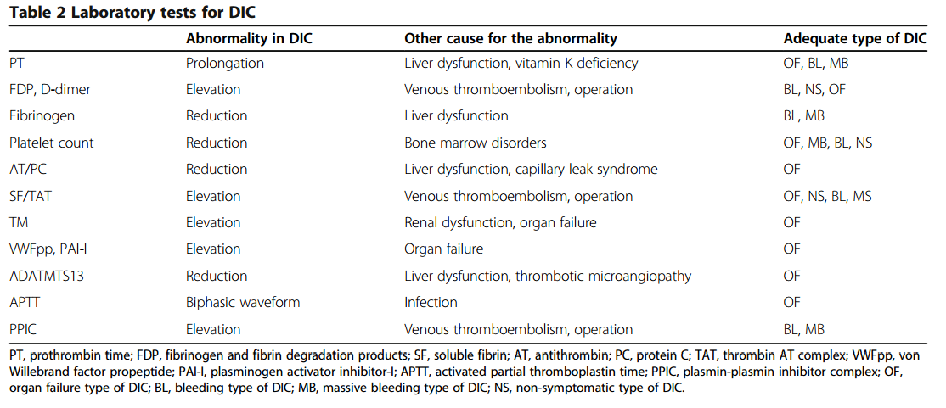
- Treatment
  - All guidelines recommend treatment of underlying condition, but no good evidence is available for this!
  - Blood-products
    - All four guidelines recommend transfusing with platelet concentrate and FFP for patients actively bleeding or subclinical who are about to undergo invasive procedures with no high-quality evidence
    - Threshold platelet count for platelet concentrate is ≦ 50k with active bleeding
    - Initial dose of FFP is recommended at 15ml/kg
  - Anticoagulants
    - Heparin (low-molecular weight heparin over unfractionated) is recommended for subclinical DIC and for organ failure type DIC (especially those with sepsis)
  - Anti-fibrinolytics
    - Recommended for the treatment of massive bleeding and bleeding subtypes
      - thrombosis is a known complication
    - Can help with trauma induced DIC if given early

