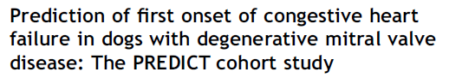
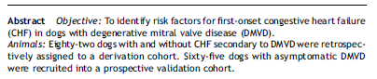
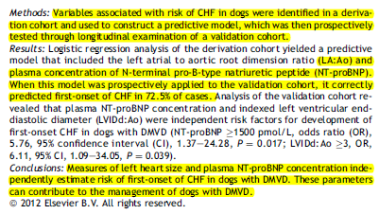

Retrospective part of study to develop model, then prospectively recruited patients
Independent, Non-echo risk factors for CHF were:
NT-proBNP >1500pmol/L
VHS >12
Echo risk factors were increased La:Ao >1.6, Increased LVIDd:Ao >3.0

