Efficacy of Benazepril Hydrochloride to Delay the Progression of Occult Dilated Cardiomyopathy in Doberman Pinschers

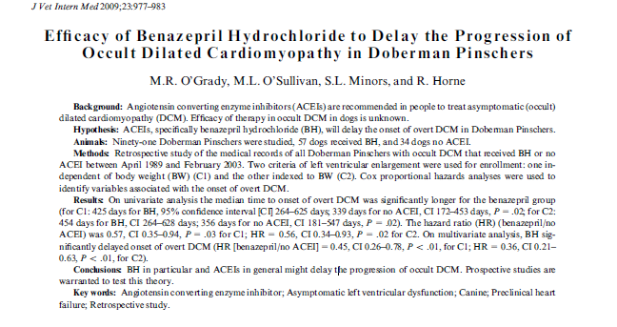

The American College of Cardiology and the American Heart Association guidelines recommend the use of ACEI therapy in people with asymptomatic LV dysfunction.

Retrospective study with Dobies that either got ACEI or no ACEI (could have gotten B-blockers, anti-arrhythmics, or thyroid supplements)
Dobies diagnosed with occult DCM via echo
No dogs that died prior to CHF were in study
91 Dobies; 57 in ACEI, 35 in no ACEI
Weight was only significant difference in groups
Average dose was 0.5mg/kg/day
Significant difference between groups in multi and univariate analysis with ACEI showing improvement in time to onset of CHF
The dogs that received benazapril had less likelihood of going into CHF or sudden death (not individually, but when those end-points were grouped together)
In general, ACEI group were dogs enrolled at a later date than other dogs, so maybe just an improvement in overall therapy.

