ARVC in Boxers
- Autosomal Dominant disease causing fatty or fibrofatty infiltrates in right (and sometimes left) ventricle
- ECG is best screening test
  - >100 VPCs or complex VPCs are strongly suggestive
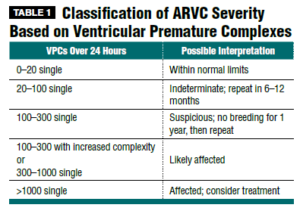
    - Complex VPCs meaning bigemony, triplets, couplets, v-tach
- Echo
  - Not the best diagnostic since changes are microscopic at first
  - Can be normal
  - Can show left ventricular dilation and systolic dysfunction
- MRI
  - Being looked into - not currently useful
- Histopath
  - Currently only for post-mortem in vet med
- Genetic testing
  - Commercially available via washington state
  - Not all dogs with mutation are affected (incomplete penetrance)
- Troponin-I
  - Higher in dogs with more VPCs
    - Overlap exists between healthy dogs and ARVC affected
Treatment
- Antiarrhythmics alone
  - If no CHF or systolic dysfunction
- Antiarrhythmics do not increase survival, but instead severity of symptoms
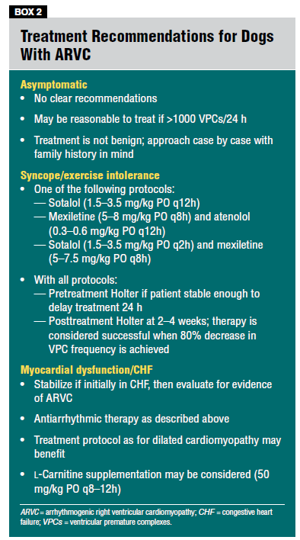
- Asymptomatic dogs
  - No treatment unless >1000 VPCs/24h or complex ventricular arrhythmias
- Syncope/Exercise intolerance
  - Sotalol
    - 1.5-3.5mg/kg PO Q12
  - OR Mexiletine 5-8mg/kg PO Q8h AND atenolol 0.3-0.6mg/kg PO Q12h
    - Better at decreasing VPCs, but not at reducing syncope
  - Recheck holter in 2-4 weeks
    - Looking for >80% decrease in VPCs
- Myocardial dysfunction or CHF
  - Supplement with L-carnitine
    - Can’t hurt, may help
  - Treat CHF
- Omega-3s may help
Prognosis
- Months-years without CHF or systolic dysfunction
  - Guarded with CHF

Questions:

- Mexiletine is a class IB anti-arrhyhtmic drug, meaning it exerts its antiarrhythmic action by ____________, resulting in a _________.
  - Sodium channel blocker; decreased excitability of myocardial cells
  - Calcium channel blocker; decreased excitability of myocardial cells
  - Sodium channel blocker; increased duration of repolarization phase of myocardial cells
  - Calcium channel blocker; increased duration of repolarization phase of myocardial cells
- ARVC in Boxers is a disease of the ______.
  - His-purkinje system
  - Interventricular septum
  - Myocardium
  - Sodium channels
- The goal of therapy for anti-arrhythmics in boxers with ARVC and no evidence of CHF or systolic dysfunction is:
  - A decrease in VPCs/24 hours by ½
  - A decrease in syncopal episodes per month
  - Prevention of complex ventricular arrhythmias
  - A decrease in VPCs/24 hours by >80%
- Which of the following treatments is considered sufficient standard of care for a boxer with ARVC and >1000 VPCs / 24 hour period
  - L-carnitine supplementation
  - Atenolol and mexiletine
  - Omega-3 fatty acid supplementation
  - Continued monitoring with Holters every 6 months without antiarrhythmic therapy
- True/False: Early treatment of ARVC in Boxers with antiarrhythmics, achieving a >80% reduction in VPCs over a 24 hours period and reduction of syncopal episodes improves prognosis

Answers
Questions:

- Mexiletine is a class IB anti-arrhyhtmic drug, meaning it exerts its antiarrhythmic action by ____________, resulting in a _________.
  - Sodium channel blocker; decreased excitability of myocardial cells
  - Calcium channel blocker; decreased excitability of myocardial cells
  - Sodium channel blocker; increased duration of repolarization phase of myocardial cells
  - Calcium channel blocker; increased duration of repolarization phase of myocardial cells
- ARVC in Boxers is a disease of the ______.
  - His-purkinje system
  - Interventricular septum
  - Myocardium
  - Sodium channels
- The goal of therapy for anti-arrhythmics in boxers with ARVC and no evidence of CHF or systolic dysfunction is:
  - A decrease in VPCs/24 hours by ½
  - A decrease in syncopal episodes per month
  - Prevention of complex ventricular arrhythmias
  - A decrease in VPCs/24 hours by >80%
- Which of the following treatments is considered sufficient standard of care for a boxer with ARVC and >1000 VPCs / 24 hour period
  - L-carnitine supplementation
  - Atenolol and mexiletine
  - Omega-3 fatty acid supplementation
  - Continued monitoring with Holters every 6 months without antiarrhythmic therapy
- True/False: Early treatment of ARVC in Boxers with antiarrhythmics, achieving a >80% reduction in VPCs over a 24 hours period and reduction of syncopal episodes improves prognosis

