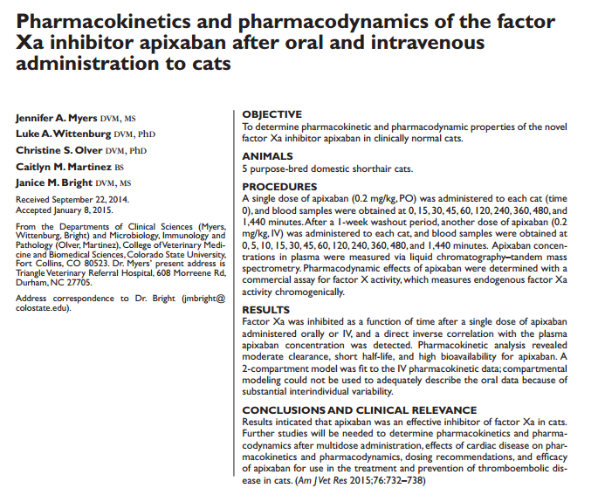
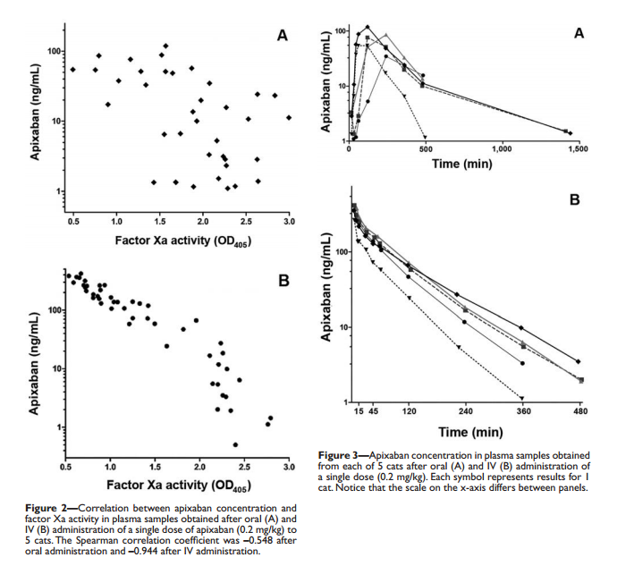
- Pharmacokinetics and pharmacodynamics of the factor Xa inhibitor apixaban after oral and intravenous administration to cats
  - Single dose apixaban (factor Xa inhibitor) effective in inhibiting Xa in cats
    - Half-life is short
      - 360 min
      - BID dosing would NOT provide constant inhibition
        - Possibly good, possible bad
    - Effects wear off with serum clearance
    - No adverse effects with single dose
    - Bioavailability is 85%

