Physiology, Pathophysiology, and Anesthetic Management of Patients with Respiratory Disease
Key Points:
1. 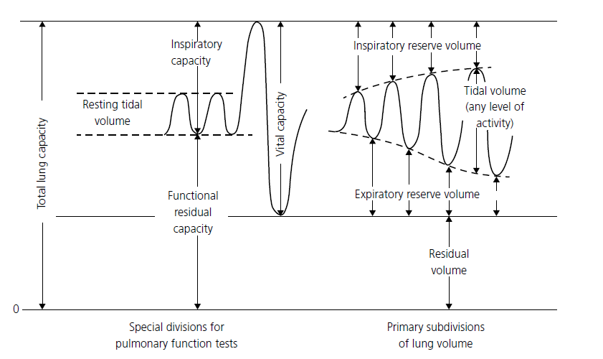
2. Dynamic C_{T} is the volume change divided by the transthoracic pressure change at the point of zero airflow
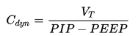
Static C_{T} is determined when the preceding inflow of air has been sufficiently slow for distribution throughout the lung
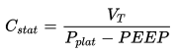
3. 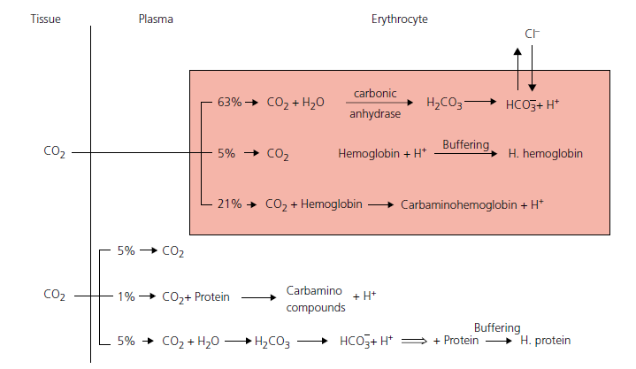
Questions:
1. Define the following

Tidal volume:

Residual volume:

Functional residual capacity:

Vital capacity:

2. Fill in the following
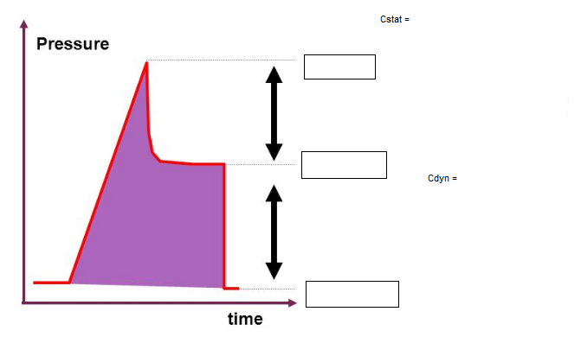

3. Draw the steps that lead to the chloride shift

- Respiration is the total process whereby oxygen is supplied to and used by body cells and CO2 is eliminated by means of gradients.
- Ventilation is the movement of gas in and out of alveoli.
- Tidal volume (VT) is the volume of air inspired or expired in one breath.
- Inspiratory reserve volume (IRV) is the volume of air that can be inspired over and above the normal tidal volume.
- Expiratory reserve volume (ERV) is the amount of air that can be expired by forceful expiration after a normal expiration.
- Residual volume (RV) is the air remaining in the lungs after the most forceful expiration

- Inspiratory capacity (IC) is the tidal volume plus the inspiratory reserve volume.
This is the amount of air that can be inhaled starting after a normal expiration and distending the lungs to the maximum amount.
- Functional residual capacity (FRC) is the expiratory reserve volume plus the residual volume.
This is the amount of air remaining in the lungs after a normal expiration. From a mechanical viewpoint, at FRC the inward ‘pull’ of the lungs due to their elasticity equals the outward ‘pull’ of the chest wall.
- Vital capacity (VC) is the inspiratory reserve volume plus the tidal volume plus the expiratory reserve volume. This is the maximum amount of air that can be expelled from the lungs after first filling them to their maximum capacity.
- Total lung capacity (TLC) is the inspiratory reserve volume plus the tidal volume plus the expiratory reserve volume plus the residual volume, or the maximum volume to which the lungs can be expanded with the greatest possible inspiratory effort (or by full inflation to 30 cmH2O airway pressure when a patient is anesthetized)
- 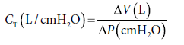
- Dynamic CT is the volume change divided by the transthoracic pressure change at the point of zero airflow (end inspiration) at a time when the previous inflow of air has been sufficiently rapid for dynamic factors to influence the distribution of air throughout the lung
- For practical purposes, dynamic CT is equal to the tidal volume divided by the peak airway pressure
- Static CT is determined when the preceding inflow of air has been sufficiently slow for distribution throughout the lung to be solely in accord with regional elasticity
- Under these conditions, gas distribution to alveoli with faster and slower filling rates is equivalent, and as a result the static CT (or CL) value is usually greater than dynamic CT (or CL).
- 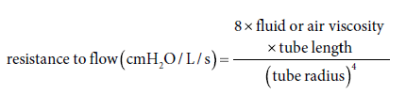
- Airway resistance increases with the rate of respiration and with narrowing of the airway by reflex contraction of the bronchiolar muscles, with small airway disease where there is edema of the airway wall and mucous accumulation, with a reduction in lung volume, or through aspiration of foreign material
- Non‐perfused alveoli do not contribute to gas exchange and constitute the alveolar deadspace
- Physiological deadspace (VD) includes VDanat and VDalv
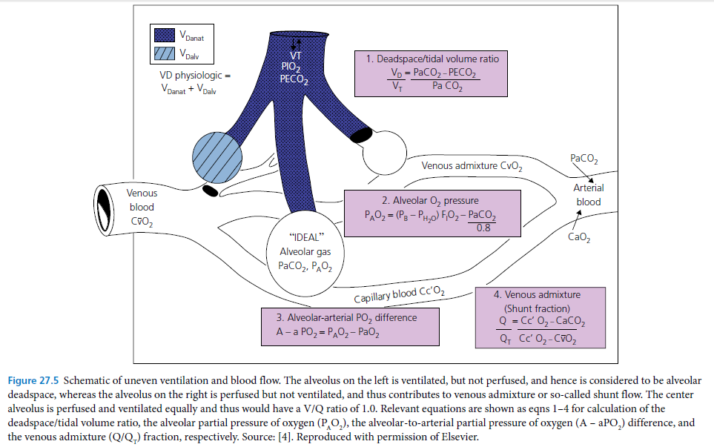
- Since CO2 is more diffusible across the alveolar capillary membrane, diffusion and V/Q problems commonly lead to decreased PaO2 levels before there is a change in PaCO2 levels
- For any given metabolic output, PaCO2 and VA are directly and inversely related: if VA falls by 50%, PaCO2 doubles; whereas, if VA is increased by 100% (say, by IPPV), PaCO2 levels will fall by 50% once equilibrium is established
- Elimination of CO2 depends on pulmonary blood flow (cardiac output) and VA
- R = VCO2/VO2
- In the plasma, some CO2 is transported in solution (5%), and some combines with water and forms carbonic acid, which in turn dissociates into bicarbonate and hydrogen ions (5%)
- Most (about 90%) of the CO2 diffuses into the red blood cells, where it is either bound to hemoglobin or transformed (reversibly) to bicarbonate and hydrogen ions through the action of the enzyme carbonic anhydrase
- The formation of bicarbonate in the red blood cells is accompanied by the chloride shift
- Release of CO2 in the lungs favors oxygen uptake (Bohr effect)
- Upon the release of oxygen, hemoglobin becomes a weaker acid and is more capable of accepting hydrogen ions, thereby facilitating its buffering effect (Haldane effect)
- Under normal conscious conditions, the nasal cavity, pharynx, and larynx are responsible for more than 50% of the total airway resistance to breathing
- The central chemoreceptors, located on the ventral surface of the medulla and bathed by cerebrospinal fluid, are exquisitely sensitive to changes in PaCO2 levels because CO2 is readily diffusible into cerebrospinal fluid and the central chemoreceptor cell
- The peripheral chemoreceptors, which are located in the carotid and aortic bodies, generally play a significant part in respiratory drive only when PaO2 levels fall below 60 mmHg
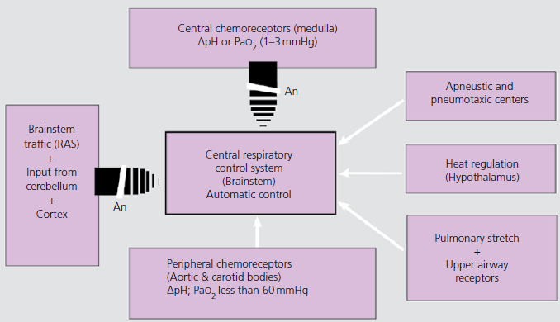
- In conscious animals, if regional ventilation is decreased, a local vasoconstriction [hypoxic pulmonary vasoconstriction (HPV)] tends to divert blood flow away from underventilated areas of the lung

