Recognizing and understanding ectopia
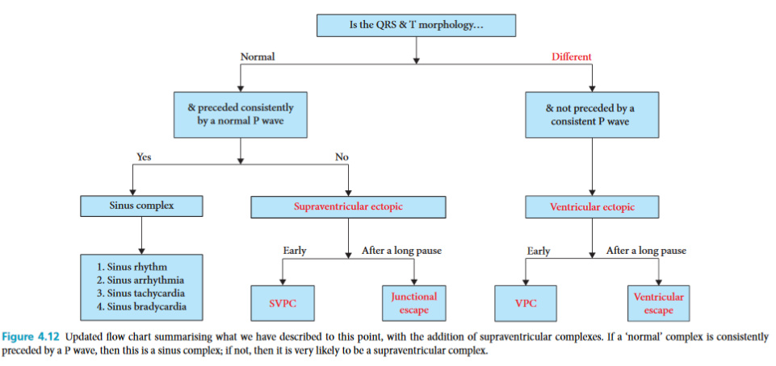

- When the QRST-T complex is a different shape than normal QRS-T for that animal, depolarization has almost certainly not arisen from the AV node, and therefore represents an ectopic beat
- These beats do not have a P wave, except by coincidence
- If there is a shorter R-R interval = PVC
- If there is a longer R-R interval = ventricular escape beat
- A supraventricular beat is a beat arising from above the AV node and NOT the SA node
- P waves of APCs are often buried in the T wave of the previous beat
  - When visible, they are usually different morphology than normal p waves for that animal
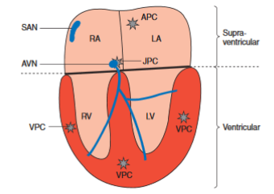

Questions:
- What type of complex is indicated by the black arrow?
  - Is there a compensatory pause after this complex?
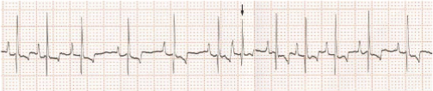
- What type of complex is indicated by the black arrow?
  - Is there a compensatory pause after this complex?
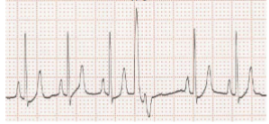

3) What determines whether a VPC appears as a positive or negative deflection in lead II?

Answers

- APC
  - No
- VPC
  - Yes
- Location of the ectopy - right vs left ventricle. Left ventrilcle will be a negative deflection, right ventricle will be a positive deflection

