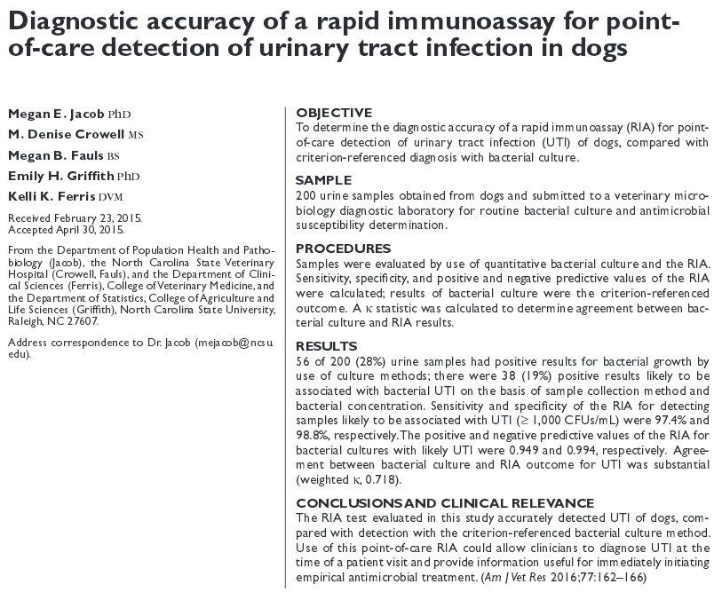
- Gram stain used in combination with a urine sedimentation examination was found to improve sensitivity and specificity, compared with results for urine sedimentation examination (urinalysis) alone.

- Test strip with 3 bands, control band, gram negative band (Escherichia coli, Klebsiella spp, Citrobacter spp, Enterobacter spp, and Serratias), gram indeterminate band (Proteus spp, Pseudomonas spp, Morganella spp, Providencia spp, Staphylococcus spp, Enterococcus spp, Actinomyces spp, and Actinobaculums).

- Sensitivity and specificity of the RIA for detecting any bacterial growth in urine samples was 71.7% and 100%, respectively

- Sensitivity of the RIA for detecting urine samples likely to be associated with UTI (collected via cystocentesis and yielded ≥ 1,000 CFUs/mL) was 97.4%, whereas specificity was 98.8%

