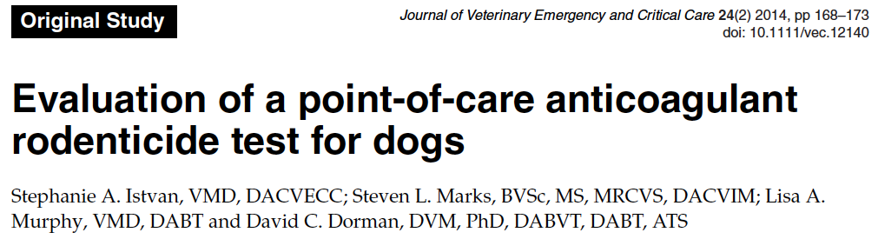

- A semiquantitative lateral flow assay for anticoagulant rodenticides developed for the detection of “super-rodenticides, warfarin, coumadin, and their derivatives” in serum or plasma was investigated
- Results: assay produced a consistently positive result with concentrations below the reported assay LOD for warfarin.
- No other anticoagulant rodenticide compound tested was recorded to be positive
- Test produced false-negative test results with serum samples spiked with brodifacoum, pindone, and chlorphacinone at >6 times higher than the manufacturer’s stated LOD

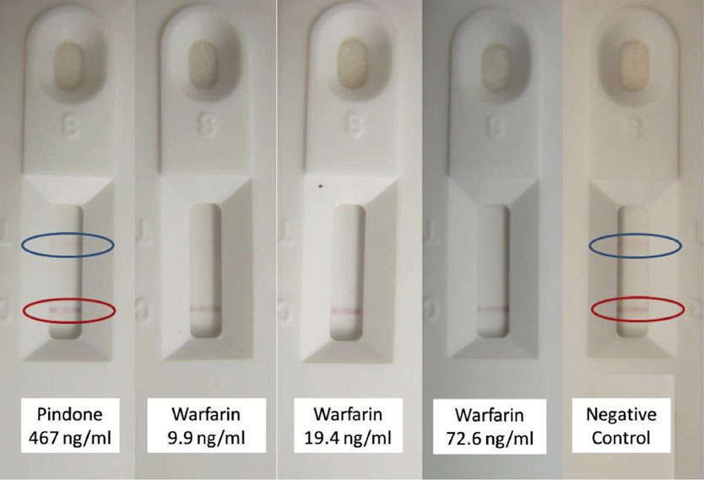

- Test interpretation: Absence of color band in the test line indicated a positive test.
- Test portion of membrane is coated with warfarin like particles and antibody to warfarin and its derivatives is conjugated to a detector particle binding to either the anticoagulant on the test line resulting in colorimetric reaction (if sample is negative) or to anticoagulant in the animal serum (if sample is positive) resulting in failure of colorimetric reaction at test line.

- Methods: Samples were collected from a single dog
- Spiked serum samples with the following concentrations were tested for each group: warfarin (10, 25, 75, 250 ng/mL), pindone (75, 250, 500 ng/mL), chlorphacinone (75, 250, 500 ng/mL), bromethalin (500 ng/mL), and desmethylbromethalin (500 ng/mL). Negative controls were also tested.

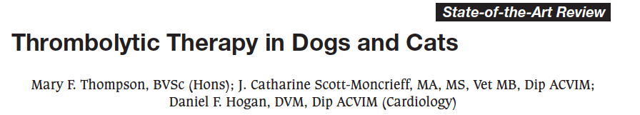

- Injured tissues and vascular endothelium respond to thrombus formation with slow release of tissue plasminogen activator (t-PA) which converts plasminogen into plasmin
- t-PA normally exists in low concentrations in the plasma
  - Secretion is controlled by physical and hormonal factors such as venous pressure and vasoactive substances including thrombin
- Single chain urokinase plasminogen activator (scu- PA) also exists in the plasma at a very low concentration and participates in natural thrombolysis
- The major circulating inhibitor of plasmin is α -2-antiplasmin or α -plasmin inhibitor, with α -2-macroglobulin contributing to this inhibition

Thrombolytic agents
(a) First generation: includes streptokinase (SK) and urokinase (UK). Lack fibrin specificity, which theoretically increases the risk of a secondary hypocoagulable state attributable to non-specific degradation of fibrinogen, factors V, VII, XII, and prothrombin

(b) Second generation: endogenous agents that possess some fibrin selectivity. Include tissue plasminogen activator (t-PA) and single chain urokinase plasminogen activator (scu-PA or pro-UK)

(c) Third generation: includes anisoylated plasminogen-streptokinase activator complex (APSAC). Possess enhanced properties that increase and prolong fibrin specificity activity

Streptokinase
- Does not directly convert plasminogen to plasmin
- Acts by binding to plasminogen in a 1:1 ratio, forming an active enzymatic complex capable of subsequent conversion of other plasminogen molecules to plasmin
- Also degrades coagulation factors including V, VIII, and prothrombin
- Recommendations in humans: myocardial infarction (MI), pulmonary embolism (PE), proximal deep vein thrombosis, acute peripheral artery thrombosis, and for recanalization of indwelling catheters and arteriovenous shunts

Urokinase
- Fibrin specific
- An important advantage of urokinase over streptokinase in humans is the lack of antigenicity - cannot be assumed in the dog and cat
- Definite recommendations in humans: acute myocardial infarction and pulmonary embolism.

t-PA
- Non antigenic in humans
- The mechanism of action involves formation of a complex between fibrin, t-PA, and plasminogen.
- t-PA is a weak activator of plasminogen in the absence of fibrin, but in the presence of fibrin produces a 500 to 1000 fold increase in activation
- Fibrin specificity of t-PA is relative, and when the dose of t-PA is increased to achieve effective thrombolysis, the risk of plasma proteolysis and excessive bleeding increases
- Recommendations in humans: acute myocardial infarction and acute pulmonary embolism.
- t-PA is less antigenic, does not induce hypotension, and is the preferred treatment for lysis of aged thrombi (vs streptokinase)

scu-Plasminogen activator
- Does not bind directly to fibrin
- Activates thrombus-associated LYS-plasminogen much more readily than the unbound GLU-plasminogen present in plasma.

Anisoylated Plasminogen-streptokinase Activator Complex
- Plasminogen component is capable of binding to fibrin. Once bound to fibrin, deacylation occurs and allows the complex to activate other plasminogen molecules without creating the systemic fibrinogenolysis characteristic of streptokinase
- Anisoylated plasminogen-streptokinase activator complex is significantly more fibrin specific than either urokinase or streptokinase but less so than t-PA

Human Data
PTE
- Patients with shock due to massive PTE - thrombolytic therapy reduces mortality, probably due to rapid restoration of pulmonary blood flow and improved right ventricular function
- Hemodynamically stable patients with PTE - thrombolysis has not been found to significantly reduce the mortality or risk of recurrent PTE with the exception of the subset of patients with evidence of right ventricular dysfunction.

ATE
- Streptokinase - Clearance of the affected artery is obtained in approximately 67% of cases of recent occlusion (less than 72 hours) treated by intensive and prolonged thrombolysis (up to 72 hours)

Heparin
- Because fibrinolytic agents do not prevent formation of a new thrombus, anticoagulant therapy with intravenous unfractionated heparin or subcutaneous low molecular weight heparin (LMWH) is generally recommended after fibrinolytic therapy in humans.
- Heparin accelerates the anticoagulant activity of antithrombin III, which decreases the tendency towards thrombus formation.
- Initiated 48 hours after thrombolytic therapy and continued for as long as there is predisposition to thrombosis

Veterinary medicine
- Streptokinase in dogs – Ramsey et al – treatment of ATE in 4 dogs with streptokinase.
Partial or complete resolution of clinical signs associated with the thrombosis was seen in all dogs.
Side effects: minor hemorrhage requiring no treatment other than cessation of streptokinase.
No signs related to antigenicity or reperfusion were reported.
- Streptokinase in cats
Killingsworth, et al investigated streptokinase therapy in seven cats with experimentally created aortic thrombosis
Both groups demonstrated minimal perfusion of the pelvic limbs with no improvement over the 180-minute treatment period.
Ramsey, et al – 8 cats with naturally occurring ATE. All of the cats died suddenly during maintenance streptokinase infusion. PM suggested that MI was cause of death in some of the cats.
Moore et al JVECC 2000, Retrospective study with 46 cats - Twenty-five (54%) of the cats had return of pulses within 22-24 hours of treatment, and 15 cats (33%) were ultimately discharged from the hospital. Eighteen cats died in the hospital and 13 were euthanatized due to poor response to treatment or complications. Eleven cats (24%) developed signs of clinical bleeding.

3. tPA in cats – Reported from CVT X
43% percent of cats with ATE survived therapy and were walking within 48 hours of presentation
50% of the cats died during therapy.
Of the cats that died: 70% died as a result of reperfusion injury (hyperkalemia and metabolic acidosis), 15% of congestive heart failure, and 15% of arrhythmia attributed to embolization of left atrial thrombi to coronary

- tPA in dogs – two older case studies, less consistent results

Adverse Effects of Thrombolysis
- Most predictable effect is hemorrhage
- Hypotension occurs in 10-15% of humans treated with streptokinase
- Allergic reactions (pruritis, rash, or fever) in 5% of humans
- The incidence of anaphylaxis is approximately 0.1% in humans
- Ab to streptokinase develop 5 days after treatment and persist for 6-12 months. Ab activity as not been determined in dogs or cats
- Reperfusion of ischemic myocardium associated with ventricular arrhythmias in humans
- Electrolyte and metabolic abnormalities secondary to reperfusion of large areas of muscle mass contribute to mortality in small animals treated with thrombolytic agents for ATE
  - Hyperkalemia and metabolic acidosis result when potassium and metabolic waste products such as lactate accumulate distal to thrombus and are released into systemic circulation

Potential veterinary uses
- The majority of veterinary experience with thrombolytic agents to date is treatment of ATE
  - Use of both streptokinase or t-PA in small numbers of dogs and cats.
  - hrombolytic therapy is efficacious for cats with ATE but associated with high mortality.
  - Thrombolysis for systemic thromboembolism has not been investigated
- JVECC 2009
  - Veterinary experience with thrombolytics to date is limited to anecdotal reports involving streptokinase, urokinase, and alteplase only.
  - Prospective clinical trials are needed to determine the safety and efficacy of these agents in veterinary patients. No consensus on their administration exists and the use of these drugs remains controversial.

Dosing
- Streptokinase (cats): 90,000 U IV over 30 minutes, followed by a maintenance dosage of 45,000 U/h IV for various intervals
- Streptokinase (dogs): recommended loading dose of 90,000 U (administered during a period of 20 to 30 minutes), followed by a maintenance rate of 45,000 U/h IV for 7-12 hours
- Currently, the small number of animals treated with varying protocols makes it impossible to provide safe and effective dose recommendations for t-PA.
- No dosage information available regarding the clinical use of urokinase, scu-PA and APSAC in small animals at this time

Questions

1. Match drugs with mechanism of action

Drug | Mechanism of Action
a. Desmopressin | 1. Potentiates AT’s anti-Xa activity
b. Streptokinase | 2. Lysine analogue, delay fibrinolysis by impairing plasminogen’s interaction with fibrin
c. Aspirin | 3. Analogue of arginine vasopressin, increases plasma vWf concentration
d. Unfractionated heparin | 4. Binds to AT facilitating inhibition of IIa, Xa, IXa. Reduces thrombin catalyzed activation of V and VII
e. EACA | 5. Fibrinolytic drug. Plasminogen activator.
f. Fondaparinux | 6. Thienopyridine, inhibition of ADP receptor to decrease platelet aggregation
g. Clopidigrel | 7. Irreversable acetylation of COX preventing formation od TXA2

- What is the risk of administering Vit K via IV and IM route?

3. Name three differences between unfractionated heparin and LMWH

4. Thrombolytic therapy in cats (with plasminogen activators) can lead to
- metabolic acidosis, hyperkalemia
- metabolic acidosis, hypokalemia
- metabolic alkalosis, hyperkalemia
- metabolic alkalosis, hypokalemia

5. Dose regimens have been provided for ________________ in dogs and cats.
a. tPA
b. Streptokinase
c. Urokinase
d. scu-PA

Answers

1. Match drugs with mechanism of action
A:
Desmopressin – 3. Analogue of arginine vasopressin, increases plasma vWf concentration
EACA – 2. Lysine analogue, delay fibrinolysis by impairing plasminogen’s interaction with fibrin
Aspirin – 7. Irreversable acetylation of COX preventing formation od TXA2
Clopidigrel – 6. Thienopyridine, inhibition of ADP receptor to decrease platelet aggregation
Unfractionated heparin – 4. Binds to AT facilitating inhibition of IIa, Xa, IXa. Reduces thrombin catalyzed activation of V and VII
Fondaparinux – 1. Potentiates AT’s anti-Xa activity
Streptokinase – 5. Fibrinolytic drug. Plasminogen activator.

Drug | Mechanism of Action
a. Desmopressin | 1. Potentiates AT’s anti-Xa activity
b. Streptokinase | 2. Lysine analogue, delay fibrinolysis by impairing plasminogen’s interaction with fibrin
c. Aspirin | 3. Analogue of arginine vasopressin, increases plasma vWf concentration
d. Unfractionated heparin | 4. Binds to AT facilitating inhibition of IIa, Xa, IXa. Reduces thrombin catalyzed activation of V and VII
e. EACA | 5. Fibrinolytic drug. Plasminogen activator.
f. Fondaparinux | 6. Thienopyridine, inhibition of ADP receptor to decrease platelet aggregation
g. Clopidigrel | 7. Irreversable acetylation of COX preventing formation od TXA2

2. What is the risk of administering Vit K via IV and IM route?
A: Anaphylaxis, hematoma

3. Name three differences between unfractionated heparin and LMWH
A:
- Size 15000Da (UH) vs 4-5000Da (LMWH)
- Due to smaller size have higher bioavailability and longer plasma half life than UH
- Inhibit factor II to a much lesser degree than Xa
- Do not prolong aPTT like heparin at therapeutic levels

4. Thrombolytic therapy in cats (with plasminogen activators) can lead to
- metabolic acidosis, hyperkalemic
- metabolic acidosis, hypokalemia
- metabolic alkalosis, hyperkalemia
- metabolic alkalosis, hypokalemia

5. Dose regimens has been provided for ________________ in dogs and cats.
a. tPA
b. Streptokinase
c. Urokinase
d. scu-PA

