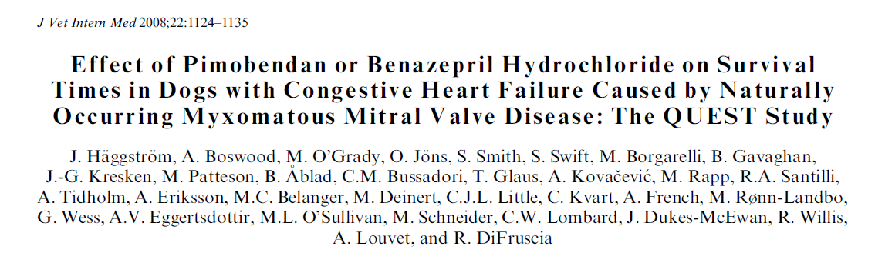

Hypothesis: Pimobendan in addition to conventional therapy will extend time to sudden cardiac death, euthanasia for cardiac reasons, or treatment failure when compared with conventional therapy plus benazepril in dogs with congestive heart failure (CHF) attributable to MMVD
Animals: Two hundred and sixty client-owned dogs in CHF caused by MMVD were recruited from 28 centers in Europe, Canada, and Australia.
Methods: A prospective single-blinded study with dogs randomized to PO receive pimobendan (0.4–0.6 mg/kg/d) or benazepril hydrochloride (0.25–1.0 mg/kg/d). The primary endpoint was a composite of cardiac death, euthanized for heart failure, or treatment failure.
- One hundred and twenty-four dogs were randomized to pimobendan and 128 to benazepril
- One hundred and ninety dogs reached the primary endpoint; the median time was 188 days (267 days for
- pimobendan, 140 days for benazepril hazard ratio 5 0.688, 95% confidence limits [CL] 5 0.516–0.916, P 5 .0099)
- The benefit of pimobendan persisted after adjusting for all baseline variables
- A longer time to reach the endpoint was also associated with being a Cavalier King Charles Spaniel, requiring a lower furosemide dose, and having a higher creatinine concentration
- Increases in several indicators of cardiac enlargement (left atrial to aortic root ratio, vertebral heart scale, and percentage increase in left ventricular internal diameter in systole) were associated with a shorter time to endpoint, as was a worse tolerance for exercise
Conclusions and Clinical Importance: Pimobendan plus conventional therapy prolongs time to sudden death, euthanasia for cardiac reasons, or treatment failure in dogs with CHF caused by MMVD compared with benazepril plus conventional therapy
Key points:
1. Pimobendan plus conventional therapy prolongs time to sudden death, euthanasia for cardiac reasons, or treatment failure in dogs with CHF caused by MMVD compared with benazepril plus conventional therapy
2. Application to real life is more challenging as ACEi are standard therapy and there should be a group with both treatments.
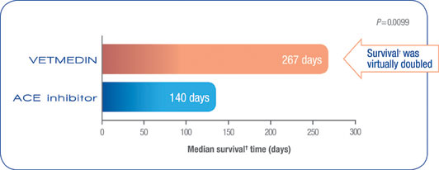
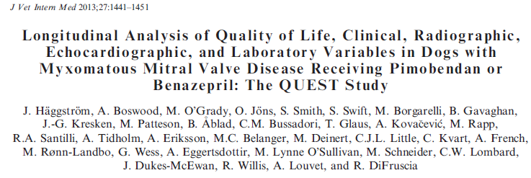
Objectives: To compare, throughout the period of follow-up of dogs that had not yet reached the primary endpoint, the longitudinal effects of pimobendan versus benazepril hydrochloride treatment on quality-of-life (QoL) variables, concomitant congestive heart failure (CHF) treatment, and other outcome variables in dogs suffering from CHF secondary to MMVD.
Results:
- No difference was found between groups in QoL variables during the trial.
- Time from inclusion to 1st intensification of CHF treatment was longer in the pimobendan group (pimobendan 98 days, IQR 30–276 days versus benazepril 59 days, IQR 11–121 days; P = .0005)
- Post inclusion, dogs in the pimobendan group had smaller heart size based on VHS score (P = .013) and left ventricular diastolic (P = .035) and systolic (P = .0044) dimensions, higher body temperature (P = .030), serum sodium (P = .0027), and total protein (P = .0003) concentrations, and packed cell volume (P = .030)
- Incidence of arrhythmias was similar in treatment groups
Key Points:
1. Pimobendan versus benazepril resulted in similar QoL during the study, but conferred increased time before intensification of CHF treatment
2. Pimobendan treatment resulted in smaller heart size, higher body temperature, and less retention of free water
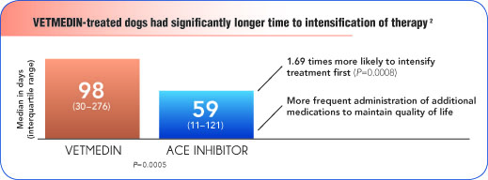
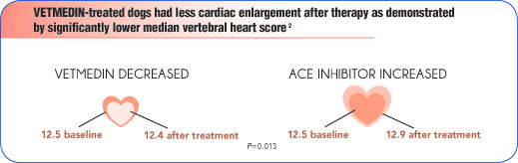
Questions:
1. Do these papers change how you treat heart failure?

2. Are these results applicable to other cardiovascular diseases?

3. Explain the physiology of how Pimobendan may help in cases of MMVD.

