Proper Ventilator Setup and Monitoring
Summary
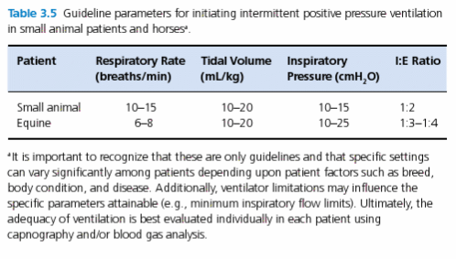
- There are a variety of anesthesia ventilator models available, training for each machine is required

Proper Ventilator Setup and Monitoring
- Make sure it is plugged in
- Connect scavenge hose from the ventilator to a scavenge system, may have 2 scavenging systems, one to the ventilator and one for the anesthetic machine
- Empty reservoir bag into the scavenge system, remove the reservoir bag and connect the ventilator breathing hose to the reservoir bag mount. Close the APL valve. Some machines with built in ventilators do not require removal of the reservoir bag and closure of the valve, instead a switch or dial is used to isolate the reservoir bag and APL from the ventilator
- Allow the bellow to fill, this can be helped out by momentarily increasing the fresh gas flow rate. The flush valve should not be used for this purpose unless the fresh gas flow cannot be suitably increased to fill the bellows in a relatively rapid fashion (large animal vent)
- Initiate ventilation based on the predetermined ventilation parameters. Monitor peak airway pressures and other monitored parameters (ETCO2, ABG, arterial BP)

Selected Ventilator Models
- Drager Small animal Ventilator (SAV)
- Engler ADS 100 and 2000 Veterinary Anesthesia Delivery System and Critical Care Ventilator
- Hallowell EMC 2000 and 2002 and Matrx 3000 Anesthesia Ventilator
- Mallard Medical Model 2400V Anesthesia Ventilator
- Ohio V5A Ventilator
- Ohmeda 7000 and 7800 Series Electronic Anesthesia Ventilator
- Surgivet SAV 2500
- Vetronics Merlin Small Animal Ventilator

Respiratory Assist Devices
- Manual Resuscitators – Ambu bags
- Demand Valves
  - Used to deliver intermittent positive pressure ventilation
  - Set to deliver O2 when the patient begins to inspire (creating slight negative pressure activating gas delivery) until exhalation starts or until a certain preset pressure is reached
  - Expiration is passive through the valve, may be restrictive in large patients
  - Attached to endotracheal tube

