Physiology, Pathophysiology and Anesthetic Management of Patients with Hepatic Disease

Key Points:
- The liver can be divided into four main lobes (left, right, quadrate, and caudate lobes)
The right and left lobes may be further subdivided into separate lateral and medial lobes
In some species the bile duct terminates directly on the duodenum (e.g., canine),in others it shares a common duct with the pancreas (e.g., cat)
Blood returning from most of the gastrointestinal tract and spleen travels through the portal vein
A second blood supply is from the hepatic artery, which delivers highly oxygenated blood to help sustain hepatocellular function

- Albumin production is regulated (via feedback) in part through plasma oncotic pressure in addition to its plasma concentration
Each hepatocyte has an osmoreceptors
- Xenobiotic biotransformation can be divided into Phase I ( oxidation, reduction, or hydrolysis) and Phase II (conjugation) reactions
Phase II reactions are responsible for conferring further hydrophilicity to a drug, facilitating its excretion

Questions:
1. Label the following diagram (view if in the abdomen and looking underneath towards the head)
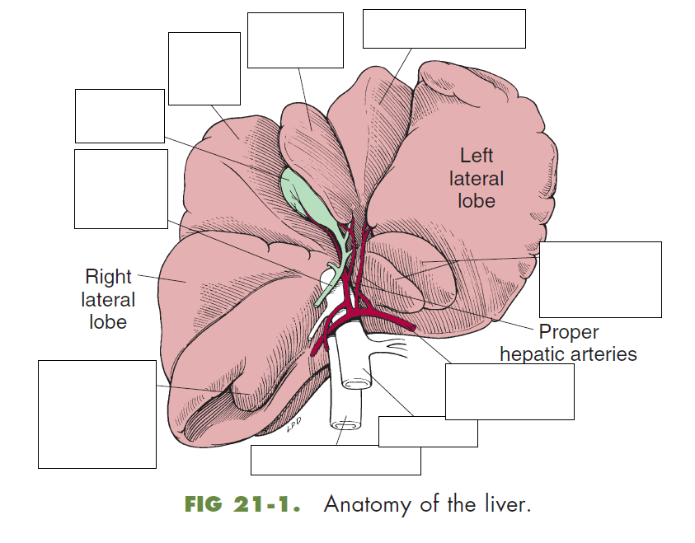
2. Name the 3 ways that biotransformation occurs in Phase 1 in the liver
3. Oxidation is largely a function of the _____________________ system, which is part of the non-specific mixed function oxidase system in the endoplasmic reticulum.

4. Describe what happens in the liver when there is decreased serum albumin

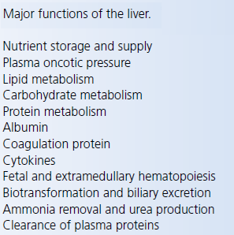
- The liver can be divided into four main lobes (left, right, quadrate, and caudate lobes)
- The right and left lobes may be further subdivided into separate lateral and medial lobes
- In some species the bile duct terminates directly on the duodenum (e.g., canine)
- In others it shares a common duct with the pancreas (e.g., cat)
- Blood returning from most of the gastrointestinal tract and spleen travels through the portal vein
- The portal circulation supplies the majority of blood flow to the liver
- A second blood supply is from the hepatic artery, which delivers highly oxygenated blood to help sustain hepatocellular function
- Albumin production is regulated (via feedback) in part through plasma oncotic pressure in addition to its plasma concentration
- Several coagulation factors, such as fibrinogen, prothrombin, factors V, VII, IX, X, XI, XII, and XIII, prekallikrein, and high molecular weight kininogen are synthesized or activated by the liver
- The liver is also responsible for the synthesis of proteins that modulate coagulation, such as, plasminogen, plasminogen activator inhibitor‐1, α2‐antiplasmin, antithrombin, and proteins C and S
- It performs vitamin K dependent carboxylation of prothrombin, factor VII, IX, and X, and proteins C and S
- Xenobiotic biotransformation can be divided into Phase I ( oxidation, reduction, or hydrolysis) and Phase II (conjugation) reactions
- Phase II reactions are responsible for conferring further hydrophilicity to a drug, facilitating its excretion
- The liver has a large role in host defense, bacteria and toxins that gain access to the portal circulation are routinely phagocytized and processed by Kupffer cells in the sinusoids
- Mechanisms of hypoglycemia in hepatic dysfunction include one or a combination of the following: decreased gluconeogenesis, decreased glycogen storage, and diminished response to glucagon
- A decrease in systemic vascular resistance could possibly translate into a decrease in hepatic blood flow and subsequently decreased drug elimination capacity or further hepatic insult
- In the absence of HE, benzodiazepines can be used safely in patients with liver disease, although hepatic elimination is likely reduced and prolonged effects may occur
- Hepatic blood flow is unchanged in normal dogs after intravenous administration of up to 10 μg/kg, based on the radioactive microsphere method
- Propofol has been shown to maintain hepatic blood flow via arterial vasodilation in dogs and thiopental appears to have similar effects
- Etomidate is in a propylene glycol‐based vehicle.
- Propylene glycol is a hyperosmolar molecule and may cause erythrocyte rupture, because some patients presenting with hepatobiliary disease may have bilirubinemia and icterus due to biliary obstruction or decreased hepatic conjugation, the potential hemolysis caused by etomidate could further overload the liver
- Dissociative anesthetics such as ketamine are reasonable choices for the induction of anesthesia in patients with hepatic disease
- Inhalant anesthetics alter hepatic blood flow in a dose‐dependent fashion
- Isoflurane in a lipid emulsion was demonstrated to have a protective effect on hepatic ischemic/reperfusion (IR) injury when injected intravenously into rats
- The mechanism for such protection seemed to be related to Kupffer cell inhibition
- The disposition of neuromuscular blocking drugs (NMBs) may be affected by liver disease
- Vecuronium, rocuronium, and mivacurium all have increased volumes of distribution, prolonged elimination half‐lives, and prolonged durations of effect in human patients with hepatic cirrhosis
- Atracurium and cis‐atracurium undergo liver‐independent elimination (by non‐specific ester hydrolysis or Hofmann elimination) and have similar pharmacokinetics and pharmacodynamics in both healthy and liver‐diseased patients
- Opioids are the mainstay of analgesia in the perioperative period
- In humans, morphine can cause spasm of the common bile duct by constriction of the sphincter of Oddi, which increases the size and pressure in the gall bladder
- All NSAIDs have the potential to cause hepatic injury, either intrinsically (as is usually the case with aspirin and acetaminophen) or idiosyncratically (as tends to be the case with other NSAIDs, including the COX‐2 selective agents)
Answers
1. 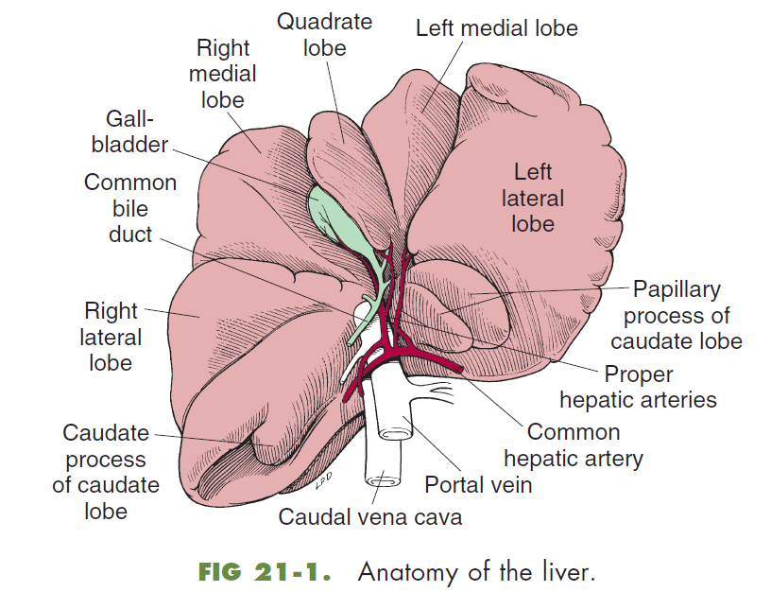
2. Phase I ( oxidation, reduction, or hydrolysis)
3. Oxidation is largely a function of the cytochrome P450 system, which is part of the non-specific mixed function oxidase system in the endoplasmic reticulum.

