Pharmacology of Anesthetic and Analgesic Drugs

Definitions
- Receptor: component of a cell, usually a protein or glycoprotein, which interacts with the signaling messenger substance
- Ligand: signaling messenger substance (hormones or drugs)
- Action of a drug: initial pharmacological effect of the combination of a ligand with receptor
- Effect of a drug: succeeding effects of a drug
- Affinity of a drug: affinity of the ligand for a receptor, high affinity does not mean high activity
- Activity of a drug: ability of a ligand to produce an action
- Selectivity of a ligand: capacity of a ligand to produce a particular effect, highly selective ligands will produce 1 effect through activity at only 1 class of receptor
- Specificity of a ligand: capacity of a ligand to associate with 1 specific type of receptor, which may have several effects
- Receptor agonist: ligand binds to the receptor and activates it as an endogenous molecule would
  - Full agonist: fully activates the receptor
  - Partial agonist: does not fully activate the receptor – less intense maximum effect
- Neutral antagonist: ligand will bind to the receptor but will be unable to activate it
- Reverse agonist: ligand that will activate the receptor but produce the opposite effect to the agonist ligand

Receptor Structure
- Na+ Ion Channel
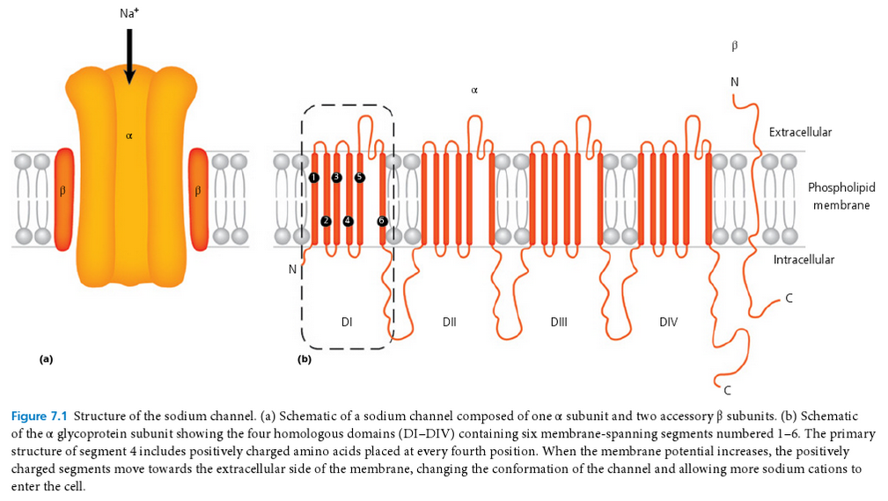
- GABA Receptors
    - Activated by γ-aminobutyric acid (GABA)
    - GABA_{A} (fast response) receptors are anion channels
      - Ligand-gated anion channel allow passage Cl anions into cell
      - Activation leads to hyperpolarization – inhibits subsequent depolarization – reduces CNS activity
      - ie: Barbiturates, benzodiazepines, propofol, etomidate, alfaxalone, inhalant anesthetics, ethanol, etc
    - GABA_{B} (slow response) receptors are G-protein-coupled receptors
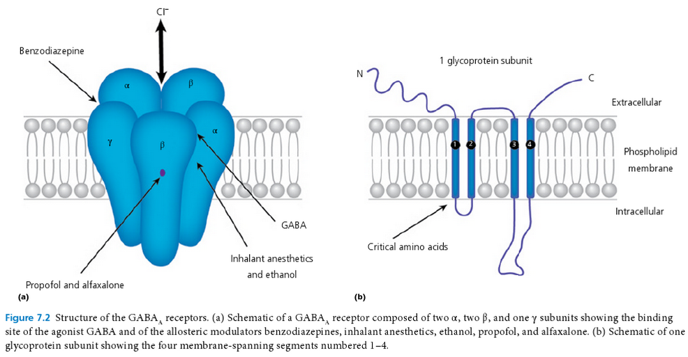

- AMPA and NMDA Receptors
    - Both cation channels on the same postsynaptic mb
    - AMPA Receptor
      - Endogenous agonist is glutamate
      - Ligand-gated ionotropic receptor
      - Allows entry of Na+ into cells and exit of K+
    - NMDA Receptor
      - Endogenous agonist is glutamate and aspartate, glycine is needed as a co-agonist to open the channel efficiently
      - Ligand-gated and voltage-gated ionotropic receptor
      - Allows entry of Na+ and Ca+ and exit of K+
      - A molecule of Mg²⁺ keeps channel closed until a strong enough depolarization of the postsynaptic mb occurs
      - ie: amantadine, gabapentin, ketamine, ethanol, xenon, nitrous oxide some opioids (tramadol, methadone) – NMDA antagonists
      - Mg, Na, Ca, K, Zn, Cu are modulators of NMDA receptors
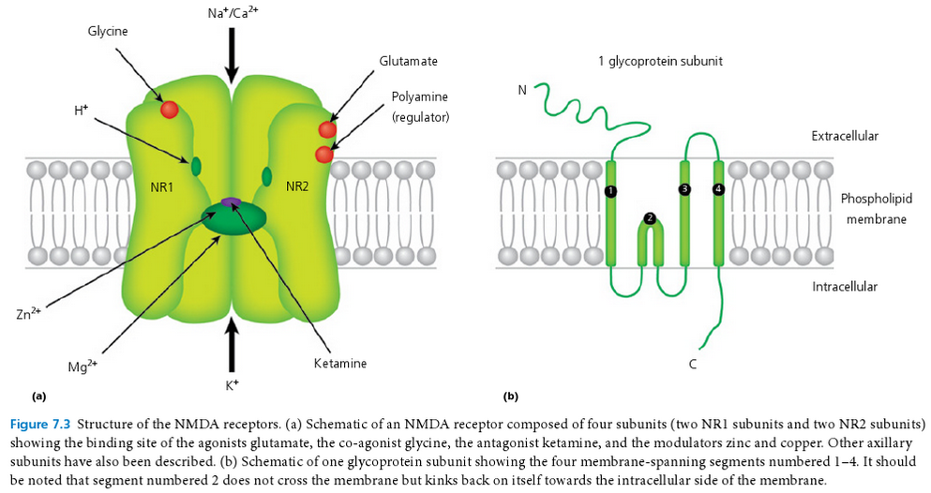

- G-Protein Receptors-second messengers
    - To transduce extracellular signals, some transmembrane receptors use intermediaries such as guanine nucleotide-binding proteins (G-proteins)
    - Guanosine triphosphate (GTP) supplies the energy required by G-protein receptors
    - ie: β-adrenergic receptors
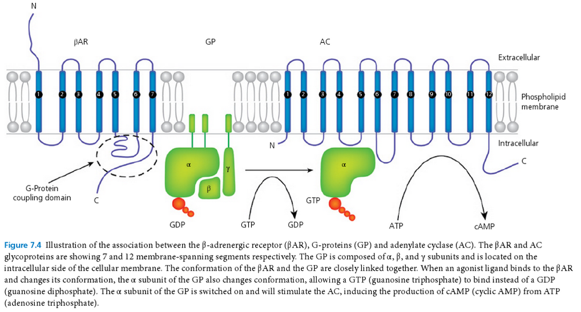

Clinical Evaluation of Drug Effects
- Maximum Efficacy: maximal pharmacological effect of a drug or a ligand, this is directly proportional to the percentage of activated receptors
- Potency: concentration of drug needed to obtain a pharmacological effect equal to 50% of the maximal effect (EC₅₀), the lower the EC₅₀, the < drug needed to achieve
- Concentration-response relationship: the effect as a function of the ligand concentration
- Effective dose (ED₅₀): dose of drug necessary to induced desired effect in 50% of animals
- Lethal dose (LD₅₀): dose of drug necessary to induce death in 50% of animals
- Toxic dose (TD₅₀): dose of drug necessary to induce toxic effects in 50% of animals
- Therapeutic index: ratio LD₅₀:ED₅₀ or TD₅₀:ED₅₀, the higher the therapeutic index, the safer the drug
Pharmacokinetics and Pharmacodynamics
- Pharmacokinetics: body’s action on the drug (Absorption, Distribution, Metabolism, Excretion)
- Pharmacodynamics: drug’s action on the body
- Half-life of Elimination: time needed for the plasma concentration of a drug to be reduced to 50% of its initial value, affected by:
  - Metabolism: affected by species, age, gender, weight, disease state (renal vs hepatic), drug interactions
  - Elimination: affected by disease state (renal vs hepatic)
- Apparent Volume of Distribution V_{d}: represents the degree to which a drug is distributed in body tissue rather than the plasma, V_{d} is directly correlated with the amount of drug distributed into tissue; a higher V_{d} indicates a greater amount of tissue distribution, measured in L/kg
  - V_{c}: Volume of central compartment – used to calculate loading doses for fast acting or toxic drugs
  - V_{dss}: Volume of distribution at steady state – used to calculate CRI or repeated analgesic dosing regimens
  - Factors affecting V_{d}:
    - Hydration status
    - Age and gender
    - Weight
    - Body composition (fat, muscle, water ratios)
    - Protein content of serum, especially protein bound drugs
    - Presence of plasma expanders such as lipids after a meal
    - Drug interactions (especially due to competition for binding sites)
- Total Body Clearance: volume of blood from which drug is completely removed per unit of time often normalized by weight (mL/min/kg or L/hr/kg), clearance can be understood as a function of V_{d} and concentration of the drug present in the sample space. Total body clearance is the sum of clearance by all mechanisms (renal, hepatic, lungs, other)
  - Extraction ratio: fraction of drug removed from the blood on each pass of the blood through the clearing organ
  - Hepatic clearance: estimated from the hepatic blood flow and the concentration differences between the drug in the hepatic blood inflow and outflow
  - Renal clearance: defines the relationship between the rate of change of the amount of drug in the urine and the plasma drug concentration, achieved by the summation of renal filtration and active tubular secretion
- Absorption: when drugs are administered through non-IV routes, the rate of absorption across mbs is proportional to the difference in concentration across the mb, area of the mb and its permeability to the drug
- Bioavailability: fraction of the dose given that finds its way into the systemic circulation

Questions
- T or F: V_{d} of fentanyl will be increased in a protein-losing nephropathy patient

- T or F: Decreased cardiac output will decrease hepatic clearance of drugs

- T or F: Absorption of an IM drug can be increased by injecting aliquots in separate sites

Answers
- T or F: V_{d} of fentanyl will be increased in a protein-losing nephropathy patient

- T or F: Decreased cardiac output will decrease hepatic clearance of drugs

- T or F: Absorption of an IM drug can be increased by injecting aliquots in separate sites

