Pericardial diseases
- A small amount (approximately 0.25 ml/kg body weight) of clear, serous fluid normally serves as a lubricant between the visceral pericardium (epicardium), which is directly adhered to the heart, and the outer fibrous, parietal pericardial layer
- Most pericardial effusions in dogs are serosanguineous or sanguineous, The fluid usually appears dark red, with a packed cell volume more than 7%
- Hemangiosarcoma (HSA) is by far the most common neoplasm causing hemorrhagic pericardial effusion in dogs; it is rare in cats
- Most HSAs arise in the right atrium or right auricle, but some also infiltrate the ventricular wall
- The most common heart base tumor is the chemodectoma (aortic body tumor), which arises from chemoreceptor cells at the base of the aorta
- Hemorrhagic pericardial effusion also can occur with pericardial mesothelioma, malignant histiocytosis, some cases of cardiac lymphoma, and occasionally with metastatic carcinoma
- Idiopathic pericardial effusion is also a relatively common cause of canine hemorrhagic pericardial effusion
- Its cause is still unknown; however, mild pericardial inflammation, with diffuse or perivascular fibrosis and focal hemorrhage, are common histopathologic findings
- Transudative effusions can develop with congestive heart failure (CHF), hypoalbuminemia, congenital pericardial malformations, and toxemias that increase vascular permeability (including uremia), these conditions usually are associated with relatively small-volume pericardial effusion, and cardiac tamponade is rare
- Cardiac tamponade develops when intrapericardial pressure rises toward and exceeds normal cardiac diastolic pressures
- Cardiac tamponade also causes an exaggerated respiratory variation in arterial blood pressure known as pulsus paradoxus. Inspiration normally lowers intrapericardial and right atrial pressures slightly, which enhances right-sided heart filling and pulmonary blood flow. Left-sided heart filling diminishes as more blood is held in the lungs and the inspiratory increase in right ventricular filling pushes the interventricular septum leftward. Thus left-ventricular output and systemic arterial pressure normally decrease slightly during inspiration. Pulsus paradoxus is an exaggeration of this normal pressure difference with respirations; patients with pulsus paradoxus exhibit a fall in arterial pressure during inspiration of 10 mm Hg or more

- Echo is highly sensitive for detection PCE
- DH view on AFAST has been shown to be useful in detecting PCE (Lisciandro JVECC 2016)
- Visualization of structures at the heart base and mass lesions is usually better before pericardiocentesis is performed
- Circulating cardiac troponin (cTn) concentrations or enzyme activities may be increased as a result of ischemia or myocardial invasion
- Elevated plasma cTnI concentrations have been documented in dogs with cardiac HAS
- Dogs with idiopathic pericardial effusion are initially treated conservatively by pericardiocentesis. After excluding an infectious cause by pericardial fluid culture or cytologic analysis, a glucocorticoid is often used (e.g., oral prednisone, 1 mg/kg/day, tapered over 2 to 4 weeks)
- Recurrent effusion that does not respond to repeated pericardiocenteses and antiinflammatory therapy is usually treated by subtotal pericardiectomy
- The less invasive techniques of thoracoscopic partial pericardiectomy or percutaneous balloon pericardiotomy are also used successfully to treat idiopathic and some cases of neoplastic pericardial effusion
- Chemotherapy has allowed survival times of 4 to 8 months in some dogs with atrial HSA

Questions:

- Name the three most important physical exam findings that lead to the investigation of pericardial effusion.

- Diagnosis?
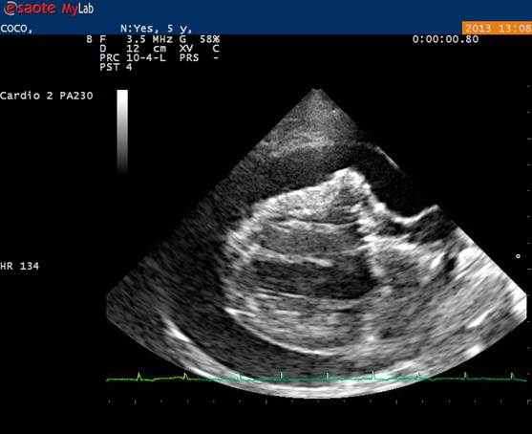

- Explain the physiology behind pulsus paradoxus in pericardial effusion

Answers
- Tachycardia, muffled heart sounds, poor peripheral pulses
- Pericardial effusion with right atrial tamponade
- Cardiac tamponade also causes an exaggerated respiratory variation in arterial blood pressure known as pulsus paradoxus. Inspiration normally lowers intrapericardial and right atrial pressures slightly, which enhances right-sided heart filling and pulmonary blood flow. Left-sided heart filling diminishes as more blood is held in the lungs and the inspiratory increase in right ventricular filling pushes the interventricular septum leftward. Thus left-ventricular output and systemic arterial pressure normally decrease slightly during inspiration. Pulsus paradoxus is an exaggeration of this normal pressure difference with respirations; patients with pulsus paradoxus exhibit a fall in arterial pressure during inspiration of 10 mm Hg or more

