Pemphigus

ETIOLOGY
- Affects the epidermis
  - Primarily composed of keratinocytes
  - Desmosomes: keratinocyte cell to cell adhesions
  - Hemidesmosomes: basilar keratinocyte to basement membrane adhesions
- Occurs when autoantibodies target desmosomes
  - Separation of the keratinocytes: acantholysis
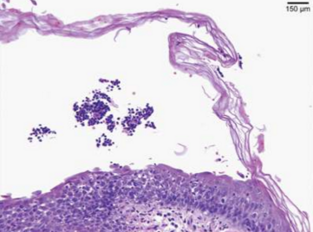
    - Acantholytic keratinocytes
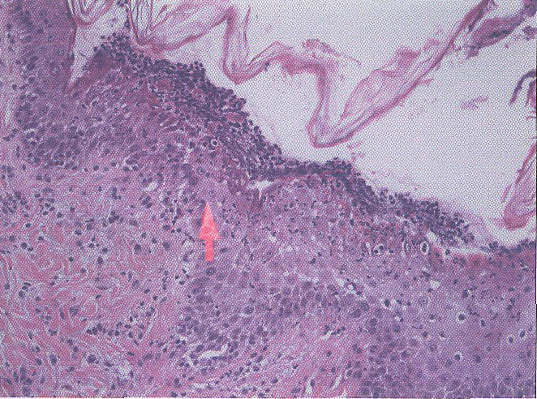
- “pemphigus”: entire group of autoimmune blistering diseases in which intradermal separation occurs via acantholysis
  - Superficial pemphigus
    - Foliaceus, erythematosus
    - Vesicles and pustules
  - Deep pemphigus
    - Paraneoplastic, vulgaris, bullous pemphigoid
    - Large blisters, ulcers
- Desmosomal antigens targeted:
  - Desmoglein 1 (Dsg1): PF
  - Dsg3: PV
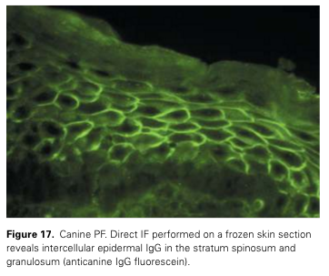
  - Dsg1 and Dsg3: PV with mucosal involvement
  - Likely a huge oversimplification….unclear at this time as huge variations exist between reports
- Drug-triggered or induced?
  - Seems to be well documented…
- Thought that some cases develop secondary to chronic, allergic skin disease

SIGNAMLENT
- Akita, Chows (PF)
  - +/- Bearded collie, Newfoundland, Schipperke, Doberman and Finnish Spitz, Dachshund, English cocker spaniels, Shar peis, collies
- Genetic basis?
  - One report of littermates with PF at 6mo of age
  - Akitas and Chows have closely related genotypes and are in close phylogenetic linkage
- Sex pre-disposition is not evident
- Age of onset of canine PF was very variable
  - Ranged from less than one up to 16 years (mean 6 years)
- Feline
  - No breed, age of onset or sex predilection

PEMPHIGUS FOLIACEUS
- 2% of cases seen at a major referral hospital (Derm, hospital-wide?)
- Clinical signs
  - Papule with rapid progression to a pustule, then widespread areas of erosions and yellow crusting
  - Large pustules spanning multiple follicular units
  - Post-inflammatory alopecia…can be extensive
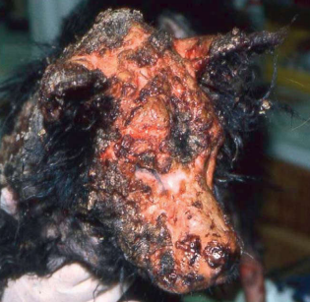
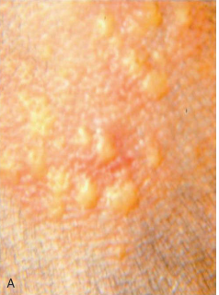
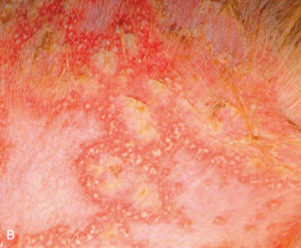
  - Acute to insidious progression
    - When acute, animal may be febrile, depressed, anorectic and with lymphadenopathy
    - Typically has a rapid progression
    - Disease may wax and wane
  - Pruritus variable
    - 17-36% of cases is moderate to severe
  - Head, face, ears (well-demarcated lesions) with bilateral symmetry
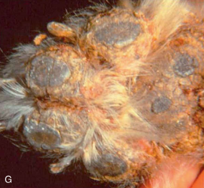
  - Lesions may be more extensively apparent after shaving
  - Nasal depigmentation later in disease course
  - Footpads: fissures and crusting
    - May be the only affected site
  - Mucosal lesions are extremely rare

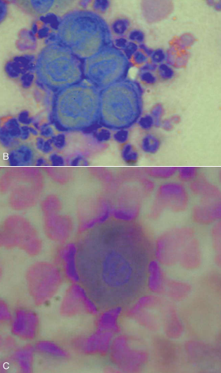
- Diagnosis
  - Main differential is staph pyoderma
    - Do not commence on the face or ears
    - Does not cause crusting of the footpads
  - Other Ddx: demodicosis, dermatophytosis (Tricophyton), pemphigus erythematosus, systemic and discoid LE, dermatomyositis, leishmaniosis
  - Intact pustule cytology and biopsy
    - Acantholytic keratinocytes +/- neutrophils and eosinophils
    - +/- secondary bacterial infection
  - Bacterial and fungal culture of intact pustule
  - CBC/ chem: systemic health, pre-therapy monitoring
    - Neutrophilia

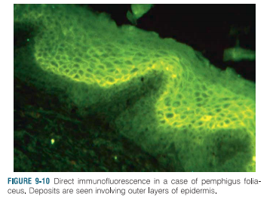

- Treatment
  - Corticosteroids
    - 2mg/kg to 6mg/kg daily, divided
    - Most cases will improve over 10-14 days, dose reduced over the next 30-40 days
    - Hope to achieve 1mg/kg EOD
  - +/= azathioprine, chlorambucil (rather than steroids), topical steroids
- Prognosis
  - ‘Satisfactory response’ in 93% of cases
  - Complete remission: 52%
  - Partial remission: 35%

PEMPHIGUS VULGARIS
- More severe than PF, though rare
  - 0.1% of cases at a referral and GP
- No breed predilection
- Clinical signs
  - Acute or gradual onset
  - Vesiculobullous lesions, progressing to erosions and ulcerations
  - Typically a disease of the oral cavity and mucocutaneous junction
    - May spread to other areas
  - Nikolsky sign: lack of epidermal cohesion allows the skin to be peeled back with a blunt instrument
  - +/- footpad and clawbed involvement
    - Onychomadesis: shedding of the nail bed
      - May be the only presenting sign
  - Often febrile and anorexic
- Differential diagnoses
  - Bullous pemphigoid, epidermolysis bullosa acquisita
  - Causes for oral ulceration
- Diagnosis
  - Cytology is unrewarding, no acantholytic keratinocytes
  - Histopathalogic diagnosis
    - Suprabasilar intraepidermal cleft
  - +/- direct immunofluorescence
- Prognosis: poor, 25% surviving to 1 year post-diagnosis
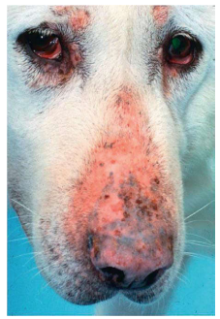
- Aggressive therapy (immunosuppressives and antibiotics)

PARANEOPLASTIC PEMPHIGUS
- Poor prognosis
- Lesions unresponsive to therapy even if primary tumor removed

PEMPHIGUS ERYTHEMATOSUS
- PF and DLE
- Symmetrical crusting of face, ears and nose
- +/- ulceration, erosion and depigmentation of the nose
- Histopathology
  - Intragraular and subcorneal pustules with lichenoid interface dermatitis
- Light-sensitive: may respond to use of sunscreen
- Amenable to immunsuppressives, or tetracycline and niacinamide

FELINE PEMPHIGUS
- Very uncommon, single cases reported
- PF more common
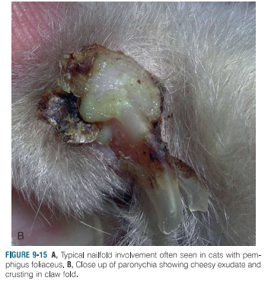
- Focal crusting lesions predominate, occasional pustules
- Head, face, ears bilateral symmetrically affected (80%)
  - Legs 10%
  - Claw folds 30%
- Pruritus mild to severe: 80% of cases
- Anorectic, febrile, lethargic common
- Histopathologic diagnosis
  - Intracorneal and subcorneal pustules
  - Neutrophils, +/_ eosinophils
  - Acantholytic keratinocytes
- Prognosis: good
  - Prednisilone 4-5mg/kg +/- chlorambucil, triamcinolone
  - DM not an uncommon development

QUESTIONS
- PF/PV is the more commonly seen form of pemphigus, and diagnosis can readily be made from histopathology/intact pustule cytology.
- Staph pyoderma and canine PF have many clinically similar presentations. Which of the following clinical findings are unique to canine PF? (multiple correct answers)
  - Alopecia
  - Crusting of the foot pads
  - Pustules
  - Initial lesions appearing on the face, nose and ears
  - Pruritus
- T/F: As the prognosis for PF is generally good, side effects encountered with therapeutics are always manageable, worthwhile and temporary.
- T/F: Therapy for PV involves immunosuppressants with possible antibiotic use in select cases.

QUESTIONS AND ANSWERS

- PF/PV is the more commonly seen form of pemphigus, and diagnosis can readily be made from histopathology/intact pustule cytology.
- Staph pyoderma and canine PF have many clinically similar presentations. Which of the following clinical findings are unique to canine PF? (multiple correct answers)
  - Alopecia
  - Crusting of the foot pads
  - Pustules
  - Initial lesions appearing on the face, nose and ears
  - Pruritus
- T/F: As the prognosis for PF is generally good, side effects encountered with therapeutics are always manageable, worthwhile and temporary.
- T/F: Therapy for PV involves immunosuppressants with possible antibiotic use in select cases.

