PANCREAS 829-834
 | Pancreatic Abscess | Pancreatic Necrosis
Definition | A collection of purulent and necrotic pancreatic tissue.  Can be multiple foci of necrotic debris rather than discrete abscess | Severe form of acute pancreatitis.  The presence of one or more diffuse or focal areas of nonviable pancreatic parenchyma
Incidence | Infrequent  High Mortality  *Abscess formation is always preceded by necrosis  Sequel to acute pancreatitis in some cases Abscess can be a continuation of a single severe inflammatory process with accompanying necrosis that becomes more clinically apparent in the dog 1 to 2 weeks after disease onset | Infrequent  High mortality  * Necrosis is not always followed by abscess formation
History  Physical Exam Findings | Nothing particularly pathognomonic for pancreatic abscess in the dog  Similar to findings for acute pancreatitis | Similar to findings for acute pancreatitis
Lab Findings | Nothing that distinguishes pancreatic abscess from necrotizing pancreatitis.  Leukocytosis common.  Acute pancreatitis may cause platelet consumption and thrombocytopenia.  Prolonged PT, PTT can reflect DIC.  Serum chemistry abnormalities same as those reported in dogs with AP: hypoproteinemia, hyperglycemia as a result of relative insulin insufficiency, hypoglycemia, hypocalcemia associated with hypoalbuminemia and saponification; elevated liver enzymes +/- hyperbilirubinemia.  cPLI, fPLI tests have not proved useful | *See abscess  Abdominal fluid is common (exudative, sterile)  Pancreatic infection more common in humans  Staphylococcus saprophyticus, Klebsiella pneumonia, E. coli, Enterococcus, Pseudomonas, Streptococcus, and Bacteroides have been reported in canine peritoneal fluid.
Imaging | No distinctive features for pancreatic abscess formation vs other forms of severe AP  Abdominal radiographs: increased fluid pattern in the anterior abdomen (diffuse or more localized to the upper right abdomen)  Abdominal us: cavitation of a pancreatic abscess, but it is not readily distinguished from pancreatic pseudocyst or pancreatic phlegmon
Treatment | Most patients will have been treated medically for 7 to 14 days before any decision for surgery is made.  Use of antibiotics for severe ANP without the demonstration of sepsis is not recommended in human medicine  No glucocorticoids  Analgesics, nutrition, antiemetics, IV fluid therapy, +/- Pressors  In humans, surgery is indicated if: worsening clinical condition, the need for jejunostomy tube placement, the need to grossly assess the degree of pathology, the demonstration of infected pancreatitis | The accepted principles of surgical management of necrotizing pancreatitis are the removal of the necrotic pancreatic and peripancreatic tissue (necrosectomy), as well as providing drainage of ascites from the peritoneal cavity.
Treatment |  | Johnson et al. compared the treatment of pancreatic abscesses via surgical omentalization with abdominal closure versus open peritoneal drainage in 15 dogs.  5/8 treated with omentalization survived  1/4 with open peritoneal drainage survived  3 dogs died or were euthanized  Anderson study - all 36 dogs with pancreatic abscess went to surgery  23/36 dogs had one surgery  13/36 had multiple surgeries  Multiple surgical procedures did not influence outcome  No difference in outcome between dogs managed with open abdominal drainage or Sump-Penrose drainage and those managed with primary closure
 | 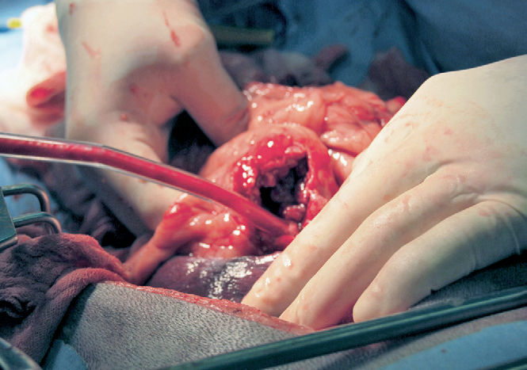 | 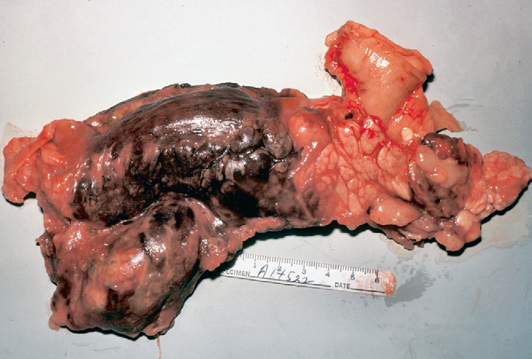

 | Pancreatic Pseudocyst | Pancreatic Phlegmon
Definition | Collection of enzyme-rich pancreatic fluid containing variable amounts of tissue debris and blood.  Results from autodigestion and liquefaction of pancreatic tissue during severe pancreatitis and is highly associated with necrosis and hemorrhage.  Lined by inflammatory tissue. | A solid mass that results from acute intrapancreatic inflammation with fat necrosis and pancreatic parenchymal necrosis.  Usually found in association with necrotizing pancreatitis and are characterized by necrotizing pancreatic and peripancreatic tissue.  Substantial peritonitis (sterile exudate) occurs  A fluid pocket is not present.  Phlegmon develops within days after a severe bout of pancreatitis  *Characterized by the presence of a palpable or radiographic abdominal mass and prolonged leukocytosis.
Incidence | Rare in dogs and cats | Rare in dogs and cats
History  Physical Exam Findings | Sequel to acute pancreatitis.  The acute pancreatitis can resolve uneventfully, or it can culminate in a pseudocyst over a period of a weeks.  Clinical signs may include palpable abdominal mass. | Pancreatic necrosis is only distinguished from pancreatic phlegmon by the eventual mass-like lesion that develops with phlegmon within 5 to 7 days of severe clinical illness.
Lab Findings | The laboratory features of pancreatic pseudocyst will vary from normal to those similar to AP.  Minimal abnormalities will be present if the pseudocyst forms after the inflammatory phase has ceased.  Cyst fluid containing high concentrations of amylase and lipase, and TLI have been reported. | No laboratory tests to distinguish between severe acute pancreatitis, pancreatic necrosis, pancreatic abscess, and pancreatic phlegmon.  Usually have elevated serum liver enzyme concentrations and hyperbilirubinemia
Imaging | The sonographic appearance of pseudocyst will likely be indistinguishable from other types of pancreatic masses.  CT provides an excellent visualization of pancreatic pseudocyst. | Radiographic abnormalities: a mottled appearance in the peritoneal cavity with a loss of serosal detail. Mass effect in the pancreatic region that often displaced the pylorus or ascending proximal transverse colon.  Ultrasonographic finding: hyperechoic mass in the pancreatic region containing hypoechoic and anechoic area
Treatment | In humans pseudocysts are monitored for several weeks to ensure they are not infected, not causing pressure on nearby structures, and not showing evidence of spontaneous rupture.  In many cases, the cyst will resolve spontaneously.  Transabdominal fine-needle aspiration of the cyst contents is commonly performed in humans (has been reported in dogs)  Potential complications include leakage of cyst fluid into the peritoneal cavity, hemorrhage, and introduction of infection.  Surgical resection is done if the less-invasive techniques fail to resolve the problem or if bacterial infection is present | The treatment of sterile necrosis is controversial when considering the option for surgery.  Intense medical treatment is done before surgery is considered.  In humans, most patients found to have sterile necrosis heal successfully without debridement
 | 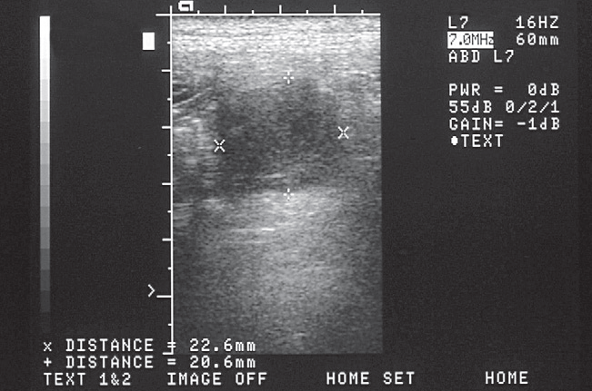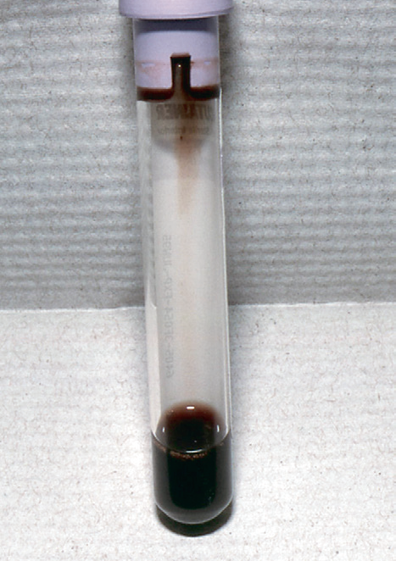 | 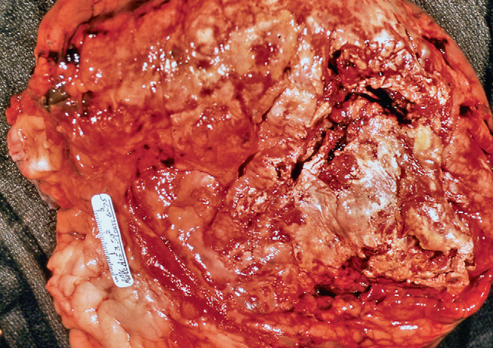

Infected Pancreatitis
- The veterinary literature suggests that cultures of pancreatic tissue are usually negative
  - Veterinary patients might show a higher incidence of infected pancreatitis if tissue and/or abdominal fluid samples were obtained prior to administering antibiotics.
- Regardless of its rare occurrence, infected pancreatitis should be suspected in every case of pancreatic necrosis or phlegmon.
- Fine-needle aspiration of any abdominal fluid or parenchymal tissue samples should be obtained to identify bacterial infection.
- Treatment should begin with a broad-spectrum antibiotic(s) while the results of culture and sensitivity are pending.
Questions
- True or False. Necrosis is always followed by abscess formation.

- True or False. In dogs, a pancreatic abscess can also be caused by secondary infection of a Pseudocyst.

- In Anderson’s review (2008) what was the most common clinicopathological abnormality in the 36 dogs?
- Anemia (9/36)
- Leukocytosis (25/36)
- Thrombocytopenia (10/36)
- Prolongation of PT

- True or False. The diagnosis of pancreatic abscess will usually not be made until the patient goes to surgery.

- True or False. A pseudocyst is a structure lined by epithelial cells.

- In the case of pancreatic pseudocyst, surgery is indicated if
- The cyst does not resolve in <4 weeks
- The cyst occupies >20% of the abdomen
- The cyst ruptures

7. Pancreatic necrosis is described as
- Collection of enzyme-rich pancreatic fluid containing variable amounts of tissue debris and blood (Pseudocyst)
- The presence of one or more diffuse or focal areas of nonviable pancreatic parenchyma
- A collection of purulent and necrotic pancreatic tissue (abscess)
- A mass that results from acute intrapancreatic inflammation with fat necrosis and pancreatic parenchymal necrosis (phlegmon)

8. _______________develops within days after a severe bout of pancreatitis
- Pancreatic necrosis
- Pamcreatic abscess
- Pseudocyst
- Phlegmon

9. ‘Pancreatic ascites’ accompanies which of the following conditions
- Pancreatic necrosis
- Pamcreatic abscess
- Pseudocyst
- Phlegmon

10. Regardless of its rare occurrence, infected pancreatitis should be suspected in every case of ________________ or ________________.
a. Pancreatic necrosis or phlegmon
b. Pancreatic necrosis or abscess
c. Pancreatic pseudocyst or abscess
d. Pancreatic psudocyst or phlegmon

Answers
1. True or False. Necrosis is always followed by abscess formation.
Abscess formation is always preceded by necrosis, although necrosis is not always followed by abscess formation

2. True or False. In dogs, a pancreatic abscess can also be caused by secondary infection of a Pseudocyst.
Answer: In humans, a pancreatic abscess can also be caused by secondary infection of a pseudocyst, but the latter pathogenesis is apparently rare in dogs and cats

3. In Anderson’s review (2008) what was the most common clinicopathological abnormality in the 36 dogs?
- Anemia (9/36)
- Leukocytosis (25/36)
- Thrombocytopenia (10/36)
- Prolongation of PT

4. True or False. The diagnosis of pancreatic abscess will usually not be made until the patient goes to surgery.
This particular patient will be one that does not respond well to the standard of care for treating acute pancreatitis and may have evidence of a mass effect on abdominal imaging.

5. True or False. A pseudocyst is a structure lined by epithelial cells.
A pseudocyst is not a true cyst in that it is lined by inflammatory tissue instead of epithelium.

6. In the case of pancreatic pseudocyst, surgery is indicated if
- The cyst does not resolve in <4 weeks
- The cyst occupies >20% of the abdomen
- The cyst ruptures

7. Pancreatic necrosis is described as
- Collection of enzyme-rich pancreatic fluid containing variable amounts of tissue debris and blood (Pseudocyst)
- The presence of one or more diffuse or focal areas of nonviable pancreatic parenchyma
- A collection of purulent and necrotic pancreatic tissue (abscess)
- A mass that results from acute intrapancreatic inflammation with fat necrosis and pancreatic parenchymal necrosis (phlegmon)

8. _______________develops within days after a severe bout of pancreatitis
- Pancreatic necrosis
- Pamcreatic abscess
- Pseudocyst
- Phlegmon

9. ‘Pancreatic ascites’ accompanies which of the following conditions
- Pancreatic necrosis
- Pamcreatic abscess
- Pseudocyst
- Phlegmon

10. Regardless of its rare occurrence, infected pancreatitis should be suspected in every case of ________________ or ________________.
a. Pancreatic necrosis or phlegmon
b. Pancreatic necrosis or abscess
c. Pancreatic pseudocyst or abscess
d. Pancreatic psudocyst or phlegmon

