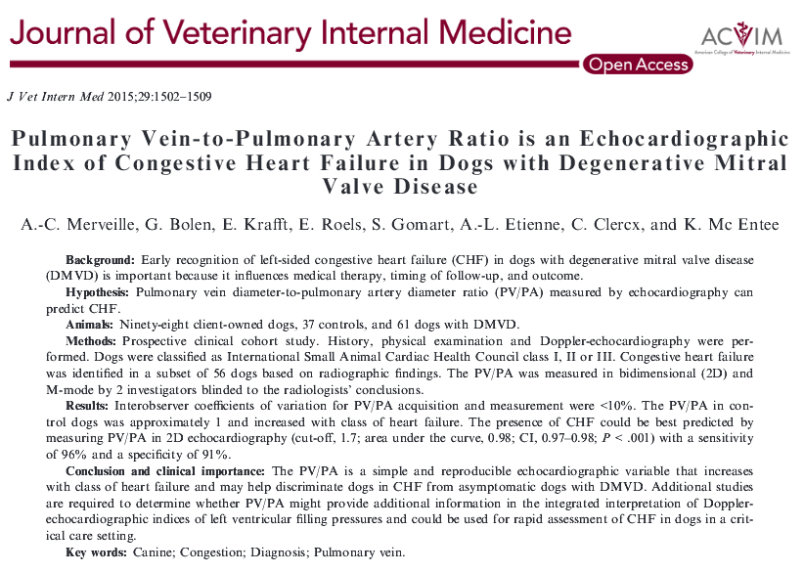
Increased pulmonary venous pressure associated with venous enlargement → increase in the PV/PA ratio

LA/Ao, has been shown to increase with increasing class of heart failure

PV/PA increased with increasing class of heart failure

A PV/PA value >1.7 in 2D predicted
CHF with an accuracy >90%, a sensitivity of 96%, and a specificity of 91%

Concurrent pulmonary hypertension could contribute to false negative results by decreasing the PV/PA ratio

Cut-off value of 1.7 in 2D, PV/PA discrimination of dogs in CHF from asymptomatic dogs
