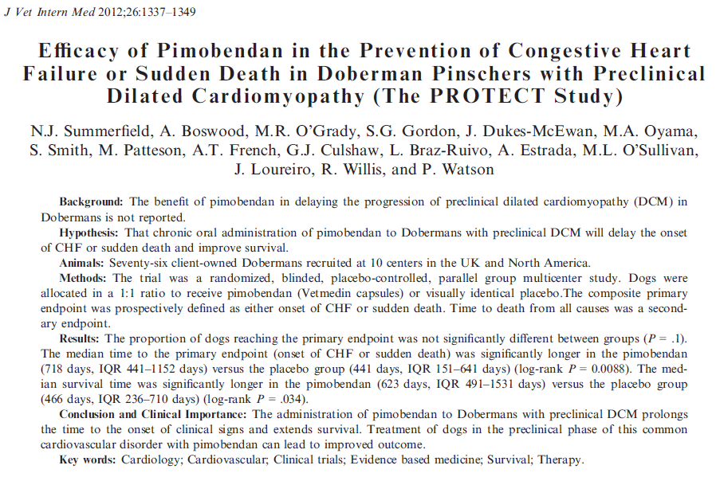
- DCM most common form of cardiomyopathy in dogs, 2nd most common form of acquired heart disease after MVD
- 25-50% Purebred Dobermans develop DCM
- DCM in Dobermans:
  - Preclinical stage (>2-3 years): progressive L ventricular systolic dysfunction and dilation, +/- ventricular, supraventricular arrhythmias
  - Sudden death in 25-30% from Vtach, Vfib, before CHF
  - Survival after CHF 2-4 months, 90% fatality rate after 1 year
- Inclusion criteria: 4-9 year old Doberman with echo evidence of preclinical DCM based on weight dependent left ventricular internal diameter in systole (LVIDS)
- Exclusion criteria: other cardiac disease, clinical DCM, syncope within past 6 months, sustained (>30 s) Vtach based on 24hr Holter, afib, cardiac or resp medication, including steroid, general anesthesia in the past 28 days, pregnant, lactating or females intended for breeding, hypothyroid were initially excluded, after 38 months they were included if: no clinical signs of hypothyroidism, normal T4, no change in dose in past 60 days, LV systolic dysfunction persisted despite thyroxine supplementation
- Randomized, blinded, placebo-controlled, parallel group, multicenter study, 76 dogs
- Primary end point: onset of CHF or sudden death
- Secondary end point: all cause death
- Dogs >35.1 kg 2 x 5 mg Pimobendan bid, Dogs <35 kg 1 x 5mg Pimobendan bid
- NSAIDs, antibiotics, levothyroxine were allowed; Sotalol and mexiletine were allowed if arrhythmias developed during the study time
- After initial workup, PE, echocardiogram, Holter and routine hematology, and blood biochemistry were repeated in 1–2 months. PE 6 months after enrollment, q 6 months thereafter, and at study end.

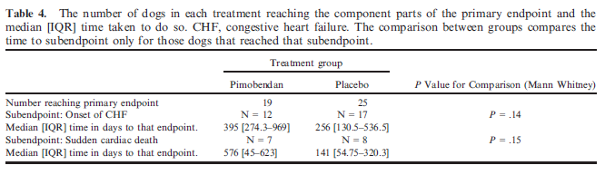

- Dogs in placebo group were 3.3 times more likely to reach primary endpoint
- Hazard of reaching primary end point doubled for every 0.1 unit increase in normalized systolic diameter
- Dogs with >4 VPC/3 min and an above median heart rate were 7 times more likely to reach primary end point first
- >4 VPC /3 min increases risk of reaching primary end point 2.5 fold
- Pimobendan in preclinical DCM Dobermans
  - prolonged onset of CHF or sudden death by 9 months
  - did not increase the presence of, or frequency of, VPCs or sudden death
  - demonstrated a significant reduction in heart size after 30 days

Questions:
- What is the mechanism of action of Pimobendan?

- What is the prognosis for DCM in Dobermans with CHF?

- Name 3 independent predictors of adverse outcome in preclinical DCM Dobermans

Questions:
- What is the mechanism of action of Pimobendan?

Benzimidazopyridazinone, phosphodiesterase III inhibitor, increases intracell Ca sensitivity

Potent positive inotropic and a vasodilatory effect

- What is the prognosis for DCM in Dobermans with CHF?
Survival after CHF 2-4 months, 90% fatality rate after 1 year

- Name 3 independent predictors of adverse outcome in preclinical DCM Dobermans
Greater dilation of the left ventricle in systole
Higher HR
At least 4 VPCs on a 3min ECG

