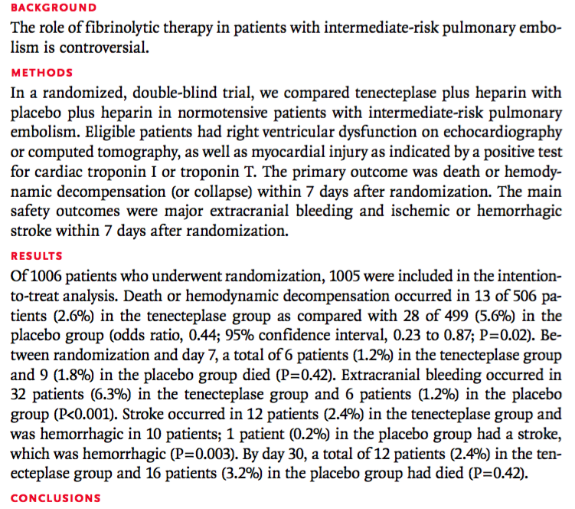
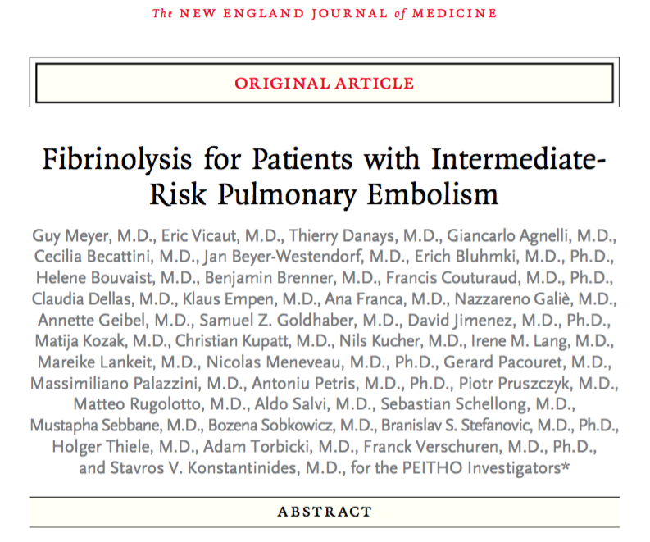
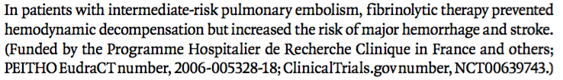

- Approximately 10% of all patients with acute pulmonary embolism die within 3 months after the diagnosis
- Acute right ventricular pressure overload at diagnosis is an important determinant of the severity and early clinical outcome of pulmonary embolism
- High-risk pulmonary embolism is characterized by overt hemodynamic instability and warrants immediate advanced therapy, including consideration of fibrinolysis
  - Versus standard anticoagulant therapy alone for patients presenting without systemic hypotension or hemodynamic compromise
- Intermediate-risk pulmonary embolism is characterized by acute right ventricular dysfunction and myocardial injury without overt hemodynamic compromise
- Fibrinolytic agents versus heparin alone has been studied in patients with acute pulmonary embolism and have been shown to rapidly improve hemodynamic variables
  - Their effects on the clinical outcome, particularly in patients without hemodynamic instability at presentation, have not been determined
- The PEITHO trial was designed to investigate the clinical efficacy and safety of fibrinolytic therapy (single-bolus injection of tenecteplase, tPA) in addition to standard anticoagulation therapy with heparin in normotensive patients with acute pulmonary embolism and an intermediate risk of an adverse outcome
- Patient Population
  - 18 years or older
  - Objectively confirmed acute pulmonary embolism with an onset of symptoms 15 days or less before randomization
  - Right ventricular dysfunction confirmed by echocardiography or spiral CT of the chest
  - Myocardial injury confirmed by a positive test for troponin I or troponin T test
- Fibrinolysis group:
  - Received a single weight-based intravenous bolus (given over a period of 5 to 10 seconds) of tenecteplase
  - Heparin CRI, adjusted to achieve and maintain an aPTT 2.0-2.5x the upper limit of the normal range
- Standard therapy group:
  - Placebo bolus
  - Heparin CRI, as described above
- The primary efficacy outcome was the clinical composite of death from any cause or hemodynamic decompensation/collapse within 7 days after randomization
- The secondary outcomes included death within 7 days after randomization, hemodynamic decompensation within 7 days, confirmed symptomatic recurrence of pulmonary embolism within 7 days, death within 30 days, and major adverse events within 30 days
- Safety outcomes were defined as ischemic or hemorrhagic stroke (including hemorrhagic conversion of ischemic stroke) within 7 days after randomization, extracranial major (moderate or severe) bleeding within 7 days, and serious adverse events within 30 days
- Standard anticoagulation therapy: 5.6% incidence of death or hemodynamic decompensation (the primary efficacy outcome) within the first 7 days
- Fibrinolysis therapy: 2.6% incidence of the primary outcome
  - 2.0% rate of hemorrhagic stroke
  - 6.3% rate of major extracranial hemorrhage
- Results indicate that prompt fibrinolysis therapy can reduce the risk of hemodynamic decompensation or death in intermediate-risk patients
- Fibrinolysis is associated with a lower risk of bleeding in younger patients than in patients over 75 years of age (though this difference was not significant)
- Great caution is warranted when considering fibrinolytic therapy for intermediate-risk patients with PTE

Questions
- High-risk vs intermediate-risk PTE patients differ in that:
  - High-risk patients have multiple confirmed emboli
  - High-risk patients have overt hemodynamic instability
  - High-risk patients have a previous history of PTE
  - High-risk patients have not demonstrated improvement to standard therapy alone
- Approximately _______% of all patients with acute pulmonary embolism die within __________ after the diagnosis
  - 30%, 3 months
  - 30%, 10 months
  - 15%, 1 month
  - 10%, 3 months
- Prompt fibrinolysis therapy can reduce the risk of hemodynamic decompensation or death in intermediate-risk patients
  - And use is warranted due to improved overall survival
  - And use is cautioned due to the added expense, intensive treatments, and relatively minimal improvement in overall survival
  - And use is cautioned due to the increase in serious side effects
  - And use is warranted due to the minimal increase in serious side effects

Questions and Answers
- High-risk vs intermediate-risk PTE patients differ in that:
  - High-risk patients have multiple confirmed emboli
  - High-risk patients have overt hemodynamic instability
  - High-risk patients have a previous history of PTE
  - High-risk patients have not demonstrated improvement to standard therapy alone
- Approximately _______% of all patients with acute pulmonary embolism die within __________ after the diagnosis
  - 30%, 3 months
  - 30%, 10 months
  - 15%, 1 month
  - 10%, 3 months
- Prompt fibrinolysis therapy can reduce the risk of hemodynamic decompensation or death in intermediate-risk patients
  - And use is warranted due to improved overall survival
  - And use is cautioned due to the added expense, intensive treatments, and relatively minimal improvement in overall survival
  - And use is cautioned due to the increase in serious side effects
  - And use is warranted due to the minimal increase in serious side effects

