Oxygen Therapy and Mechanical Ventilation

SUMMARY
1. Oxygen therapy can lead to greater degree of hypoventilation, oxygen toxicity and absorption atelectasis (rare in dogs and cats)
2. Mechanical ventilation leads to increased intrapleural pressure which decreases venous return, right ventricular preload and cardiac output. In diseased lungs protective strategies should be implemented such as low tidal volumes and PEEP to avoid lung collapse.

Physiological effects of oxygen therapy
- High FiO2 during anesthesia contribute to development of atelectasis
  - Absorption of alveolar gas (>soluble with higher O2 content)- responsible for loss of functional alveolar volume
  - Minor impact in dogs and cats
  - May be a consideration when imaging under anesthesia (may need < FiO2)
  - Preoxygenation with face mask 100% FiO2 has been shown in people to result in a greater degree of atelectasis compared FiO2 of 60-80% (not a problem in vet med since face masks at best will have an FiO2 80%)
  - May also lead to increased PaCO2 – greater degree of hypoventilation – depression of respiratory control mechanisms
- Oxygen toxicity (Hyperoxic Acute Lung Injury):
  - High inspired O2 levels >70% for prolonged periods of time will produce pulmonary dysfunction
  - Requires FiO2 >0.7, producing PaO2 > 450 mmHg and a prolonged exposure
  - In CC, if prolonged mechanical ventilation, FiO2 should only be increased to the point where PaO2 levels are in the 90-100 mmHg with Hb O2 saturation close to or >90%

Physiological effects of mechanical ventilation
  - Anesthesia ventilators are designed to be compatible with anesthetic delivery systems
  - FiO2 cannot be controlled (as in CC vents) - receive FiO2 >0.95
  - Healthy dogs and cats receiving FiO2 >0.95 – PAO2 should reach values > 450 mmHg*
*Alveolar gas equation: PAO2: [(P_{atm}-P_{H20}) x FiO2 – PCO2/Resp Q]
  - PaO2 < PAO2:
  - V/Q mismatching
  - Intrapulmonary shunting
  - Status of the alveolar capillary mb
  - Lung disease: low tidal volume ventilation + PEEP that minimize lung collapse are recommended
  - Cardiovascular effects:
- Intrapleural pressure increases during inspiration
- Decrease in venous return and right ventricular output
  - Dependent on degree, duration of intrapleural pressure change
  - Greater increase in intrapleural pressure: large tidal volumes, PEEP or short expiratory times – greater negative impact on venous return and right ventricular preload
- Initial increase in left ventricular preload due to lung inflation producing compression on pulmonary capillaries – reduced right ventricular output will reduce left atrial preload within several heartbeats
- In patients with left ventricular failure – positive pressure ventilation may improve hemodynamic stability by reducing left ventricular afterload
Clinical Implications of Altered Respiration during Anesthesia
- Dogs and Cats
  - 100% FiO2 = arterial PaO2 450-525 mmHg, in cardiopulmonary healthy dogs and cats
  - Guidelines for respiratory component:
    - Patients should be intubated when administering anesthetics if possible
    - FiO2 at least 30-35% in all anesthetized or deeply sedated patients
    - Hypoxemia is rare in spontaneously breathing patients breathing 100% FiO2
    - Inflate lungs to 30 cm H2O of airway pressure (“sigh” the lungs) periodically and at the end of anesthesia or maintain a PEEP 5 cm H20
    - Prolonged immobility and excessive fluid administration can lead to increased venous admixture and a fall in PaO2

Anesthesia for Animals with Respiratory Disease Dysfunction
- Upper airway disease or dysfunction
  - Brachycephalic airway obstructive syndrome, laryngeal paralysis, collapsing trachea, foreign bodies, intraluminal masses
  - Reduction in airway diameter and associated increase in upper airway resistance to compensate a greater negative intrathoracic pressure is created- May need ventilation
  - Choose drugs with low potential for emesis, antiemetics, avoid NSAIDs
    - Opioids
    - Opioids + Acepromazine
    - α2-agonists – considerable upper airway muscle relaxation and resp depression - not recommended
    - Propofol – does not affect laryngeal function
  - Preoxygenate
  - Stylet and small varied sized endotracheal tubes available, tracheostomy ready

- Lower airway and pulmonary parenchymal disease
  - Feline asthma, pneumonia, pulmonary masses, contusions, atelectasis
  - Preoxygenate
  - Reactive airway disease anticholinergic may be considered – controversial
  - Acepromazine inhibits histamine release – may be beneficial
  - Hypoventilation or apnea can be worsened by opioid and sedatives - induce anesthesia first then add opioid analgesics once ventilation is adequate
  - Lidocaine in cats for bronchospasm
  - Ketamine and propofol is recommended due to their relative bronchodilating effects
  - Ventilation: low tidal volume and PEEP, also use of slow inspiratory time and long expiratory time will allow full exhalation and prevent air trapping

- Intrathoracic or chest wall disease
  - Pneumothorax, Pleural effusion, diaphragmatic hernia, penetrating chest wound, abdominal distention
  - Thoracocentesis
  - Ventilation to help work of breathing
  - Re-expansion pulmonary edema (changes in vascular integrity, infiltration of immune cells, mechanical stress) – limit crystalloid volume administration, use diuretics, steroids

One lung ventilation (OLV)
- Used to facilitate ease of surgery by providing better visualization of the operating field and to isolate bronchial communications of diseased from healthy lung lobes during surgery
- Endobronchial blocker or double-lumen tube is used to separate the lungs
- Endoscopy is needed to verify correct positioning
- In vet med, surgery is usually laterally recumbent and at an FiO2 of 100% - hypoxemia is rare
- Low PEEP 3-5 cm H2O during ventilation of dependent lung will minimize atelectasis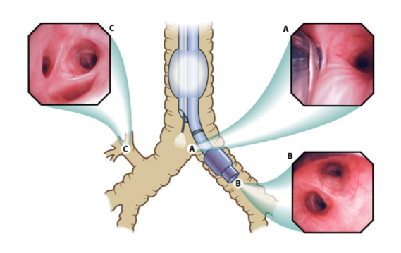
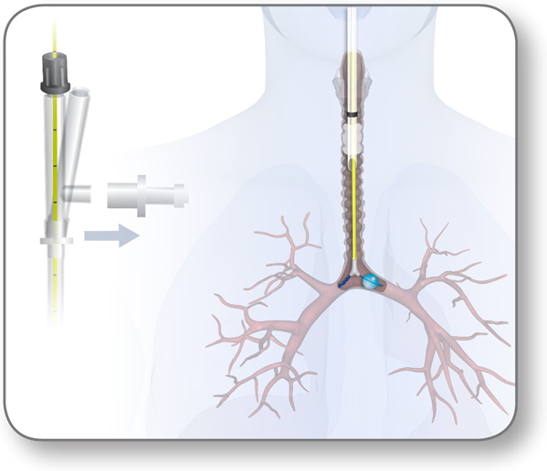
Questions:
- Patients with lung disease may be at higher risk of lung injury due to mechanical ventilation. What are some lung protective strategies that can be implemented?

- T or F: Mechanical ventilation may be beneficial in patients with left ventricular failure due to a decrease in left ventricular afterload

- Intrapleural pressure can increase during mechanical ventilation. Name 3 settings that should be evaluated to decrease this pressure and mention if it should be increased or decreased.

Answers:
- Patients with lung disease may be at higher risk of lung injury due to mechanical ventilation. What are some lung protective strategies that can be implemented?
Low tidal volume 5-8 ml/kg
PEEP that minimizes lung collapse

- T or F: Mechanical ventilation may be beneficial in patients with left ventricular failure due to a decrease in left ventricular afterload

- Intrapleural pressure can increase during mechanical ventilation, leading to a decrease in venous return and right ventricular preload. Name 3 settings that can be modified and if they should be increased or decreased to improve venous return.

Lower tidal volume
Decrease PEEP
Longer expiratory time

