
Commonly used induced models of myocardial or valvular disease:
- rapid ventricular pacing
- microembolization
- chordae tendineae rupture

Spontaneous occurring cardiac disease:
- Myocardial diseases
  - dilated cardiomyopathy
  - arrhythmogenic right ventricular cardiomyopathy
- Valvular diseases
  - mitral valve prolapse
  - myxomatous mitral valve disease

Biomarkers are objective measures that predict the presence, risk, or outcome of disease. As such, they act as surrogates for clinically relevant conditions (i.e. presence of disease) or outcomes (i.e. heart failure, death).

Assessing multiple biomarkers can be additive or synergistic
- NT-proBNP and cardiac troponin-I provide complementary prognostic information in dogs with SOCD
- Dogs with elevations of both NT-proBNP and cardiac troponin-I have worse prognosis than those with elevations of either biomarker alone.

Biomarker panels that include a sampling of markers across different pathophysiological categories likely provide superior information than testing multiple markers with a high degree of correlation within categories.

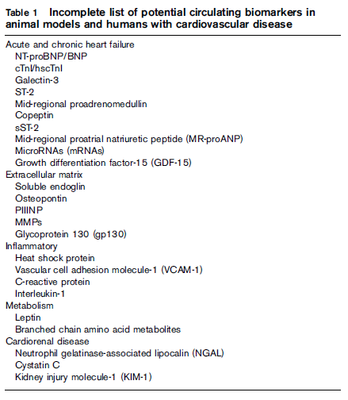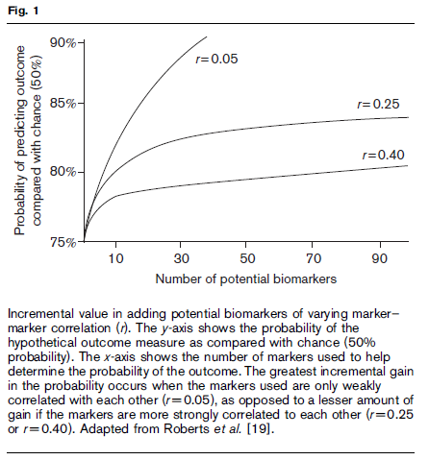
Several cardiorenal biomarkers have been proposed as a means to specifically identify cardiorenal syndrome, stratify injury severity, and to guide subsequent therapy.
New Cardiovascular Biomarkers
MicroRNA
- short noncoding RNAs that block translation and speed breakdown of specific target messenger RNA
- helps regulate a variety of aspects of cardiovascular function including hypertrophy, fibrosis, apoptosis, cardiac conduction, and energy utilization
- atrial fibrillation: miRNA-29 and miRNA-26 are downregulated and contribute toward pathological fibrotic atrial remodeling and overexpression of the inward-rectifying K+ current

Matrix metalloproteinases
- endopeptidases capable of degrading and remodeling extracellular matrix
- involved in a wide variety of cell functions including apoptosis, differentiation, and proliferation
- Animal models of disease will be useful in determining whether pharmacological modulation of MMP activity can reduce pathological cardiac remodeling

Leptin
- adipose tissue-derived hormone that helps regulate energy expenditure, metabolism, and hunger
- direct effects on cardiomyocyte fatty acid utilization, hypertrophy, inflammation, and fibrosis
- indirect effects on renal function, insulin resistance, and body weight
- In dogs with SOCD, leptin gene transcription was increased in the myocardium and blood compared with healthy controls, and was highest in the dogs with the most severe heart failure

Neutrophil gelatinase-associated lipocalin
- (NGAL) is a glycoprotein that is released by renal tubular cells secondary to kidney injury
- once in circulation, NGAL promotes apoptosis and inflammation of other organs, including the heart
- human patients with elevations of both NGAL and NT-proBNP were identified to be at highest risk
- elevated urinary NGAL in patients being treated for acute heart failure was a superior determinant of worsening renal function at 72–96 h versus conventional means

