- Pancreatitis
  - Either Inflammatory or necrotizing
    - Necrotizing can have minimal inflammation
      - often fatal
  - Acute
    - No fibrosis or atrophy
  - Chronic
    - histopathology - fibrosis and atrophy
  - No standardized terminology
    - Possibly different diseases or severities
- Prevalence
  - Occurs in approximately 0.8% of dogs
    - Clinical
  - Up to 65% of dogs at necropsy have evidence of inflammation in some part of the pancreas
  - Mortality
    - Mostly for severe forms
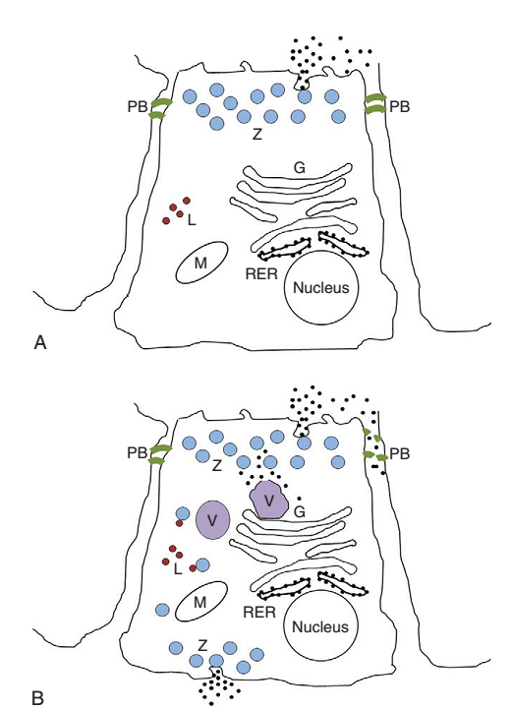
    - can be up to 20-42%
- Pathogenesis and pathophys
  - Early activation of zymogens in acinar cells
    - Colocalization theory
      - Zymogen granule accumulation allows fusion with lysosomes which leads to activation of trypsinogen to trypsin
    - Disruption of paracellular barriers in pancreatic ducts
      - Leads to active trypsin in interstitial space
    - Starts in pancreas, leaks into peritoneum and can go systemically
  - Main inflammatory mediators are:
    - IL-1
    - IL-2
    - IL- 6
    - IL- 18
    - TNF-ɑ
    - Substance-P
    - Platelet activating factor

- Etiology and Risk
  - Unknown etiology
    - Humans = alcoholism and biliary obstruction and autoimmune
  - Hypertriglyceridemia

    - Suspect
    - Research in Mini Schnauzers with >862mg/dL serum triglyceride levels were at higher risk
  - Suspect DM, Cushings and Obesity are risk factors
- Breed
  - Consistently implicated
    - Mini Schnauzers
    - Yorkshire terriers
    - other terriers
  - Suggested
    - Boxers
    - Cavaliers
    - Cockers
    - Collies
- Diet
  - High Fat diets - experimental studies
    - Possibly leading to hypertriglyceridemia
  - Access to ‘unusual foods’ implicated
- Drugs
  - No cause and effect established
  - More commonly occurs in dogs on:
    - KBr
    - Pheno
    - l-asparaginase
    - azathioprine
    - meglumine antimonate (leishmaniasis drug)
- Endocrine diseases
  - DM, cushings, hypothyroidism were more commonly present in dogs with pancreatitis
    - Possibly due to increased serum triglycerides
- Obesity
  - Dogs with pancreatitis are more frequently obese
- Other
  - Older dogs, hypercalcemia, hypotension, surgical manipulation, Pancreatic duct obstruction, neoplasia, chronic GI disease
- History and Exam Findings
  - What you would expect - all non-specific
    - anorexia, vomiting, weakness, PU/PD, diarrhea
    - dehydration, abdominal pain (only 58%), fever, icterus
- Lab work (CBC/Chem/UA)
  - All non-specific such as hemoconcentration, pre-renal azotemia, etc…
- Treatment
  - Mainly supportive care
  - Treatment of possible inciting factors
    - Hypertriglyceridemia, hypercalcemia, endocrine diseases, obesity, toxins, drugs, diet
- Nutrition
  - EARLY ENTERAL FEEDING
    - CCK does not stimulate pancreas to secrete as much in pancreatitis
    - Jejunal feeding tubes do not show benefit
      - only for dogs with refractory vomiting or having laparotomy for other reasons
- Fluids
  - as needed based on clinical picture - no specific recommendations
- Plasma and Blood products
  - pRBCs only if needed for anemia
  - Plasma has ɑ1- proteinase inhibitor and ɑ2-macroglobulin which may protect from worsening pancreatitis, however, no studies have established benefit
    - reserve plasma for coagulopathic pancreatitis
      - One study showed dogs receiving plasma were more likely to die, but this was retrospective
- Electrolyte and acid base disturbances
  - fix them
- Analgesia
  - use it
- Antiemetic
  - Use cerenia if possible for central and peripheral blockade of substance P
    - But ondansetron and dolasetron are fine
- Antibiotics
  - No benefit to prophylactic antibiotic use in people has been showing in multicenter, double-blinded, placebo-controlled studies or meta-analysis.
    - Studies in dogs lacking
  - ABs with good pancreatic penetration (reach therapeutic levels in pancreatic tissue)
    - Cefotaxime
    - Ciprofloxacin
    - metronidazole
    - clindamycin
    - chloramphenicol
- Surgery
  - Only if abscessation occurs
    - they will still probably die - 50-85% mortality
  - Peritoneal dialysis has been shown to be beneficial in experimentally induced pancreatitis
  - EHBDO - surgery if does not resolve on own

- Steroids
  - because of humans getting immune-mediated pancreatitis
    - only use in dogs as last resort
- Prognosis
  - depends on severity - shocking
    - no methods to predict outcome

