NECROSIS AND INFLAMMATION: FELINE p.821-829
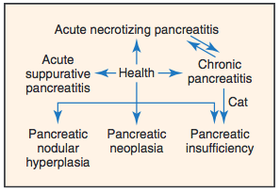
- Significant overlap exists between several disease categories
Acute necrotizing pancreatitis | Predominant feature = necrosis  +/- Inflammation, hemorrhage, mineralization, fibrosis
Acute suppurative pancreatitis | Predominant feature = neutrophilic inflammation  +/- Necrosis  Less common than ANP; younger cats
Chronic non suppurative pancreatitis  Continuum of disease from necrosis to fibrosis? | Lymphocytic inflammation, fibrosis, acinar atrophy.  +/-Necrosis and suppuration

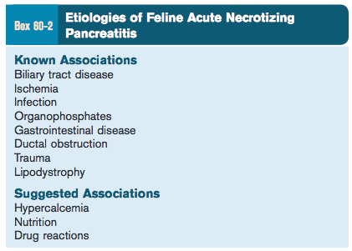
  - Biliary tract disease
  - Cholangitis*, stricture, neoplasia, calculus
  - Cats with suppurative cholangitis have significantly increased risk for pancreatitis.
  - Why?
    - Anatomic and functional relationship between the major pancreatic duct and common bile duct?
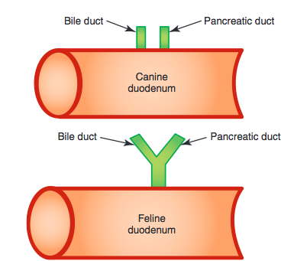
    - Mechanical or functional obstruction of this common duct bile reflux into pancreatic duct.
  - Concurrent GI disease
    - IBD*
      - Factors that contribute to this association:
        - High incidence of IBD
        - Chronic vomiting (from IBD) increase in intraduodenal pressure increase in the incidence of pancreaticobiliary reflux
        - Feline pancreaticobiliary anatomy
        - Feline intestinal microflora: higher concentration of aerobic, anaerobic and total bacteria in proximal SI. And difference in GI motility and immunology proliferation of bacteria
  - Ischemia
  - Pancreatic ductal obstruction
    - Neoplasia, flukes, calculi, duodenal FB
    - ductal pressure exceeds exocytosis pressure pancreatic lysosomal hydrolases colocalize with digestive enzyme zymogens (activation of trypsin…)
  - Infection
    - Toxoplasma gondii, FHV-1, FIP (none reported as important causes of ANP in recent clinical cases)
    - Calicivirus?
  - Trauma
  - OPP poisoning
  - Lipodystrophy

Clinical presentation
- DSH
- Anorexia*, lethargy*
- GI signs = sporadic in cats
- PE: dehydration, hypothermia, icterus, fever, abdominal pain, abdominal mass
Lab findings
- Anemia or hemoconcentration, leukocytosis or leukopenia (worse prognosis), elevated LEs, hypercholesterolemia, hyperbilirubinemia, hyperglycemia, hypocalcemia (more common than in dogs; worse prognosis)
Therapy
- Possible life-threatening complications: hypocalcemia, DIC, TE, arrhythmia, sepsis, ATN, pulmonary edema, pleural effusion
- Analgesia
- Antiemetic agents
- Calcium gluconate
- Histamine antagonists (H1 and H2)
  - Histamine induces increase in microvascular permeability; associated with development of hemorrhagic necrosis in experimental pancreatitis.
  - Histamine: role in pain associated with pancreatitis?
  - Mast cell activation/degranulation (histamine) and SIRS?
  - To inhibit pancreatic enzymes secretion: directly and indirectly by inhibiting gastric acid secretion (and increasing intraduodenal pH)- many studies failed to demonstrate reduction and pancreatic exocrine secretion.
  - Some studies showed that cimetidine was associated with higher rates of pain and complications than placebo.
- Dopamine CRI
  - 5 μg/kg/min
  - decrease in ductal or microvascular permeability.
- Antibiotics
  - May begin as a sterile process, but necrosis and inflammation predispose to bacterial translocation and colonization of the pancreas
    - Using florescence in situ hybridization, bacteria were identified in 35% (11 of 31) of pancreatic biopsy samples from cats with moderate to severe pancreatitis (especially acute necrotizing and acute suppurative pancreatitis) and in only 1 normal control cat.
      - Simpson KW, Twedt DC, McDonough SP, et al: Culture-independent detection of bacteria in feline pancreatitis. Proceedings of the Forum of the American College of Veterinary Internal Medicine, 2011
- Ductal decompression
  - If acute obstruction (calculus, neoplasia)

Complications of ANP
- Chronic non suppurative pancreatitis
  - Histopath is needed for differentiation
- EPI
  - From chronic pancreatitis, fibrosis and acinar atrophy
  - Difficult to diagnose
  - TLI
  - Cobalamin deficiency
- Hepatic lipidosis
  - Poor prognosis
- Diabetes
  - From progression to chronic non suppurative form

