Chapter 14
Muscle Relaxants and Neuromuscular Blockade

Non-Neuromuscular Effects of NMBAs
- Primary effects at the nicotinic cholinergic receptors at motor nerve plate
  - May have effects at muscarinic receptors and autonomic nerve ganglia
- Undesirable effects include receptor blockade or mimicking of ACh

- Cardiovascular effects
  - Increased, decreased HR and arrhythmias
  - Hypotension, secondary to histamine release from rapid IV infusion of d-turbocurarine
  - Hypertension, tachycardia with rapid IV infusion of pancuronium
    - Stimulates NE release from sympathetic nerves?
  - Atracurium, vecuronium have minimal CV effects
    - Mild histamine release, though no clinical hypotension
  - Pipecuronium, doxacurium, rocuronium are unlikely to be associated with profound changes in CV function

- Histamine release
  - NMBAs have a quaternary ammonium structure that results in histamine release
    - Vasodilation with decrease in BP, and possible reflex tachycardia
  - Less of a concern with newer agents
  - Avoid histamine release by administering slow IV infusions, and not exceeding recommended doses

- Placental transfer
  - All NMBAs are large, hydrophilic polar molecules and thus transfer across the placenta is limited

- CNS Effects
  - Due to large, hydrophilic nature the NMBAs do not cross the BBB readily
    - However, evidence of CNS effects exists
      - Pancuronium variably reduced MAC in humans (depending on the study)
    - NMBA admin into the CSF results in myotonia, autonomic effects, and seizures
    - Some NMBA degredation products are able to cross the BBB, and may result in CNS stimulation if given in large doses
- Protein-binding
  - All non-depolarizing NMBAs are protein bound
  - Theoretically, only free drug is able to interact with ACh receptors
  - In low-protein conditions, no clinically appreciable difference in amount of protein-bound drug (and therefore no alteration needed of dose)
- Non-neuromuscular effects of succinylcholine
  - Transient increase in serum potassium levels
    - Due to persistently open ion channels as succinylcholine is not degraded by ACh-esterase
    - No clinical significance as long as pre-treatment potassium is normal and patient does not have cardiovascular disease
  - Increased intraocular pressure
    - Smooth intubation may decreased additional exacerbation
  - Increased intragastric pressure
    - Due to initial muscle fasciculations resulting in increased abdominal pressure
    - May increase incidence of regurgitation
  - Increased intracranial pressure
    - Also due to muscle fasciculations?
    - May be prevented by prior administration of d-tubocurarine
    - Smooth intubation may decreased additional exacerbation
  - Humans experience muscle soreness following use of succinylcholine
- Muscle relaxants in anesthetized animals
  - Indications
    - Eliminate laryngeal spasm and facilitate intubation
    - To provide a motionless and centrally positioned eye during ocular surgery
    - Prevention of unconscious spontaneous movement
    - Reduced resistance to controlled ventilation
    - Facilitate surgical access during surgery
  - Precautions
    - Ventilation must be controlled
    - No sedative, analgesic or anesthetic properties
- Factors affecting neuromuscular blockade
  - Impaired metabolism and excretion commonly seen with renal or hepatic insufficiency, and thus effects of NMBAs may be prolonged
    - Avoid high doses, repeated doses, or continuous infusions of drugs that primarily rely on renal or hepatic elimination in patients with renal or hepatic disease
  - Anesthetic drugs
    - Inhalent anesthetics cause a time and dose dependent enhancement of the intensity and duration of block produced by muscle relaxants
    - Injectable anesthetics typically have only minor effects on the neuromuscular blocking properties of muscle relaxants
  - Acid-base disturbances
    - Respiratory acidosis increases the intensity of muscle blockade
    - Respiratory alkalosis decreases the effect
  - Electrolyte disturbances
    - Alterations of K, Mg and Ca influence neuromuscular blockade
      - May increase or decrease the effects of the NMBA
  - Antimicrobial and other drug interactions
    - Most notable effects occur with polymyxin and aminoglycoside
    - Also seen with tetracycline, lincosamide and clindamycin
    - Depressed ACh release through Ca chelation….?
- Monitoring neuromuscular blockade
  - Appropriate monitoring will facilitate proper dosing of both NMBA and antagonist
  - Monitoring must be continued until function is fully restored
  - Evoked motor responses to peripheral nerve stimulation are used to evaluate the degree of neuromuscular blockade
  - Sites of stimulation
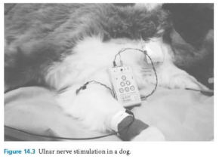
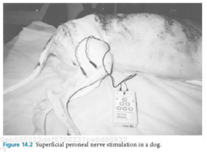
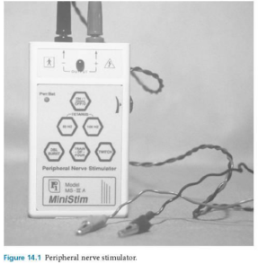
    - Peroneal and ulnar nerves
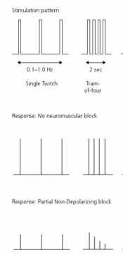
  - Pattern of stimulation
    - Single twitch: Simplest form of nerve stimulation
      - Degree of relaxation is assessed by dividing the elicited response by the prerelaxant response
    - Train of four: Degree of relaxation is determined by comparing the ratio of the intensity of the fourth twitch to the first twitch
- Reversal of neuromuscular blockade
  - Non-depolarizing blockade
    - Administration of ACh-esterase inhibitor/anticholinesterase
      - Edrophonium, neostigmine, pyridostigmine
      - Prolonged elimination in those with impaired renal function
      - Systemic effects, so use of an anticholinergic is recc’d
      - Centrally acting muscle relaxants
        - Guaifenesin: disrupts internuncial neurons of the sopinal cord, brainstem and subcortical areas of the brain
          - When administered IV in high concentrations, can cause hemolysis, hemoglobinuria and thrombosis
        - Dantrolene
          - Interferes with excitation-contraction coupling, thus relaxing skeletal muscle via decreased Ca-release from the SR
          - Drug of choice with malignant hyperthermia

Questions
- T/F: NMBAs readily cross the blood:placental barrier and are contraindicated in pregnant animals
- The degree of neuromuscular blockade is evaluated and monitored by:
  - Twitch test
  - Central nerve stimulation
  - Train of four test
  - Superficial vs deep pain assessment
  - a+ c
  - b + d
- Use of ______________ prior to administration of an anticholinesterase is recommended to decrease systemic effects of excess ACh, including __________:
  - Dantrolene; hypotension, arrhythmias
  - Atropine; salivation, urination, defecation
  - Neistigmine; hemolysis, hemoglobinuria and thrombosis

Answers
- T/F: NMBAs readily cross the blood:placental barrier and are contraindicated in pregnant animals
- The degree of neuromuscular blockade is evaluated and monitored by:
  - Twitch test
  - Central nerve stimulation
  - Train of four test
  - Superficial vs deep pain assessment
  - a+ c
  - b + d
- Use of ______________ prior to administration of an anticholinesterase is recommended to decrease systemic effects of excess ACh, including __________:
  - Dantrolene; hypotension, arrhythmias
  - Atropine; salivation, urination, defecation
  - Neistigmine; hemolysis, hemoglobinuria and thrombosis

