Mean Electrical Axis
- Direction and magnitude of depolarization is represented by the QRS complex
- IF QRS is +, then the direction of depolarization is toward the + electrode
- If QRS is -, then the direction of the depolarization is toward the – electrode
- If QRS is equally + and -, then the direction of depolarization is moving at right angles to the + electrode

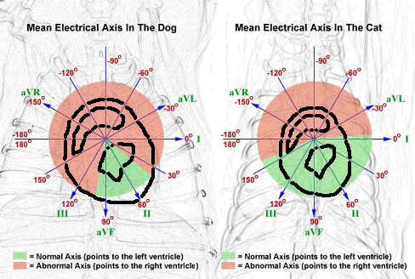

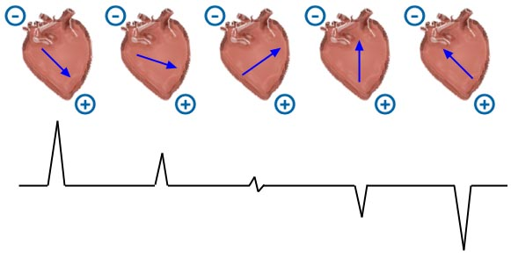

Hexaxial Method
5 Steps
- Determine the equiphasic lead
- Find that lead on the diagram
- Find the perpendicular lead
- Determine if it is positive or negative
- Find your Axis
https://www.youtube.com/watch?v=l5aVYxNCjG4

Quadrant Method
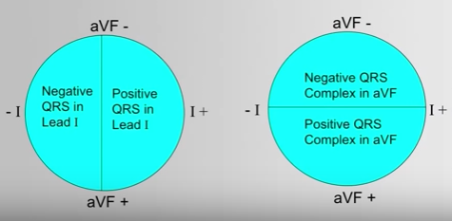
htts://www.youtube.com/watch?v=gmDBFB-7Dko&nohtml5=False

Significance
- Axis deviation occurs due to hypertrophy, dilation of ventricles and intraventricular conduction defects
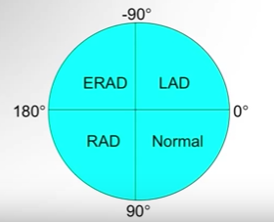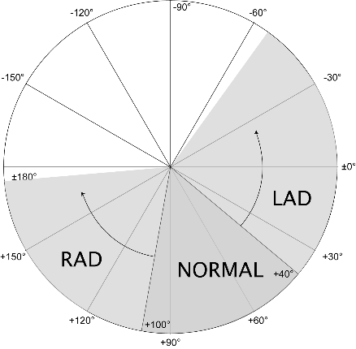
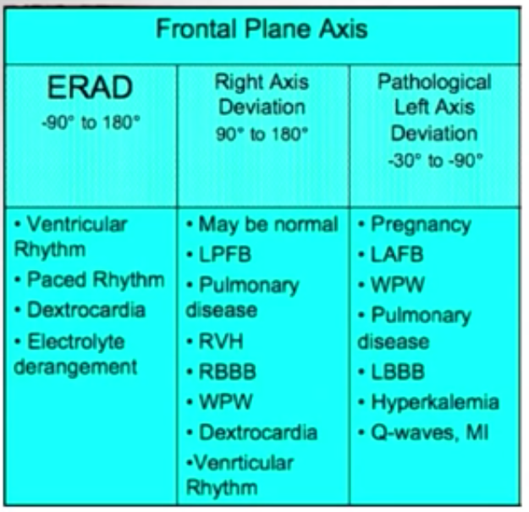
* Dextrocardia is a rare heart condition in which your heart points toward the right side of your chest instead of the left side
RVH: right ventricular hypertrophy
LPFB: left posterior bundle branch

Questions:
Determine the MEA of the following ECG
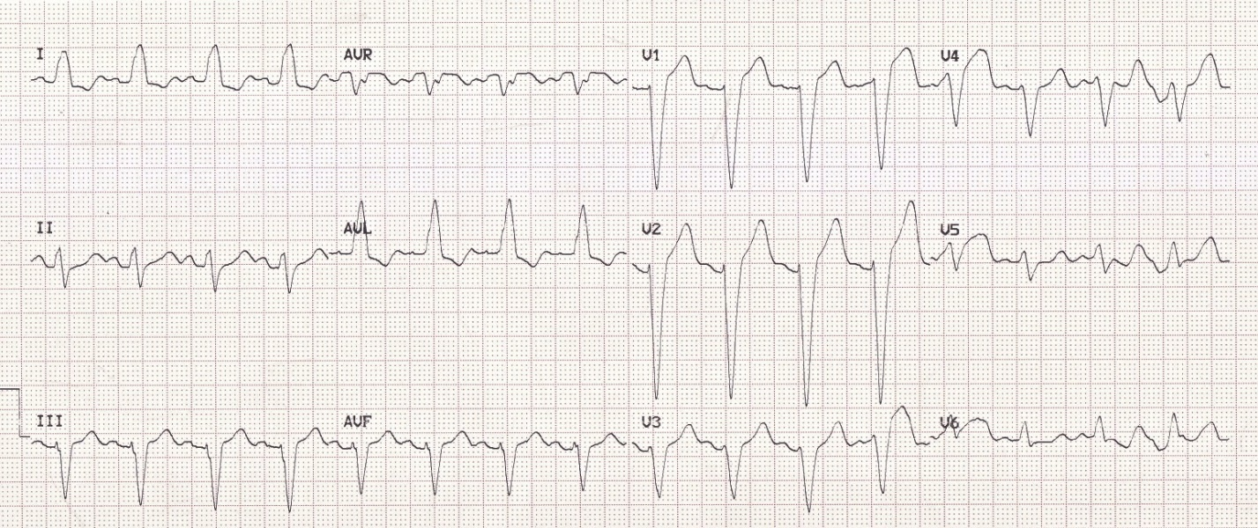
Quadrant method:

Hexaxial method:
- Determine the equiphasic lead:
- Find that lead on the diagram
- Find the perpendicular lead:
- Determine if it is positive or negative:
- Find your Axis:

What are differentials for this axis deviation?

Questions:
Quadrant method:
- AVF is negative, eliminate lower half of circle
- I is positive, eliminate left side of circle
- Left axis deviation

Hexaxial method:
- Determine the equiphasic lead: lead II
- Find that lead on the diagram
- Find the perpendicular lead: AVL
- Determine if it is positive or negative: positive
- Find your Axis: -30

What are differentials for this axis deviation?
Left Axis Deviation:
- Left anterior fascicular block
- Left bundle branch block
- Hyperkalemia

